181 North Place Residences: Automated Monitoring System

An IT Project Presented to

The Faculty of the School of Computing and Information Sciences

Saint Louis University, Baguio City

In Partial Fulfillment

Of the Requirements for

IT Project 2

By:

Jefren AGUILAR

Kenneth Van ALIMORONG

Ralph Daphene BANGSAIL

Mark Herbert CABUANG

Helga Denise GALO

Frances Mae SABADO

Kathreen Ann SILEN

Jaqueline TORRES

May 2015Department of Information Technology and Computer Sciences

School of Computing and Information Sciences

Saint Louis University

A. Bonifacio St., Baguio City, Philippines

cics@slu.edu.ph

**ACCEPTANCE SHEET**

In partial fulfilment of the requirements for the degree of Bachelor of Science in Information Technology, this IT Project entitled 181 North Place Residences: Automated Monitoring System has been prepared and submitted by Jefren R. Aguilar, Kenneth Van L. Alimorong, Ralph Daphene B. Bangsail, Mark Herbert D. Cabuang, Helga Denise B. Galo, Frances Mae N. Sabado, Kathreen Ann G. Silen, Jaqueline L. Torres and hereby endorse for approval.

___________________________

Ms. Ria Andrea F. Nana

Adviser

This is to certify that the IT Project mentioned above has been approved and accepted on 2 June 2015 be the IT project committee.

___________________________ ___________________________

Mr. Benedick Bacani Mr. Dalos Miguel

Panelist Panelist

Noted:

___________________________

Mr. Randy Domantay

IT Department Head

School of Computing and Information Sciences

___________________________

Dr. Cecilia A. Mercado

Dean

School of Computing and Information Sciences

**ACKNOWLEDGEMENT**

Our Special thanks to 181 North Place Residences for allowing us to create a system for their company and for giving us information about the company. To Ms. Camille Angela Dela Pena and to Ms. Regina Alabanza thank you for their patience, motivation, enthusiasm, and immense knowledge.

Also we are thanking our adviser Ms. Ria Andrea Nana for helping us throughout the project, for her guidance that helped us in all the time of research in writing and creating this IT Project. We could not have imagined this IT Project to be possible without her. To our panellists, Mr. Benedick Bacani and Mr. Dalos Miguel, for the suggestions and critics on how to improve our project.

To Mr. Jason Paolo R. Telles for helping us on our documentation, especially on proof reading and copy reading.

To our parents for guiding, providing us our financial needs, supporting us in every step of our project and not giving up on us in our rough times.

Lastly, to God for giving us strength, courage, knowledge and patience for this project to be a success.

Table of Contents

Chapter 1: Introduction 9

Abstract 9

Context of the Study 10

Background of the Study 12

Current Operation 14

1.1 Statement of the Problem 16

1.2 Scope of the Project 16

1.3 Statement of Objectives 18

1.4 Significance of the Study 18

Chapter 2: Methodology 18

Chapter 3: Outcomes and Results 21

Analysis 23

Minimum Hardware Requirements 24

Minimum Software Requirements 24

Design Specifications 25

Data Dictionary 30

Chapter 4: Conclusions and Recommendations 86

Conclusion 86

Recommendation 86

References 87

Appendix A 89

Appendix B 90

Interview 1 90

Interview 2 94

Interview 3 101

Interview 4 104

Appendix C 106

Appendix D 118

Appendix E 121

**List of Figures**

Figure 1: Number of Residents as of March 2015 13

Figure 2: Organizational Chart of 181 North Place Residences 13

Figure 3: Proposal System of the Management of 181 North Place Residence 14

Figure 4: Flow chart of the Current Operation of 181 North Place Residence 15

Figure 5: Incremental Process Model 19

Figure 6: System Architecture 22

Figure 7: Client/Server Architecture 23

Figure 8: Context Diagram of 181 North Place Residences: Automated Monitoring System 25

Figure 9: Level 1 Data Flow Diagram of 181 North Place Residences: Automated Monitoring System 26

Figure 10: Level 2 Data Flow Diagram of Billing Module 27

Figure 11: Level 2 Data Flow Diagram of Registration Module 28

Figure 12: Level 2 Data Flow Diagram of Report Generation Module 29

Figure 13: Relationship of 181 North Place Residences Database 41

Figure 14: Login 42

Figure 15: iLogBook 42

Figure 16: Home Page (Management) 43

Figure 17: Registration Menu 43

Figure 18: Registration (Transient) 44

Figure 19: iFloorPlan (Transient) 44

Figure 20: List of Transients 45

Figure 21: Administrators 45

Figure 22: List of Administrators 46

Figure 23: Add Administrator 46

Figure 24: Edit Profile (Administrator) 46

Figure 25: Change Password (Administrator) 47

Figure 26: Menu for Reservation 47

Figure 27: Reservation (Resident) 48

Figure 28: iFloorplan (Resident Reservation) 48

Figure 29: Registration (Resident) 49

Figure 30: Inventory Form (Resident) 49

Figure 31: List of Furniture (Registration Resident) 50

Figure 32: Upload Picture (Registration Resident) 50

Figure 33: Resident Menu 51

Figure 34: Options (Resident Menu) 51

Figure 36: Edit Profile 52

Figure 37: Edit Furniture and Gadget 53

Figure 38: Change Room 53

Figure 39: Menu for Admin Privileges 54

Figure 40: Shuttle Rate 54

Figure 41: Default Accounts 55

Figure 42: Manage Furniture 55

Figure 43: Room Rate 56

Figure 44: Transient Rate 56

Figure 46: iFloorplan 57

Figure 47: Edit Room 58

Figure 48: Notification Module 58

Figure 49: Clicking check box or check boxes 59

Figure 50: Transients and Reservations 59

Figure 51: Contact Persons for text messages 60

Figure 52: Contact Persons for sending an Email 60

Figure 53: Send Text Message 61

Figure 54: Send Email 62

Figure 55: Sending Text Messages and Emails 63

Figure 56: Sent box 63

Figure 57: Sent Box Message Details 64

Figure 58: Received Messages 64

Figure 59: Received Email 65

Figure 60: Billing of Residence 66

Figure 61: Statement of Accounts for Resident 67

Figure 63: Shuttle Ride 69

Figure 64: Statement of Accounts 70

Figure 65: Monthly Billing 71

Figure 66: Payment remittance 72

Figure 67: Report Generation 72

Figure 68: Archive 73

Figure 69: Resident Archive 74

Figure 70: Transient Archive 74

Figure 71: Visitors Archive 75

Figure 72: Admin Archive 75

Figure 73: Room Archive 76

Figure 74: Furniture Archive 76

Figure 75: Registration Archive 77

Figure 76: Reservation Archive 77

Figure 77: Logs Archive 78

Figure 78: Billing Archive 78

Figure 79: Leaved Resident Archive 79

Figure 80: Sample PDF 79

Figure 81: Sample Excel 80

Figure 82: Main Menu (Lobby) 80

Figure 83: Time In/Out 81

Figure 84: List of Residents (Register Fingerprint) 81

Figure 85: Register Fingerprint 82

Figure 86: Fingerprint Scan 82

Figure 87: Resident Search 83

Figure 89: Permit to Use Building Premises 84

Figure 90: List of Visitors (Use of Building Premises) 84

Figure 91: Visitor Logout 85

Figure 92: Reservation Form for Resident 106

Figure 93: Reservation Form for Transient 107

Figure 94: Resident Information Sheet 108

Figure 95: Room Inventory Form 109

Figure 96: Appliance and Gadget Inventory Form 109

Figure 97: Key Release Authorization Form 110

Figure 98: Contract of Lease for Minor (page 1) 111

Figure 99: Contract of Lease for Minor (page 2) 112

Figure 100: Contract of Lease for Minor (page 3) 113

Figure 101: Contract of Lease for Minor (page 4) 114

Figure 102: Contract of Lease for Non-Minor (page 1) 115

Figure 103: Contract of Lease for Non-Minor (page 2) 116

Figure 104: Contract of Lease for Non-Minor (page 3) 117

Figure 105: Contract of Lease for Non-Minor (page 4) 118

**List of Tables**

Table 1: Types of Dormitory 12

Table 2: Account Table 30

Table 3: Admin Table 30

Table 4: Billing Table 31

Table 5: Billinggadget Table 31

Table 6: Biometrics Table 32

Table 7: Controlnumber Table 32

Table 8: Credentials Table 32

Table 9: Fingerprintowner Table (View) 32

Table 10: Furniture Table 33

Table 11: Gadget Table 33

Table 12: Groupvisitcount Table (View) 33

Table 13: Logs Table 34

Table 14: Messagetemplate Table 34

Table 15: Notification Table 34

Table 16: Personperroom Table (View) 35

Table 17: Rate Table 35

Table 18: Registratin Table 36

Table 19: Rentedroom Table 36

Table 20: Reservation Table 37

Table 21: Resident Table 37

Table 22: Residentnames Table (View) 37

Table 23: Room Table 38

Table 24: Shuttle Table 38

Table 25: Transient Table 39

Table 26: Transientrate Table 39

Table 27: Visitors Table 40

# Chapter 1: Introduction

## Abstract

The management of 181 North Place Residences uses a paper based system in their reservation, registration, and billing and compiles the forms of the residents and transients using folders and organizer. The Building Administrator manually checks the logbook to know which resident exceeded the curfew hours, then will manually send a text message to the parent or guardian of the late resident. The management uses Excel spread sheet in computing the monthly fees of the residents and the transients. With the current situation of the 181 North Place Residences, the management spends hours in checking the late tenant in the logbook and sending text messages to the parents or guardians. Since their current business system is paper based, many problems are encountered, such as the difficulty of editing information, inconsistent and inaccurate data, slow access to information, lost and missing documents, storage location, and security.

“181 North Place Residences: Automated Monitoring System” is an automated monitoring system that uses a biometric device for the time logs. It has a database for keeping records and sends important notifications through text messaging and e-mail, which may contain the resident’s violations of the curfew and other house rules, special announcements, new roommates, visitors, balances and payments due. In creating the project, the proponents used the Incremental Process Model. By using the process model, the proponents achieved their objectives in creating an automated monitoring system that uses a biometric device for the time-in and time-out of the residents.

The project helps 181 North Place Residences improve their monitoring operations because of the reduction of time-consuming tasks. The project also allows the management to store the information in the database in case they need them for verification purposes. The automated monitoring system augments the security and safety of the residents through the biometric device. The automated system would be a beneficial tool for the dormitory on their daily operations as well as their future development.

.

## Context of the Study

“The automation of the monitoring system facilitates the process of routinely gathering of information through the use of finger print verification as the input. Automatic attendance system uses fingerprint verification technique where in a fingerprint is captured by user interface, which is likely to be an optical solid state or an ultrasound sensor. Generally, there are two approaches used for fingerprint verification system. Among them are Minutiae-based technique, where in minutiae is represented by ending termination and bifurcations, and image-based method or matching pattern of the fingerprint that was registered. (Rao & Satoa, 2013)”

“The finger print verification for the automated monitoring system uses a biometrics technology to validate the input with the image based method or matching pattern. Biometric technologies are defined as automated methods of identifying or verifying the identity of a living person based on unique biological (anatomical or physiological) or behavioural characteristics. Biometrics can provide very secure and convenient verification or identification of an individual since they cannot be stolen or forgotten and are very difficult to forge (Smart Card Alliance, 2011).”

“In order to support the automated monitoring process of ensuring safety and security, with the validation of the gathered biometrics input, notifications are sent to targets through email and Short Message Service (SMS) text messaging.  The U.are.U 4500 Reader utilizes optical fingerprint scanning technology for superior image quality and product reliability. The combination of the U.are.U 4500 Fingerprint Reader with the FingerJet matching engine produces an unmatched ability to recognize even the most difficult fingerprints.( USB Fingerprint Reader U.are.U 4500 Reader Crossmatch, 2014).” A notification is an official announcement about something that has happened or will happen. (Macmillian Dictionary, 2015). “The sending of email uses Simple Mail Transfer Protocol (SMTP) which is an application layer protocol for email communication. Another is the sending of notifications though SMS text messaging. SMS technology evolved out of Global System for Mobile Communications standard, an internationally accepted cell phone network specification that the European Telecommunications Standards Institute created. The sending of messages to end devices have a maximum payload of 140 octets (Brown, Shipman, and Vetter, 2007).” “FOWiz dashboard provides real-time notification on all call and messages received. All call and text messages initiated from FOWiz Cloud are sent to your device via messages and are processed by FOWiz on a FIFO model (FOWiz - Free Missed Call Setup, SMS Integration, Desktop , 2002).” “Adobe Acrobat is a family of [application software](http://en.wikipedia.org/wiki/Application_software) and [Web services](http://en.wikipedia.org/wiki/Web_service) developed by [Adobe Systems](http://en.wikipedia.org/wiki/Adobe_Systems) to view, create, manipulate, print and manage files in [Portable Document Format](http://en.wikipedia.org/wiki/Portable_Document_Format) (PDF). The family comprises Acrobat Reader, Acrobat (formerly Acrobat Exchange) and [Acrobat.com](http://en.wikipedia.org/wiki/Acrobat.com). The [freeware](http://en.wikipedia.org/wiki/Freeware) Acrobat Reader, available for several [desktop](http://en.wikipedia.org/wiki/Desktop_computer) and [mobile](http://en.wikipedia.org/wiki/Mobile_device) platforms, can view, print and annotate PDF files. (Adobe Acrobat - Wikipedia, the free encyclopedia, 2003).” “Microsoft Excel has the basic features of all spreadsheets, using a grid of cells arranged in numbered rows and letter-named columns to organize data manipulations like arithmetic operations. It has a battery of supplied functions to answer statistical, engineering and financial needs. In addition, it can display data as line graphs, histograms and charts, and with a very limited three-dimensional graphical display. It allows sectioning of data to view its dependencies on various factors for different perspectives (Microsoft Excel - Wikipedia, the free encyclopedia, 2003).” [“HTML](http://www.w3.org/html/) (the Hypertext Markup Language) and [CSS](http://www.w3.org/Style/CSS/) (Cascading Style Sheets) are two of the core technologies for building Web pages. HTML provides the structure of the page, CSS the (visual and aural) layout, for a variety of devices. Along with [graphics](http://www.w3.org/standards/webdesign/graphics) and [scripting](http://www.w3.org/standards/webdesign/script), HTML and CSS are the basis of building Web pages and Web Applications. [HTML](http://www.w3.org/html/) is the language for describing the structure of Web pages. [CSS](http://www.w3.org/Style/CSS/) is the language for describing the presentation of Web pages, including colors, layout, and fonts. It allows one to adapt the presentation to different types of devices, such as large screens, small screens, or printers (HTML & CSS - W3C,  2009).”

## Background of the Study

181 North Place Residences is a dormitory that started on August 2014. It offers safety, security and comfortable accommodation for residents and transients.

Currently, the operations of 181 North Place Residences are guided by the following:

* Registration is through paper based forms, which are kept in   folders, organizers, and filing cabinets.
* The reservations are done through Facebook page or walk in transactions and processed manually by filling out the reservation forms.
* The management monitors each resident’s time-in and time-out through the logbook. They send text messages through a mobile device and/or e-mail to resident’s parent or guardian about the curfew violation.
* The computation of fees and balances are done through Microsoft Excel 2007.
* 181 North Place Residences are currently using two (2) laptops for the transactions. The gate keeper checks the time-in and the time-out of each resident in the lobby using the logbook.
* The management puts a sticky note on the logbook for special announcements for specific residents.

A person who wants to stay at 181 North Place Residences is categorized as a resident or a transient. A transient can only stay for one (1) day to two (2) weeks. When a transient exceeds his or her two-week stay, he or she will already be considered as a resident. A resident is required to log in the logbook for their attendance in the dormitory.

The table below shows the types of the dormitory.

The table below shows the types of the dormitory.

|  |  |  |  |  |  |  |
| --- | --- | --- | --- | --- | --- | --- |
| DORM | ROOM TYPES | | | | TOTAL NUMBER OF ROOMS | TOTAL CAPACITY OF RESIDENTS OR TRANSIENTS  (excluding master suit room) |
| Single Rooms | Double Rooms | Triple Rooms | Master Suite |
| 1 | 2 | 5 | 7 | 1 | 15 | 33 |
| 2 | 2 | 5 | 7 | 1 | 15 | 33 |
| 3 | 2 | 0 | 12 | 1 | 15 | 38 |

Table 1: Types of Dormitory

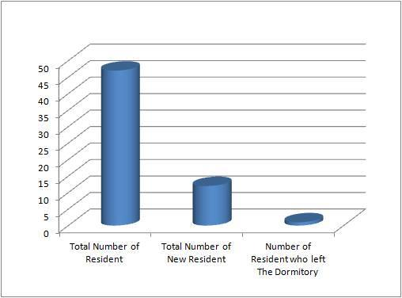

##### Figure 1: Number of Residents as of March 2015

Stakeholders

* Ms. Camille G. Dela Pena - Building Administrator
* Ms. Ma. Regina P. Alabanza - Staff Administrator
* Karina G. Dela Pena – Manager
* Security Personnel
* Residents and transients

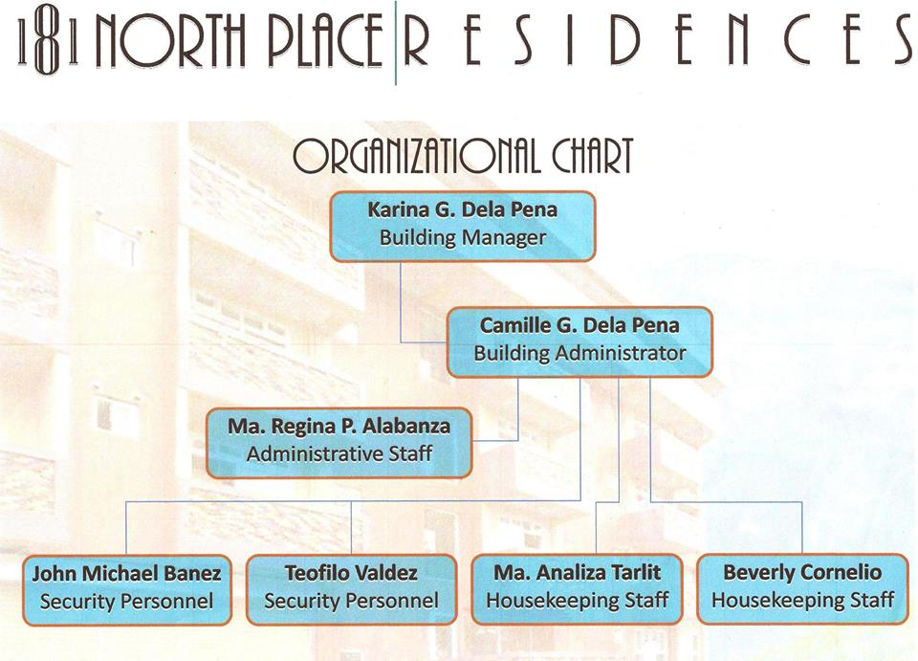

##### Figure 2: Organizational Chart of 181 North Place Residences

## Current Operation

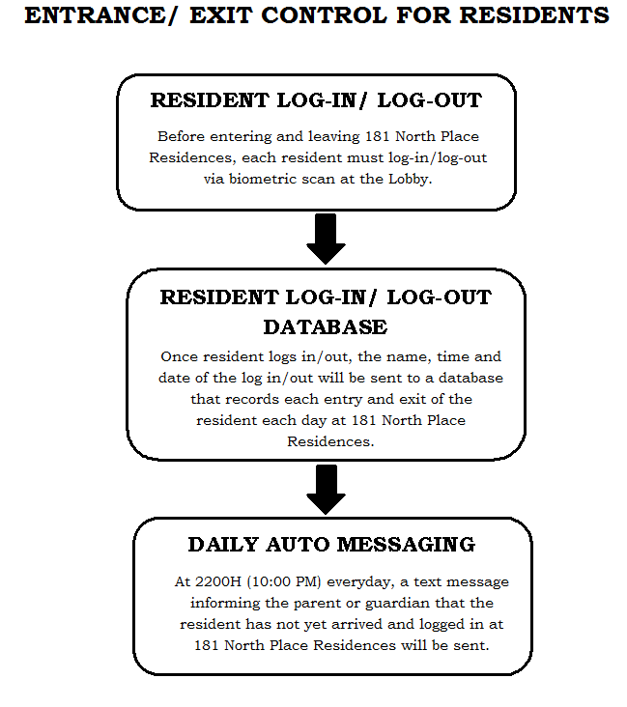

##### Figure 3: Proposal System of the Management of 181 North Place Residence

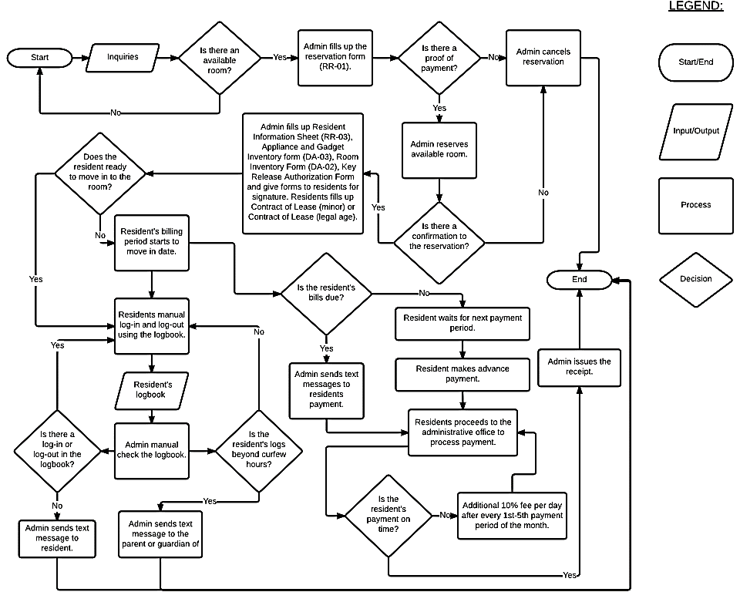

##### Figure 4: Flow chart of the Current Operation of 181 North Place Residence

### 1.1 Statement of the Problem

The project intends to investigate the benefits of an automated monitoring system to a commercial dormitory, particularly in the 181 North Place Residence. Specifically, the project proponents aim to improve the current system of 181 North Place Residences. Also, the project intends to answer the following problems:

* What are the specific business processes of the dormitory that will be automated?
* What are the functional requirements that are necessary in order for the system to function?
* What are the hardware and software requirements that are needed for the implementation of the “181 North Place Residences: Automated Monitoring System”?
* What feature of the system can facilitate maintenance for the security of “181 North Place Residences: Automated Monitoring System”?

### 1.2 Scope of the Project

This project covered the operations of 181 North Place Residences,which are mainly the admin module, reservation, registration, activation, notification, time-in and time-out, billing, report generation, backup and recovery and the help module. This project proposed and developed an Automated System that:

* Protects the database against data loss and reconstructs the database after any kind of data loss.
* Records each resident’s and transient’s balance, advance payments and other additional services acquired. The breakdown of payments can also be generated.
* Computes and breaks down the billing of the transients and residents. For the resident billing, it is automatic, but for the transient billing, it will be used as a guide.
* Includes the registration of different users such as residents, transients and management and registration of the resident’s fingerprints using a biometric device.
* Allows the management to select a resident’s account for enabling a resident to access the time-in and time-out using the biometric device and if the resident will leave the dormitory.
* Sends important notifications to targets especially to parents and guardians via text messaging and or e-mail to further ensure safety and security of the residents.
* Monitors each time-in and time-out of a resident for the dormitory attendance and resident’s late logs in real time to notify parents and or guardian of the curfew notice.
* Views the summary of transactions to help the management in decision making and also printing of documents is included.
* Aids in the easy reservation of available rooms using the iFloorPlan, an informative interface that the management uses to display room availability and status, the number of rooms available and occupied, the residents or transients occupying the room, and the list of gadgets and furniture inside the room.
* Monitors the transients’ stay inside the dormitory if the transient wants to extend its stay on the dormitory.
* Has the power to control all the modules to be used by the management
* Monitors visitors through the information entered in the lobby unit
* Assists the management on how to use the system with the different modules.

Limitations:

*Registration:*

* Maximum of two (2) contact numbers and e-mail address is recorded

*Time-in and Time-out Module:*

* Malfunction of text messaging (keeps on saying message failed although the message has been sent)
* No time-in and time-out for transient

*Notification Module:*

* The text messaging only supports 160 characters
* The system will not receive text messages from residents, guardians and parents
* Transients are not included in the notifications of late curfew
* No call via landline numbers

*Billing Module:*

* The system does not cover the computation of losses
* Computation of refunds requested by a resident and transient
* Termination of the contracts, resident should consult the management
* Security deposit on the transient will not be monitored
* The payment of the laundry and catering are not included in the computation.

*Database:*

* The purging of information of residents and transients will be decided by the management.

### 1.3 Statement of Objectives

The main purpose of the project is to build and deploy an automated monitoring system that is used by the stakeholders. Thus, the project intends to achieve the following:

* To automate the specific business processes of 181 North Place Residences
* To develop a computer-based system with functional requirements
* To define and integrate the tools and technologies for the development and implementation of the monitoring system of the 181 North Place Residences
* To create a login feature that will secure the monitoring system of the 181 North Place Residences

### 1.4 Significance of the Study

*Residents and Transients:*

The project is significant and beneficial to the residents and transients of 181 North Place Residences in terms of time management, safety, and security because the system provides a systematic order in the tracking of data associated with fingerprint verification capabilities and notifications sent as informative approach on each resident’s current activities in the dormitory and of the billing. The resident can track the balances easily.

*Management:*

The project helps the management in processing operations effectively and efficiently with the help of the automation of manual processes. The system also helps the management through easy computation of the bills of the residents. Reports and analysis provides better understanding in the monitoring of the residents.

*Project Proponent:*

It gives opportunities to the project proponents to better understand the monitoring system of time-ins and time-outs of the residents with the use of the biometric device. This project served as a training ground for the proponents to equip themselves in creating systems for their future jobs in businesses in the corporate world.

# Chapter 2: Methodology

The project proponents used the Incremental model of Mr. Winston W. Royce in developing the system to include clients or customer involvement on the developing stages and increments.

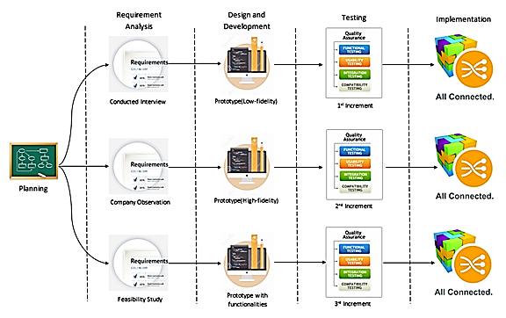

##### Figure 5: Incremental Process Model

PLANNING PHASE

The project proponents conducted a series of interviews, researches, and consultations with professionals, and understand the business process and policies of the monitoring system of the 181 North Place Residences to gather information that served a the fountain in the development of the monitoring system.

REQUIREMENTS ANALYSIS PHASE

After gathering information, the project proponents found necessary resources that helped in designing and developing the monitoring system. The project proponent used the Data Flow Diagram (DFD) (see Figure 9) as a tool to present and picture the business processes of the monitoring system.  The project proponent used storyboard (see Figure 3) to present the proposed system of the management of 181 North Place Residences and flowchart (see Figure 4) to show the current action process of the 181 North Place Residences and easily identify the marks of process development.

DESIGN AND DEVELOPMENT PHASE

In the design and development stage, the project proponents used wireframes as the initial step in designing the user interfaces. In the development of the high fidelity user interfaces (UIs) of the system, the project proponents used Integrated Development Environment (IDE) Netbeans 8.0.1., phpMyAdmin and MySQLWorkbench for the Database management.

Netbeans 8.0.1 supports Java ME where it can be used in integrating the hardware devices like biometric. Java 8 package is also available in Netbeans 8.0.1. phpMyAdmin was used for the creation of the database and MySQLWorkbench for the viewing of the database done in the phpMyAdmin.

The project proponents included a picture of the building and the logo of the company to be part of the user interfaces and created logos and icons that are appropriate as a trademark of the system of 181 North Place Residences. The project proponents asked the clients approval. After a review and revision process, a final design direction is selected, and prototypes were built. In designing the database, the project proponents first created an initial database and while every module is created and programmed, the project proponents adds tables, rows and columns to the database. Since 181 North Place Residences offers security and safety to its residents, the project proponents designed the system that is for the management to see and monitor its residents with the help of the system. The management will only be the one who can use the system.

TESTING PHASE

After the generation of codes, unit testing was performed to each module by a member of the team. After the unit testing, the integration of the modules was performed and the integration testing was done. Version one of the system was tested by the management of 181 North Place Residences. After testing, revisions and suggestions were given. The project proponent then made the necessary revisions. After that, unit and integration testing were performed again.

IMPLEMENTATION PHASE

In the implementation phase, the project proponents conducted a deployment for every module done and suggestions from the management were raised. And for every revision done based from the suggestions of the management, a new version of the module was deployed. The project proponents continued to develop and deploy the system until the management was satisfied with the monitoring system and had signed the acceptance letter.

# Chapter 3: Outcomes and Results

The system of 181 North Place Residences uses paper based forms. The management compiles the forms of the residents and transients using folders and organizers. By automating the current system, the time of the management in filing and organizing each forms of a resident and a transient and the cost in consuming papers were lessened.

The management currently uses manual text messaging in sending notifications to the residents or transients of 181 North Place Residences. One of the capabilities of the system is to inform the residents and transients by means of a notification through text messaging and e-mail regarding the resident’s or transient’s violations, billing, announcements by the management, visitors, and a new roommate.

Excel spreadsheets were used by the management in computing each resident’s monthly fee and each transient’s daily fee. The new system computes the bill by providing the breakdown of the monthly fee including the resident’s additional services such as the shuttle, catering, and the use of electricity because of additional gadgets or appliances.

Each resident’s time-in and time-out were recorded using the logbook. The management monitored the logbook daily to check violations of the curfew. The new system uses a biometric device for the time-in and time-out of each resident and captures the residents ID, date, time, and status. The iLogbook allows the management to see the residents who did not comply with the curfew hour and chooses who to send a notification. The iLogbook is designed to facilitate the control and power of the administrator or the management in the monitoring of residents.

The new system report generation helps the management in viewing the activities such as the history of the residents time-in and time-out, curfew, resident’s payments, list of visitors, and other violations of a resident and transient, prints the records of each residents and transients. However, the records will only be printed as requested.

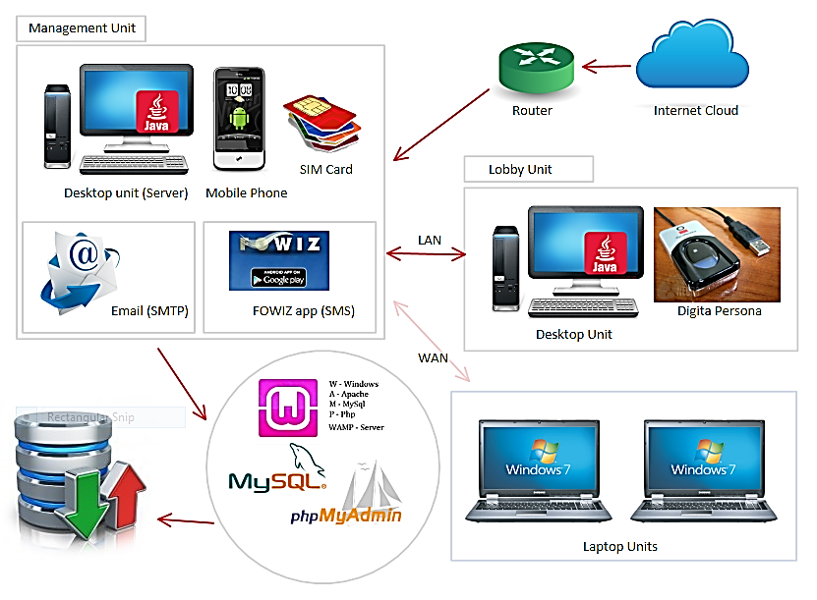

##### Figure 6: System Architecture

The figure above shows the system architecture of 181 North Place Residences Automated Monitoring System. The system architecture is comprised of two major components to execute the business processes of the automated monitoring system.

COMPONENTS:

*Management Unit:*

The management unit is a component that performs as the server for the system. The management unit is a desktop unit connected with fiber-optic internet connection. An android mobile phone with a SIM card subscribed to a post-paid bill, preferably only for texting, is also connected to the management unit for the sending of text messages. The email sending will be done through SMTP protocol. The android mobile phone is installed with FOWiz application downloaded at Google Play Store for free. The android mobile phone is connected to the internet.

*Lobby Unit*

The lobby unit is a component to serve as the data entry for the system. The lobby unit is a desktop unit connected to the biometric device for the time-in and time-out module. The data entered in the lobby unit will be displayed in the management unit. The connection to the server will be through Wide Area Network.

*Laptop Unit*

Laptop units can also be connected to the server wirelessly or with physical connection to facilitate the automated monitoring system. The same application of the management unit will be installed in the laptops. The laptop connection to the server will only be for the management. The connection to the server will be through Wide Area Network.

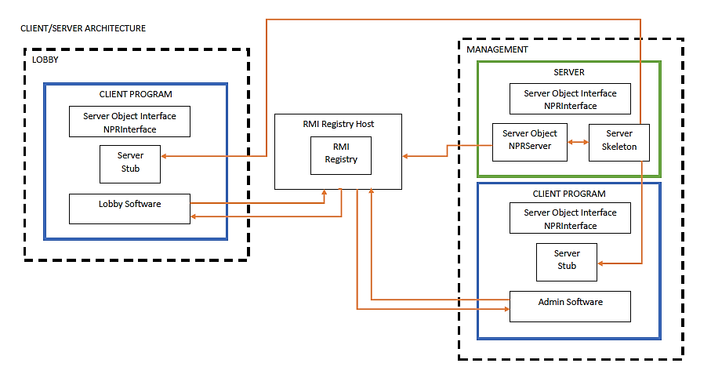

##### Figure 7: Client/Server Architecture

The figure above shows the client/server architecture of the automated monitoring system. The architecture is implemented in Java Remote Method Invocation (Java RMI).

## Analysis

         The functional requirements that are implemented in the 181 North Place Residences: Automated Monitoring System are:

* Reservation of inquiries with the use of iFloorPlan
* Registration of the inquirer who confirmed the reservation
* Activation or deactivation of each resident in using the biometric device and checkout of each transient
* Management-based decision on who to notify by text message or e-mail
* Keeping time records of a resident or a transient
* Breakdown of rental fee and other additional fee of a resident or transient
* To report generation and printing of documents into different format

## 

## Minimum Hardware Requirements

* Automatic Voltage Regulator(AVR) – at least 500W
* CPU Processor – Intel/AMD Dual Core or higher
* Random Access Memory(RAM) – at least 4GB DDR3
* DVD/CD Drive
* Hard Disk Drive – at least 500GB
* Motherboard
* USB Mouse
* USB Keyboard
* Printer
* Router
* Biometric device
* Android Phone with SIM card
* Scanner
* Back up battery/Uninterruptible Power Supply (UPS)

## Minimum Software Requirements

* Windows 7 to 8.1
* FOWiz Application
* WAMP Server
* Microsoft Office
* Adobe Reader
* Biometric Software

With the use of the hardware and software requirements listed above, the functional requirements that are implemented are the reservation, registration, activation, notification, time-in and time-out, billing and report generation modules. To secure the system, a log-in feature is implemented.

## https://scontent-sin.xx.fbcdn.net/hphotos-xta1/v/t1.0-9/11150243_931102946931232_6416799918795193731_n.jpg?oh=1f876de80de3849b9b74cd672283863c&oe=55A330C8Design Specifications

##### 

##### Figure 8: Context Diagram of 181 North Place Residences: Automated Monitoring System

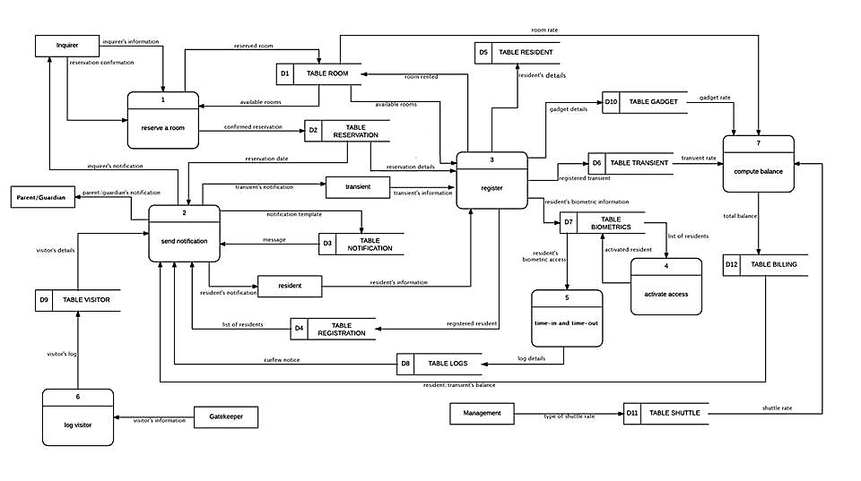

##### Figure 9: Level 1 Data Flow Diagram of 181 North Place Residences: Automated Monitoring System

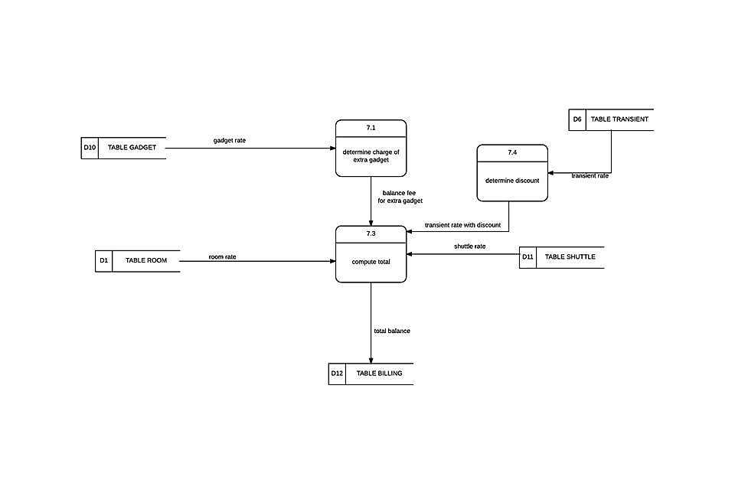

##### 

##### 

##### Figure 10: Level 2 Data Flow Diagram of Billing Module

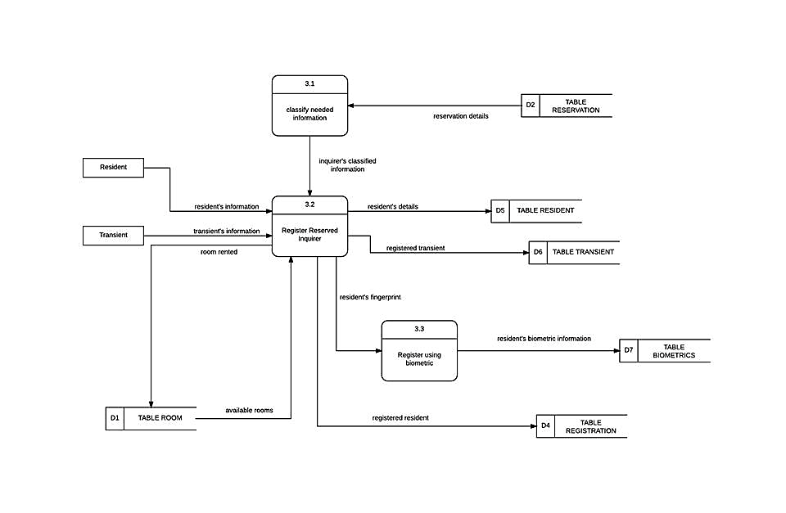

##### 

##### Figure 11: Level 2 Data Flow Diagram of Registration Module

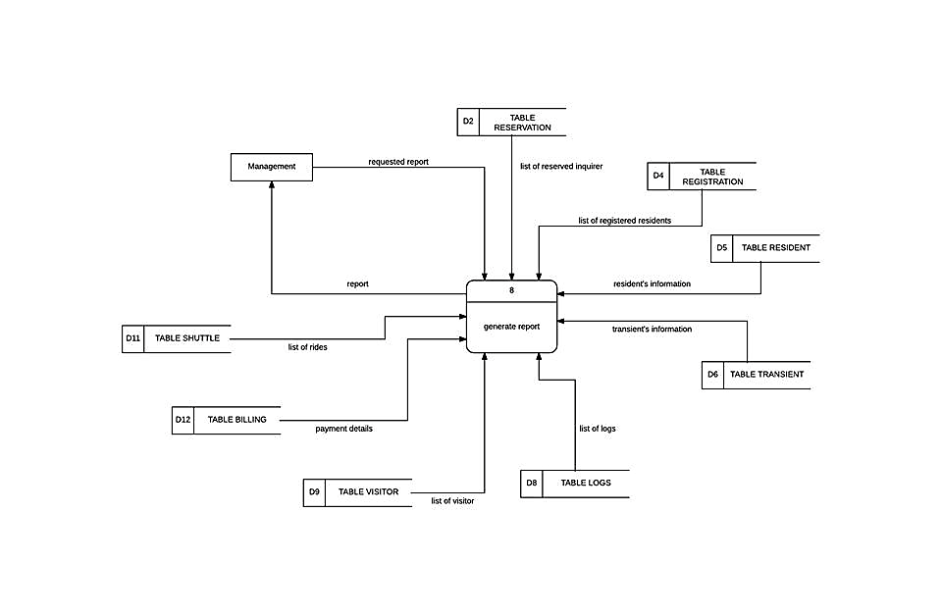

##### Figure 12: Level 2 Data Flow Diagram of Report Generation Module

**Data Dictionary**

|  |  |
| --- | --- |
| **Column** | **Type** |
| emailAccount | varchar(100) |
| emailPassword | varchar(50) |
| emailPort | varchar(10) |
| fowizUsername | varchar(100) |
| fowizPasscode | varchar(50) |
| reservationDefault | varchar(200) |
| registrationDefault | varchar(200) |
| furnitureDefault | varchar(200) |
| gadgetDefault | varchar(200) |
| transientDefault | varchar(200) |
| biometric | enum('Yes', 'No') |
| transientBillingDefault | varchar(200) |
| statementOfAccountDefault | varchar(200) |
| paymentRemittanceDefault | varchar(200) |
| curfew | time |

Table 2: Account Table

|  |  |
| --- | --- |
| **Column** | **Type** |
| adminIdnum | int(8) |
| adminFname | varchar(100) |
| adminMname | varchar(100) |
| adminLname | varchar(100) |
| adminGender | enum('Male', 'Female', '', '') |
| adminBirthdate | Date |
| adminEmail | varchar(100) |
| adminPicture | Mediumblob |

Table 3: Admin Table

|  |  |
| --- | --- |
| **Column** | **Type** |
| billingIdnum | int(8) |
| billingDatePaid | Date |
| billingDatein | Date |
| billingDateout | Date |
| billingRateType | enum('Monthly', 'Daily') |
| billingNoofdays | int(20) |
| billingRoomrate | decimal(10,2) |
| billingShuttleRatetype | enum('Monthly', 'Daily') |
| billingShuttleRate | decimal(10,2) |
| billingGadgetRate | decimal(10,2) |
| billingRemarks | varchar(500) |
| billingTotalRoomrate | decimal(10,2) |
| billingTotalShuttlerate | decimal(10,2) |
| billingTotalGadgetrate | decimal(10,2) |
| billingAdditionalfee | decimal(10,2) |
| billingTotalAmount | decimal(10,2) |
| billingAmountPaid | decimal(10,2) |
| billingBalance | decimal(10,2) |
| billingStatus | enum('Paid', 'Unpaid', 'Replaced') |
| residentIdnum | int(8) |
| roomIdnum | int(8) |
| adminIdnum | int(8) |
| billingModeOfPayment | enum('cash', 'cheque', 'bd') |

Table 4: Billing Table

|  |  |
| --- | --- |
| **Column** | **Type** |
| billingIdnum | int(8) |
| gadgetIdnum | int(8) |
| isChecked | tinyint(1) |

Table 5: Billinggadget Table

|  |  |
| --- | --- |
| **Column** | **Type** |
| biometricsIdnum | int(10) |
| fingerprintData1 | Longtext |
| fingerprintData2 | Longtext |
| Status | enum('active', 'not active') |
| residentIdnum | int(8) |

Table 6: Biometrics Table

|  |  |
| --- | --- |
| **Column** | **Type** |
| controlNumber | int(6) |
| type | enum('resident', 'transient') |
| id | int(8) |

Table 7: Controlnumber Table

|  |  |
| --- | --- |
| **Column** | **Type** |
| adminIdnum | int(8) |
| adminUsername | varchar(100) |
| adminPassword | longtext |

Table 8: Credentials Table

|  |  |
| --- | --- |
| **Column** | **Type** |
| residentIdnum | int(8) |
| resident_fullname | varchar(201) |
| fingerprintData1 | Longtext |
| fingerprintData2 | Longtext |
| Status | enum('Not Active', 'Active', 'Leave') |

Table 9: Fingerprintowner Table (View)

|  |  |
| --- | --- |
| **Column** | **Type** |
| furnitureIdnum | int(8) |
| furnitureControlNo | varchar(100) |
| furnitureColor | varchar(100) |
| furnitureBrand | varchar(100) |
| furniturePurchasedate | Date |
| furnitureItemName | varchar(100) |
| residentIdnum | int(8) |
| transientIdnum | int(8) |
| roomIdnum | int(8) |
| furnitureStatus | enum('Available', 'Taken', 'Defective') |

Table 10: Furniture Table

|  |  |
| --- | --- |
| **Column** | **Type** |
| gadgetIdnum | int(8) |
| gadgetItemName | varchar(50) |
| gadgetDescription | varchar(100) |
| gadgetSerialNo | varchar(45) |
| gadgetVoltage | varchar(50) |
| gadgetWattage | varchar(50) |
| gadgetRate | decimal(10,2) |
| residentIdnum | int(8) |

Table 11: Gadget Table

|  |  |
| --- | --- |
| **Column** | **Type** |
| residentIdnum | int(8) |
| visitorsStartDate | Date |
| visitorsTimein | Time |
| visitorsTimeout | Time |
| visitorsArea | varchar(100) |
| visitorCount | bigint(21) |

Table 12: Groupvisitcount Table (View)

|  |  |
| --- | --- |
| **Column** | **Type** |
| logsIdnum | int(8) |
| logsDate | Date |
| logsTime | Time |
| logsStatus | varchar(5) |
| residentIdnum | int(8) |

Table 13: Logs Table

|  |  |
| --- | --- |
| **Column** | **Type** |
| reservation7days | varchar(160) |
| reservation3days | varchar(160) |
| successfulRegistration | varchar(160) |
| visitorInform | varchar(160) |
| rentDueDate | varchar(160) |
| balanceAmount | varchar(160) |
| newRoommate | varchar(160) |
| curfewNotice | varchar(160) |

Table 14: Messagetemplate Table

|  |  |
| --- | --- |
| **Column** | **Type** |
| notificationIdnum | int(8) |
| notificationTime | Time |
| notificationDate | Date |
| notificationMessage | varchar(150) |
| notificationType | enum('Violations', 'Balance', 'Reservation Update', 'Successful Registration', 'Visitor', 'Due Date', 'New Roommate', 'Others') |
| notificationContact | varchar(100) |
| notificationMethod | enum('email', 'text') |
| residentIdnum | int(8) |
| notificationTable | enum('resident', 'reservation', 'transient') |

Table 15: Notification Table

|  |  |
| --- | --- |
| **Column** | **Type** |
| roomIdnum | int(8) |
| roomNumber | varchar(3) |
| numberOfResident | bigint(21) |

Table 16: Personperroom Table (View)

|  |  |
| --- | --- |
| **Column** | **Type** |
| rentRoomSingleSharing | decimal(10,2) |
| rentRoomDoubleSharing | decimal(10,2) |
| rentRoomTripleSharing | decimal(10,2) |
| rentRoomMasterSuite | decimal(10,2) |
| shuttleRateMonthly | decimal(10,2) |
| shuttleRateDaily | decimal(10,2) |

Table 17: Rate Table

|  |  |
| --- | --- |
| **Column** | **Type** |
| registrationIdnum | int(8) |
| registrationResidentCollege | varchar(100) |
| registrationResidentCourse | varchar(100) |
| registrationResidentYear | varchar(4) |
| registrationResidentDept | varchar(100) |
| registrationResidentBirthdate | Date |
| registrationResidentGender | enum('Male', 'Female', '', '') |
| registrationResidentMobileNo | varchar(50) |
| registrationResidentMobileNo2 | varchar(50) |
| registrationFatherName | varchar(100) |
| registrationFatherLandline | varchar(50) |
| registrationFatherMobileNo | varchar(50) |
| registrationFatherEmail | varchar(100) |
| registrationMotherName | varchar(100) |
| registrationMotherLandline | varchar(50) |
| registrationMotherMobileNo | varchar(50) |
| registrationMotherEmail | varchar(100) |
| registrationGuardianName | varchar(100) |
| registrationGuardianAddress | varchar(100) |
| registrationGuardianMobileNo | varchar(50) |
| registrationGuardianRelation | varchar(30) |
| registrationPicture | Mediumblob |
| registrationStatus | enum('Not Active', 'Active', '', '') |
| roomIdnum | int(8) |
| reservationIdnum | int(8) |
| registrationDate | Date |

Table 18: Registratin Table

|  |  |
| --- | --- |
| **Column** | **Type** |
| rentId | int(11) |
| rentStartDate | Date |
| rentEndDate | Date |
| rentRateType | enum('Monthly', 'Daily') |
| rentRoomRate | decimal(10,2) |
| roomIdnum | int(8) |

Table 19: Rentedroom Table

|  |  |
| --- | --- |
| **Column** | **Type** |
| reservationIdnum | int(8) |
| reservationLname | varchar(100) |
| reservationFname | varchar(100) |
| reservationMname | varchar(100) |
| reservationHomeaddress | varchar(255) |
| reservationZipCode | varchar(10) |
| reservationMobileNo | varchar(11) |
| reservationSchoolTerm | enum('First Semester', 'Second Semester', 'Summer Term', '') |
| reservationEmail | varchar(100) |
| reservationAyFrom | year(4) |
| reservationAyTo | year(4) |
| reservationOthers | varchar(100) |
| reservationDatePaid | Date |
| reservationStatus | enum('Cancel', 'Registered', 'Pending') |
| roomIdnum | int(8) |

Table 20: Reservation Table

|  |  |
| --- | --- |
| **Column** | **Type** |
| residentIdnum | int(8) |
| residentFname | varchar(100) |
| residentMname | varchar(100) |
| residentLname | varchar(100) |
| residentGender | enum('Male', 'Female', '', '') |
| residentZipCode | varchar(10) |
| residentMobileNo | varchar(11) |
| residentEmail | varchar(100) |
| residentBirthdate | Date |
| residentHomeAddress | varchar(100) |
| picture | Mediumblob |
| status | enum('Not Active', 'Active', 'Leave') |
| dateLeft | Date |
| registrationIdnum | int(8) |
| roomIdnum | int(8) |

Table 21: Resident Table

|  |  |
| --- | --- |
| **Column** | **Type** |
| residentNames | varchar(201) |

Table 22: Residentnames Table (View)

|  |  |
| --- | --- |
| **Column** | **Type** |
| roomIdnum | int(8) |
| roomNumber | varchar(3) |
| roomStatus | enum('not available', 'fully occupied', 'partially occupied', 'unoccupied') |
| roomType | enum('S', 'D', 'T', 'SU') |
| roomDorm | varchar(4) |

Table 23: Room Table

|  |  |
| --- | --- |
| **Column** | **Type** |
| shuttleDate | varchar(100) |
| shuttleNoRides | decimal(10,2) |
| shuttleRate | decimal(10,2) |
| shuttleRateType | enum('Monthly', 'Rides') |
| shuttleId | int(10) |

Table 24: Shuttle Table

|  |  |
| --- | --- |
| **Column** | **Type** |
| transientIdnum | int(8) |
| transientLname | varchar(100) |
| transientFname | varchar(100) |
| transientMobileno | varchar(45) |
| transientAddress | varchar(100) |
| transientEmail | varchar(100) |
| transientDateEntered | date |
| transientRelation | enum('Mother', 'Father', 'Brother', 'Sister', 'Grandmother', 'Grandfather', 'Aunt', 'Uncle', 'Other') |
| transientTotalAmount | decimal(10,2) |
| transientAmountpaid | decimal(10,2) |
| transientBalance | decimal(10,2) |
| transientNoreservedRoom | int(10) |
| transientReservedRoomNo | varchar(50) |
| transientArrival | date |
| transientDeparture | date |
| transientTotalNoDays | int(10) |
| transientNoAdditionalGuest | int(10) |
| transientNamesAdditionalGuest | varchar(500) |
| transientNoExtraBed | int(10) |
| transientBedcharge | decimal(10,2) |
| transientChargePerPerson | decimal(10,2) |
| transientStatus | enum('Checkout', 'Extend', 'Active') |
| residentIdnum | int(8) |
| transientControlNumber | int(6) |
| transientRemarks | varchar(200) |
| transientModeOfPayment | enum('cash', 'cheque', 'bd') |
| adminIdnum | int(8) |
| transientDiscount | decimal(10,2) |

Table 25: Transient Table

|  |  |
| --- | --- |
| **Column** | **Type** |
| transientRegularRate | decimal(10,2) |
| transientFamilyRate | decimal(10,2) |
| transientRExtraBed | decimal(10,2) |
| transientFExtraBedRate | decimal(10,2) |
| transientPrivateSuite | decimal(10,2) |
| transientPrivateExtraRate | decimal(10,2) |

Table 26: Transientrate Table

|  |  |
| --- | --- |
| **Column** | **Type** |
| visitorsIdnum | int(8) |
| visitorsName | varchar(100) |
| visitorsDate | Date |
| visitorsTimein | Time |
| visitorsTimeout | Time |
| visitorsPurpose | enum('Inquire', 'Visit', 'School works', 'Personal Business', 'Others') |
| residentIdnum | int(8) |
| visitorTable | enum('resident', 'administrator', 'transient') |
| visitorsValidId | varchar(100) |
| visitorsArea | varchar(100) |
| visitorsStartDate | Date |

Table 27: Visitors Table

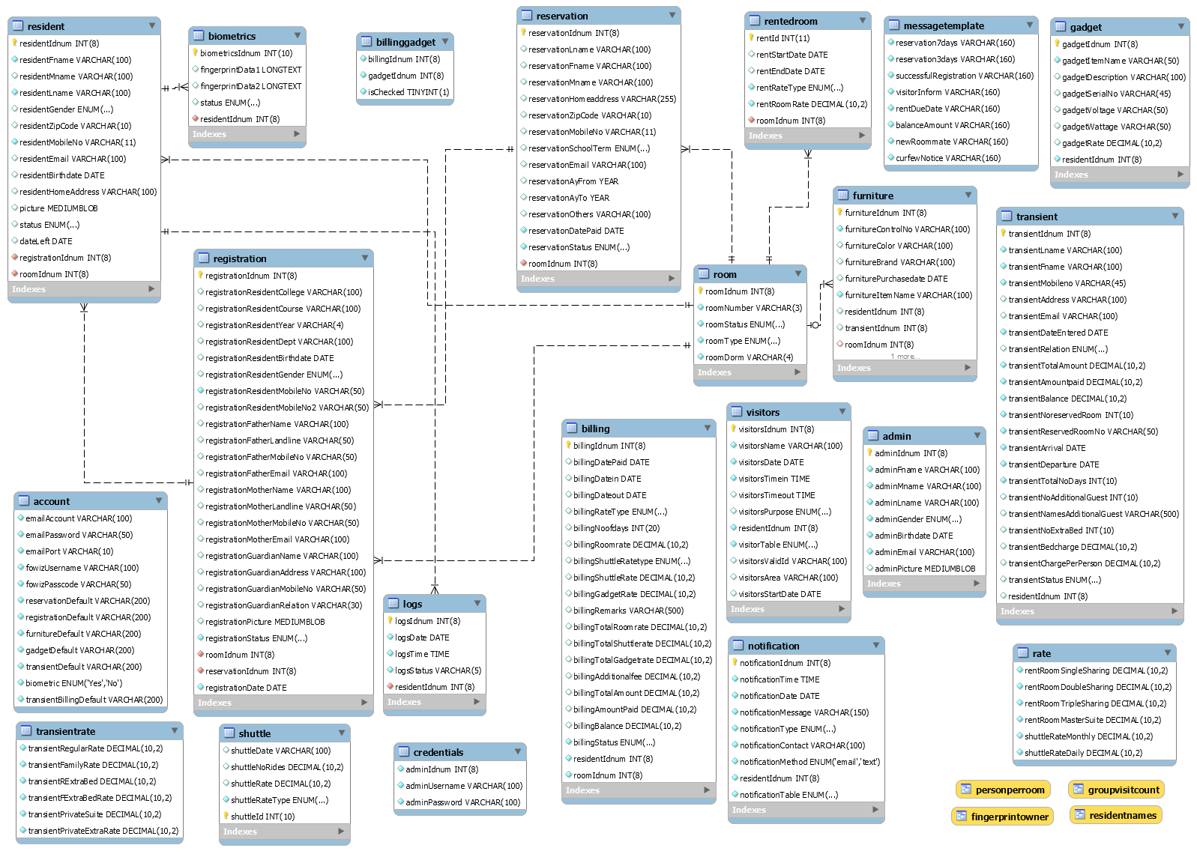

##### Figure 13: Relationship of 181 North Place Residences Database

**User Interfaces**

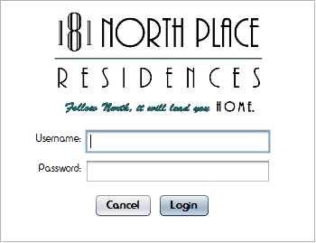

##### Figure 14: Login

Figure 14 lets only the management to login.

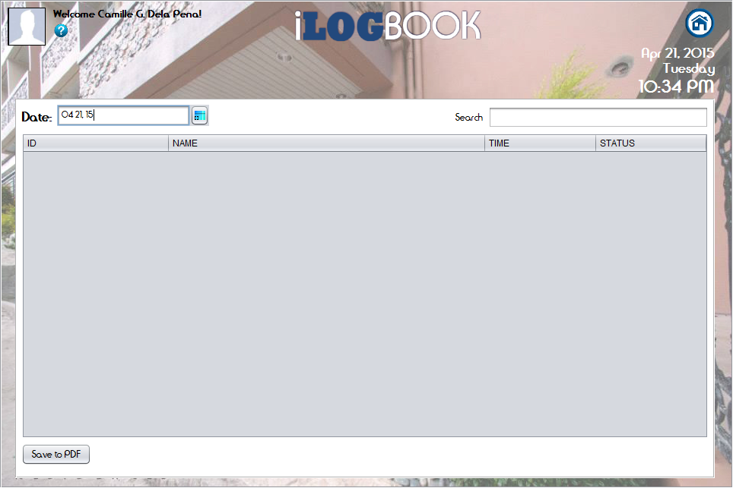

##### Figure 15: iLogBook

Figure 15 lets only the management to see the logs of the residents. It can also save the log of the residents on a PDF format depending on the date selected by the management.

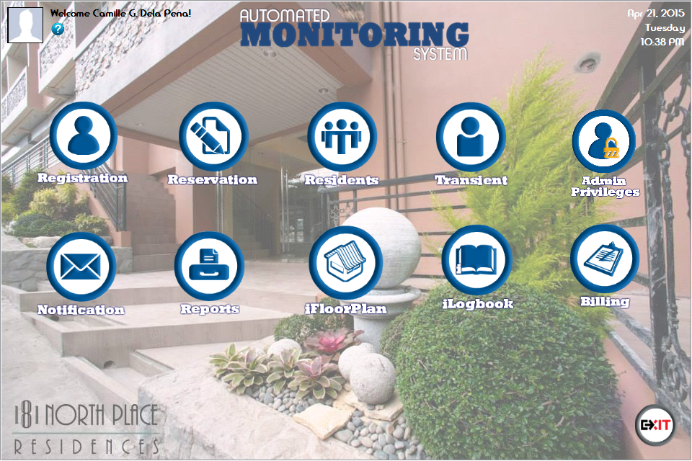

##### Figure 16: Home Page (Management)

Figure 16 shows all the operations the management can do.

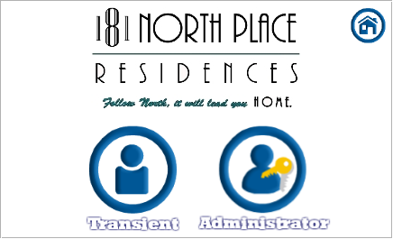

##### Figure 17: Registration Menu

Figure 17 enables the management to choose who to register, a transient or a new administrator.

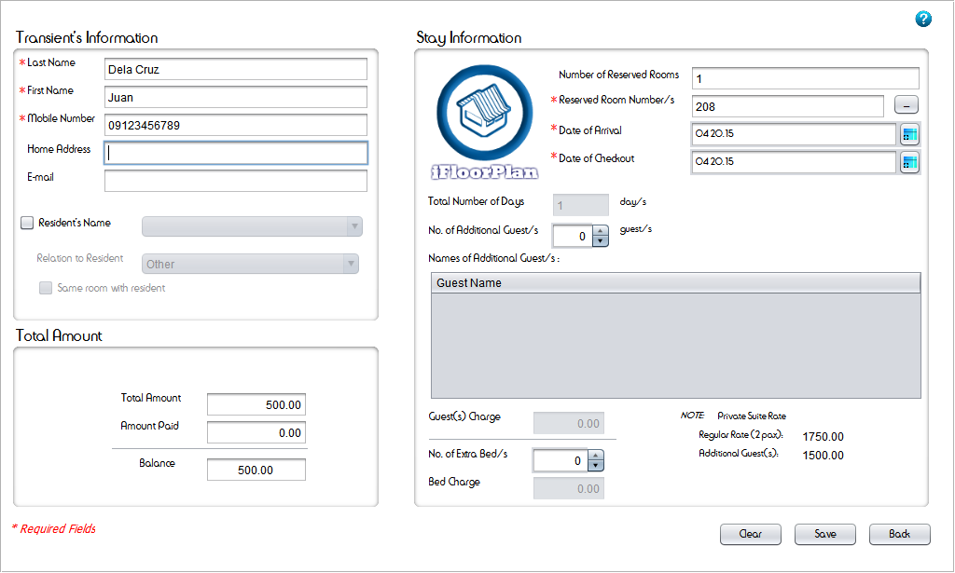

##### Figure 18: Registration (Transient)

Figure 18 lets the management to enter the information of the transient

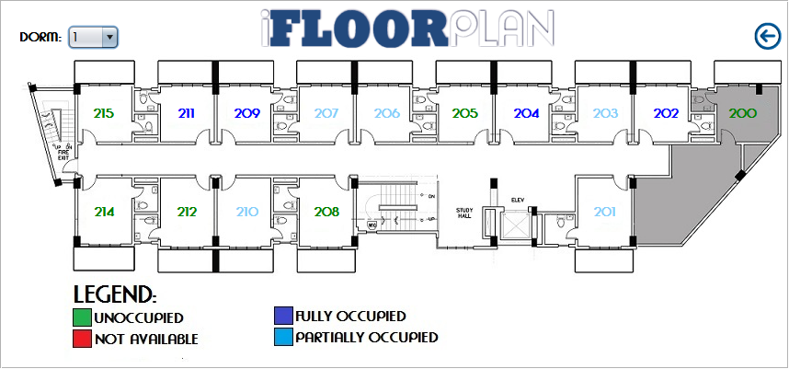

##### Figure 19: iFloorPlan (Transient)

Figure 19 lets the management to choose the room available for transient.

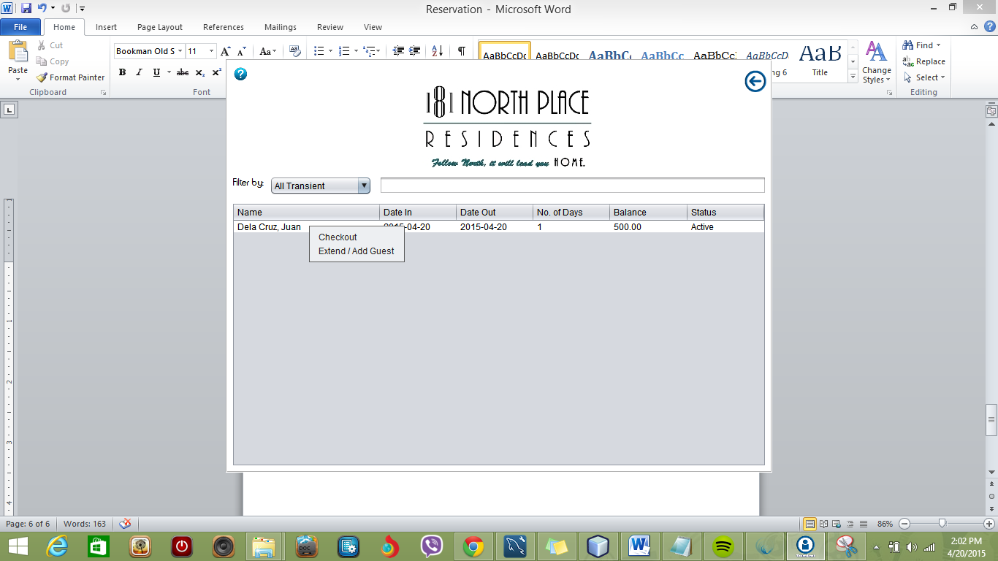

##### Figure 20: List of Transients

Figure 20 lets the management to see the list of transients with the corresponding balance. The management can also extend the transient’s stay or check out the transient by right clicking the transient’s name.

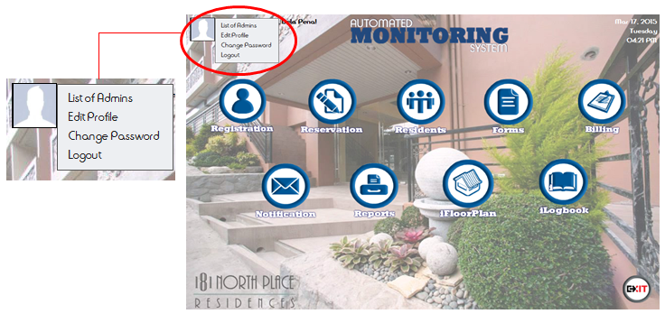

##### Figure 21: Administrators

Figure 21 lets the management to see the following options on the picture at the upper left-hand corner: List of Admins, Edit Profile, Change Password and Logout

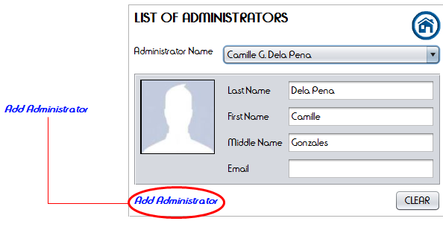

##### Figure 22: List of Administrators

Figure 22 lets the management to see the Administrator’s information. The ‘Add Administrator’ can also be clicked from this user interface.

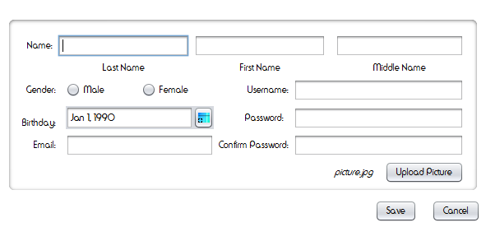

##### Figure 23: Add Administrator

Figure 23 lets the management to add a new administrator.

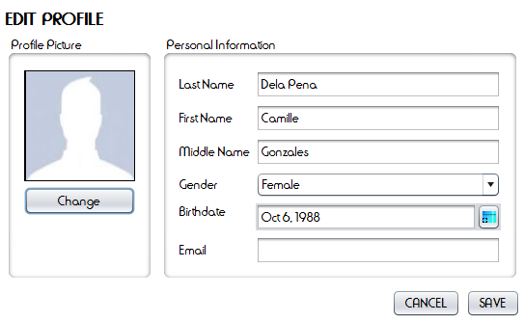

##### Figure 24: Edit Profile (Administrator)

Figure 24 lets the management to edit an administrator’s information.

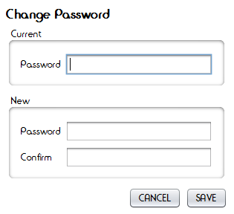

##### Figure 25: Change Password (Administrator)

Figure 25 lets the management to change an administrator’s password.

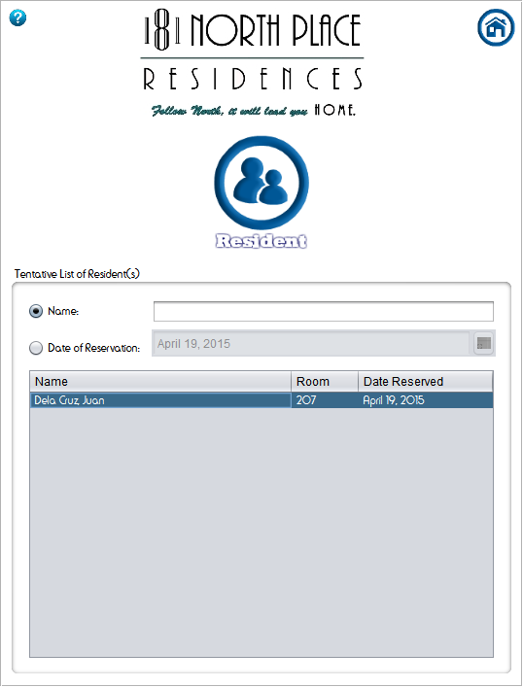

##### Figure 26: Menu for Reservation

Figure 26 lets the management to choose if the inquirer is resident or transient. The tentative list of residents is the list of the names of the person which are currently reserved.

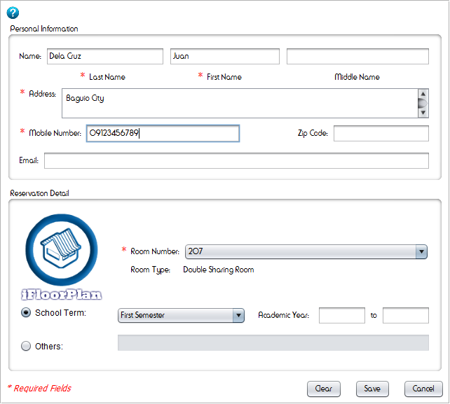

##### Figure 27: Reservation (Resident)

Figure 27 lets the management fill in information of the inquirer.

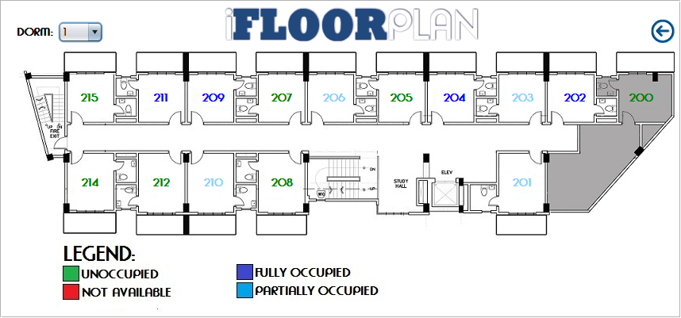

##### Figure 28: iFloorplan (Resident Reservation)

When the management will click the iFloorPlan Logo in the reservation form, the management may choose which room is available for renting.

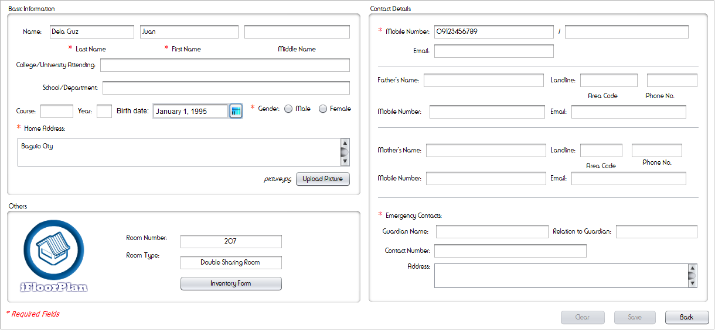

##### Figure 29: Registration (Resident)

Figure 29 lets the management fill in information of the person who reserved.

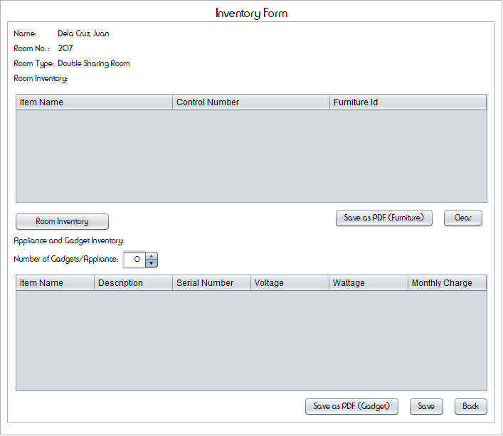

##### Figure 30: Inventory Form (Resident)

Figure 30 lets the management fill in list of gadgets and see the list of furniture to be designated to them after selecting furniture in “Room Inventory”.

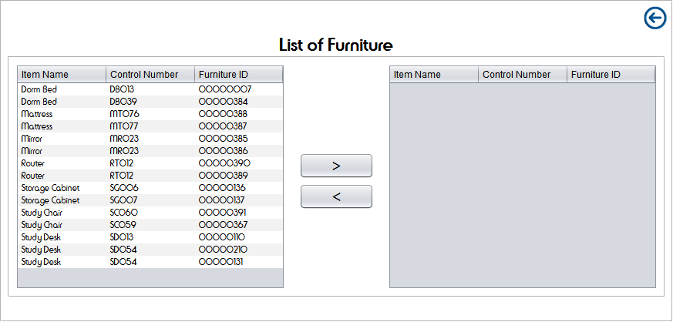

##### Figure 31: List of Furniture (Registration Resident)

Figure 31 lets the management choose the furniture to be designated to the resident.

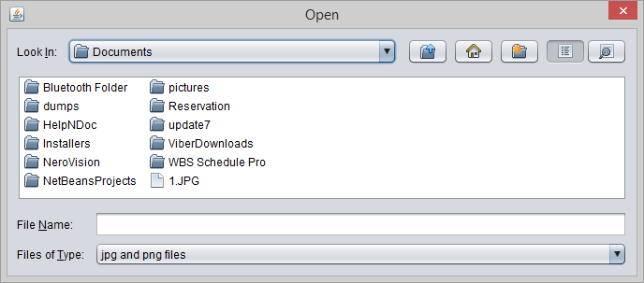

##### Figure 32: Upload Picture (Registration Resident)

Figure 32 lets the management choose the picture of the resident.

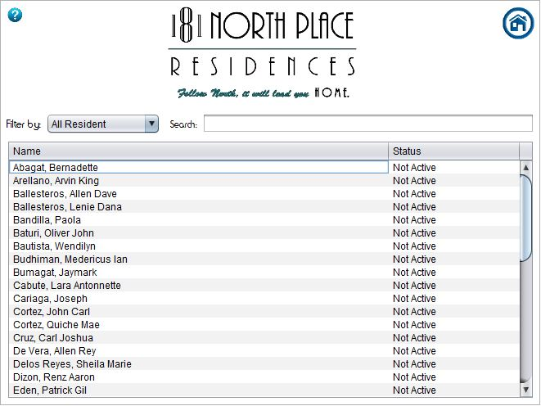

##### Figure 33: Resident Menu

The figure shows the list of the resident in the dormitory. The management can search the names of the resident and can be filtered to *Active* or *Not Active.*

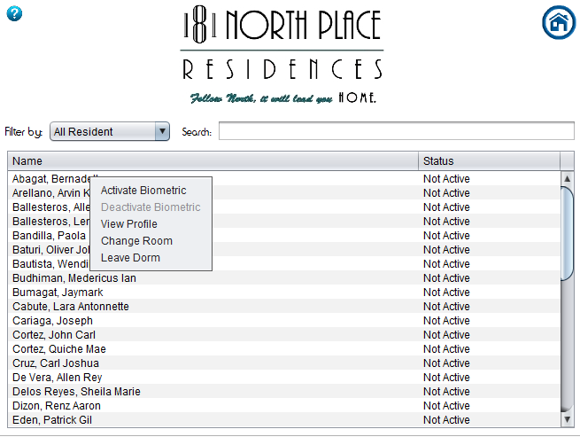

##### Figure 34: Options (Resident Menu)

The management can activate and deactivate the use of the biometric to the resident. They can also view and edit the profile of the resident. The management can also change the room of the resident and can select the *Leave Dormitory* if the resident will no longer avail the services of the dormitory.

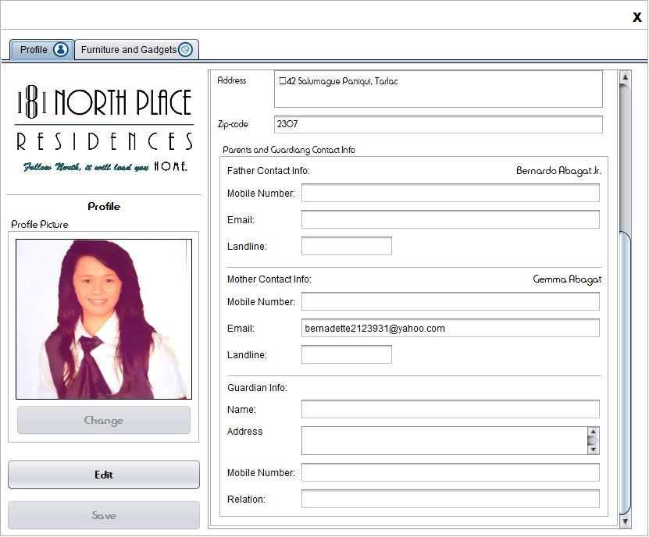

Figure 35: View Profile

The figure shows the basic information of the resident and resident’s guardian and parent.

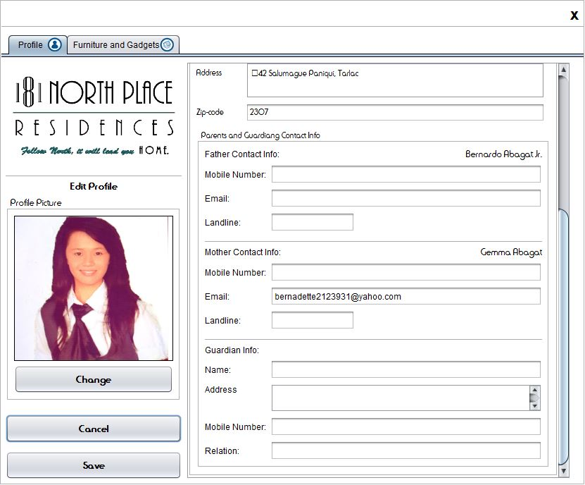

##### Figure 36: Edit Profile

After Clicking the *Edit* button, the management can edit the information of the resident and resident’s guardian and parents.

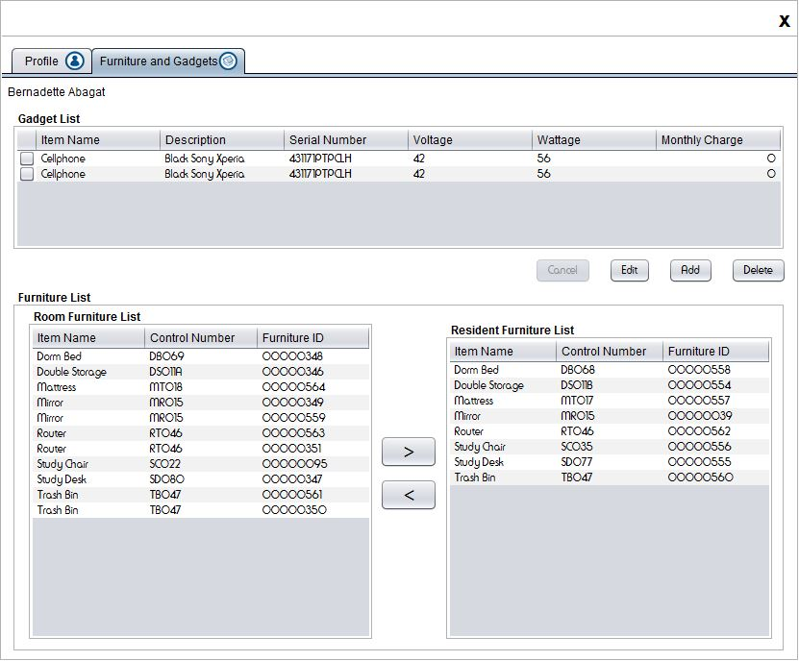

##### Figure 37: Edit Furniture and Gadget

The figure allows the management to add, edit and delete a gadget that is owned by the resident. It also allows the management to assign and remove furniture to the resident.

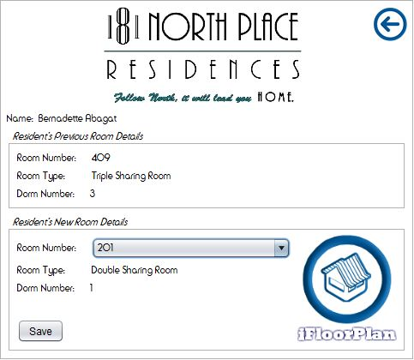

##### Figure 38: Change Room

The figure allows the management to change the room of a resident if the resident wishes to.

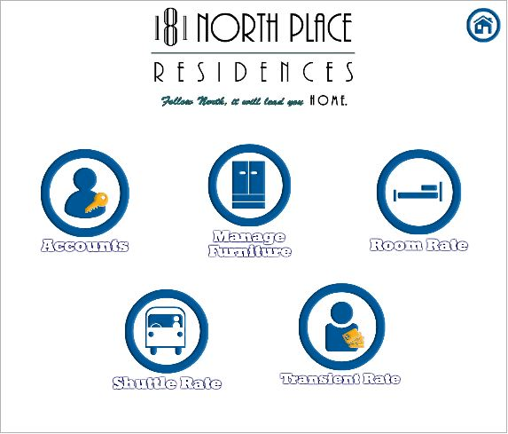

##### Figure 39: Menu for Admin Privileges

The figure shows some of the privileges given to the Management.

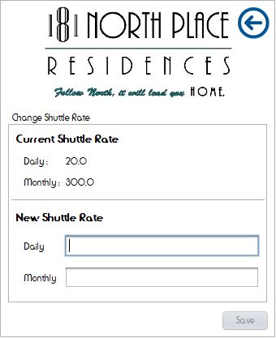

##### Figure 40: Shuttle Rate

The Management is given the privilege to change the Shuttle rate. In the figure the Management can change the Daily rate and Monthly rate of the Shuttle.

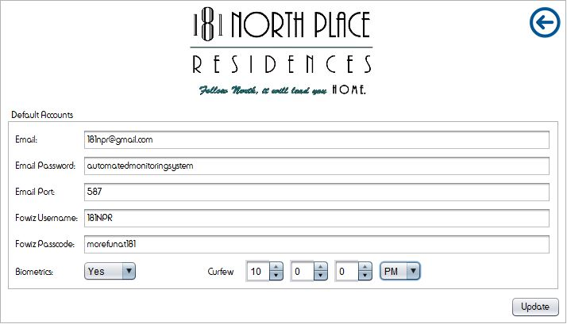

##### Figure 41: Default Accounts

The system is capable of sending email and text messages. It is also capable to save form as PDF file. In the figure the Management can change their email account, password, email port, the username and password of Fowiz, can disable and enable the use of the Biometrics.

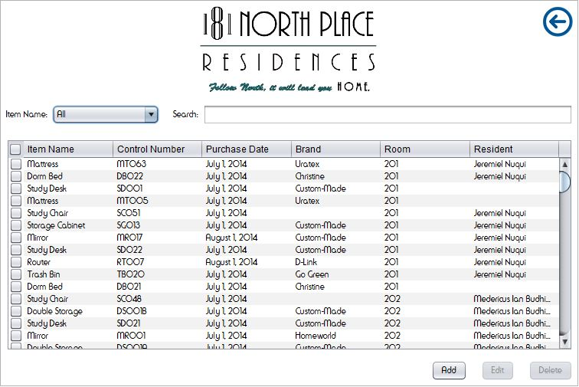

##### Figure 42: Manage Furniture

In the figure the Management is given the privilege to add, edit and delete furniture information.

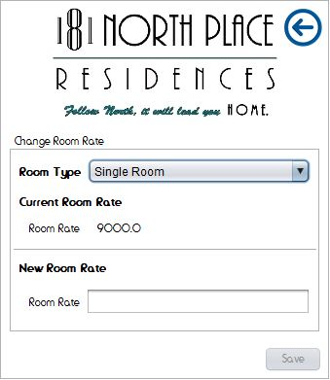

##### Figure 43: Room Rate

The Management is given the privilege to change the Room rate. In the figure the Management can change the rate of a room, Single Room, Double Room, Triple Room and the Master Suite.

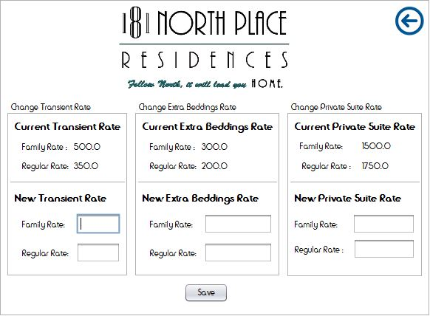

##### Figure 44: Transient Rate

The Management is given the privilege to change the Transient rate, Extra bedding rate and the Private suite rate. The management can enter two different rates, for Family rate and for Regular rate.

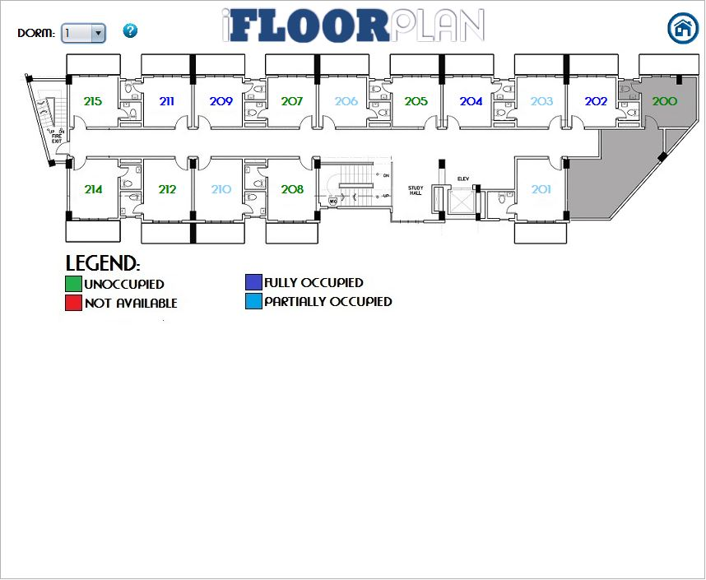

Figure 45: iFloorPlan (Continued)

The figure shows the floor plan of 181 North Place Residence together with the status of the room, unoccupied, not available, fully occupied and partially occupied.

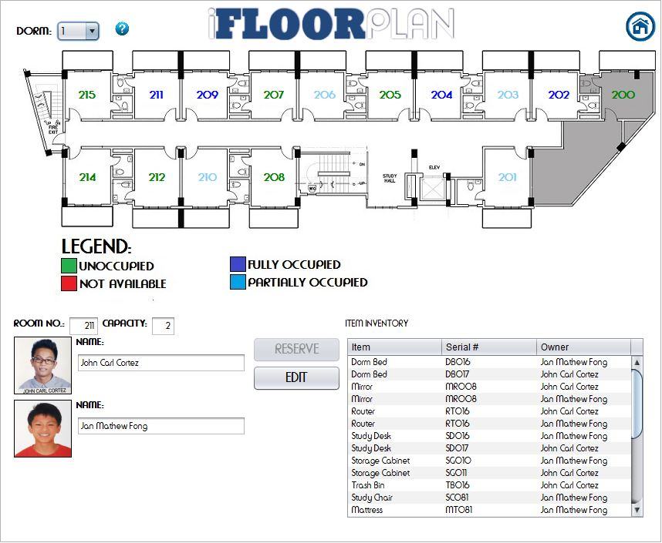

##### Figure 46: iFloorplan

When the management clicked a room number, the occupant/s of the room will be shown together with the list of furniture designated to the resident.

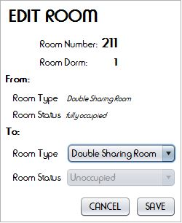

##### Figure 47: Edit Room

The figure allows the management to edit the room type.

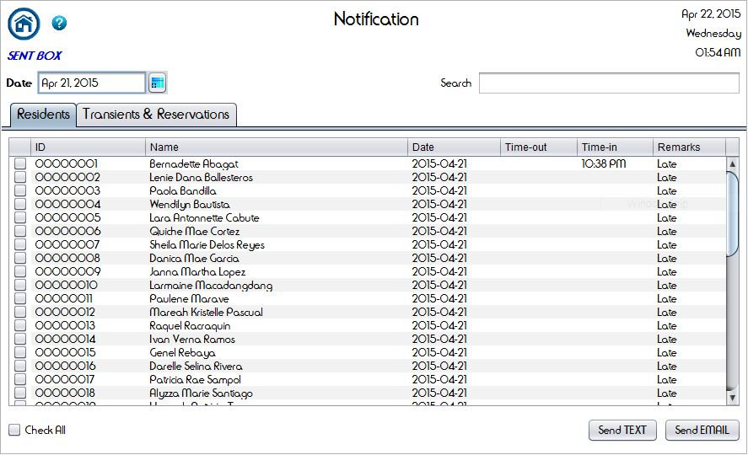

##### Figure 48: Notification Module

The notification module allows the management to notify residents, resident’s parents or guardian, transients and reserved inquirer by sending a text message or email.

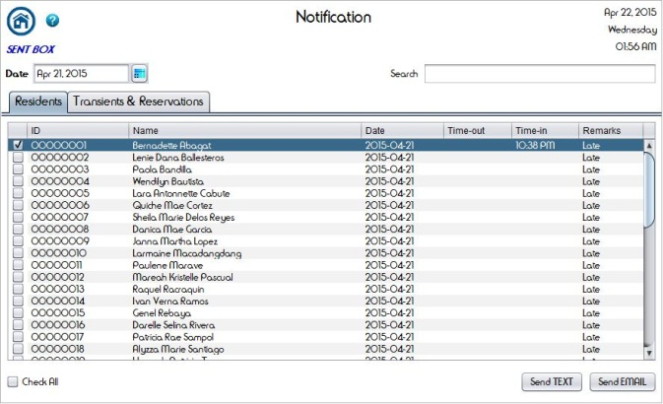 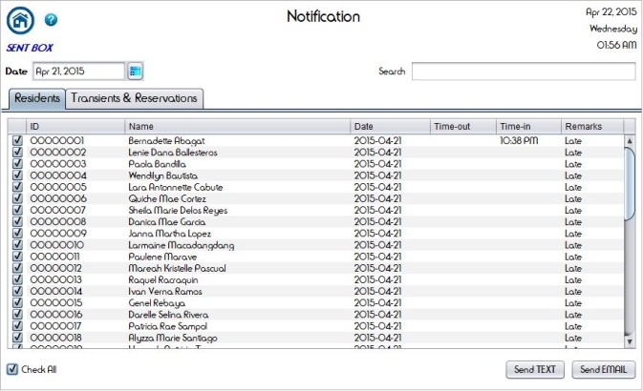

##### Figure 49: Clicking check box or check boxes

The management can choose a recipient/s by clicking a check box or check boxes for sending a text message or email. The management can also select the “Check All” check box to send a text message or email to all residents or resident’s parent or guardian.

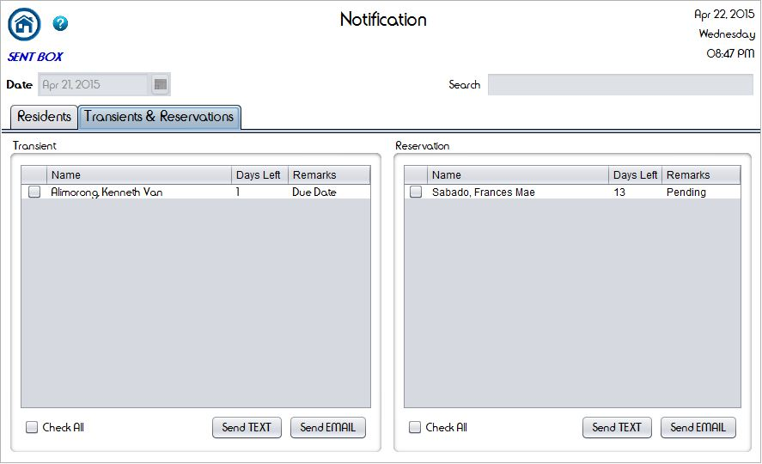

##### Figure 50: Transients and Reservations

The management can send a text message or email to the transients and to the reserved inquirer on the 7th and 11th day of their reservation for confirmation.

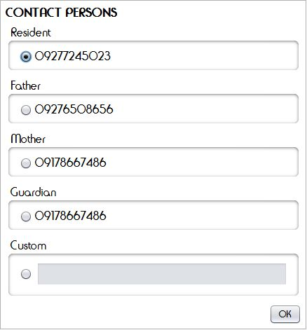

##### Figure 51: Contact Persons for text messages

The management can choose a number between the resident, resident’s parents or guardian for sending a text messages. The management can also input a contact number by clicking the “Custom” radio button if the desired recipient’s number does not exist in the contact persons.

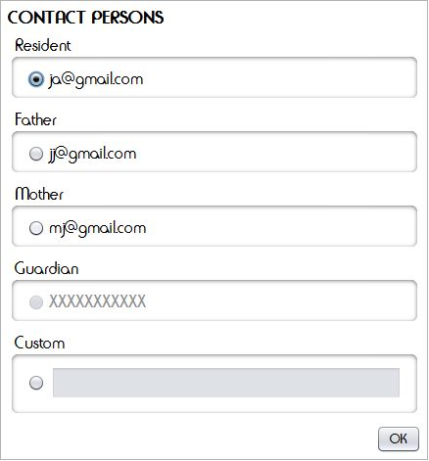

##### Figure 52: Contact Persons for sending an Email

The management can choose an email address between the resident, resident’s parents or guardian for sending an email. The management can also input an email address by clicking the “Custom” radio button if the desired recipient’s email address does not exist in the contact persons.

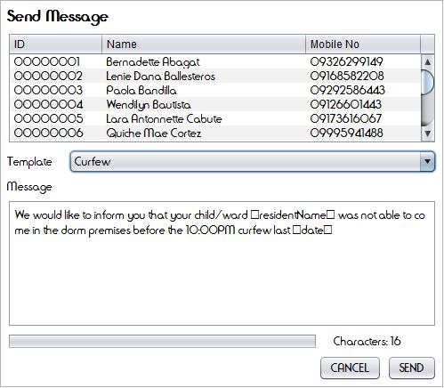 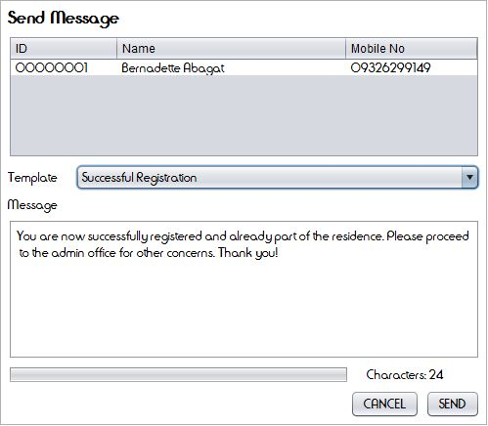

##### Figure 53: Send Text Message

The management can send a text message to a resident/s or resident’s parents or guardian for notification.

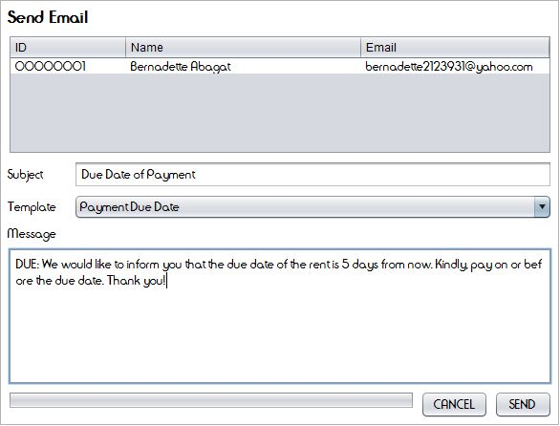 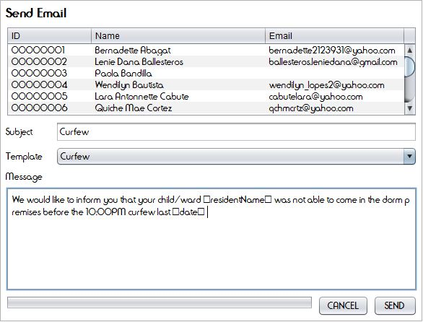

##### Figure 54: Send Email

The management can send an email to a resident/s or resident’s parents or guardian for notification.

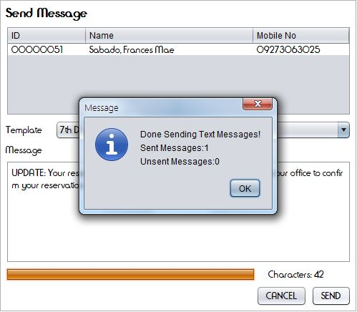 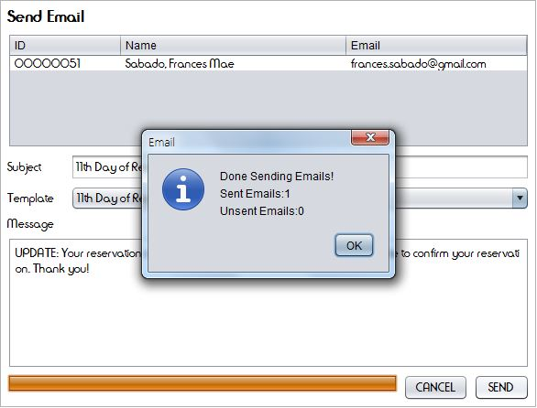

##### Figure 55: Sending Text Messages and Emails

A dialog box will promt upon sending of text messages and emails. It will indicate numbers of sent and unsent messages or emails.

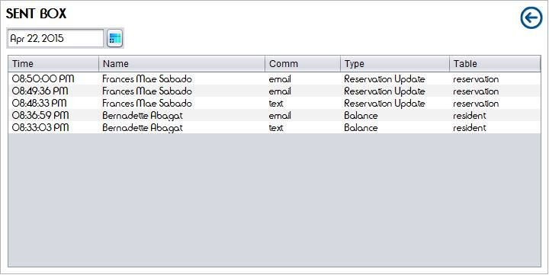

##### Figure 56: Sent box

The messages sent to the residents and resident’s parent or guardian will be saved in the Sent box.

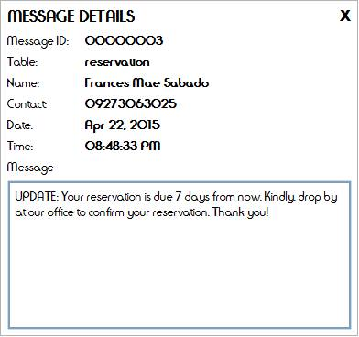

##### Figure 57: Sent Box Message Details

Specific messages in the sent box can be viewed by the management. Message ID, table, name and contact number of the recipient, date and time sent, and the sent message are shown in the message details.

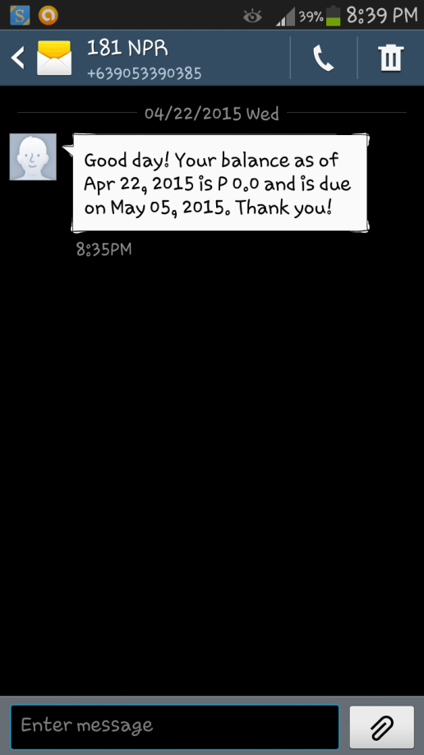 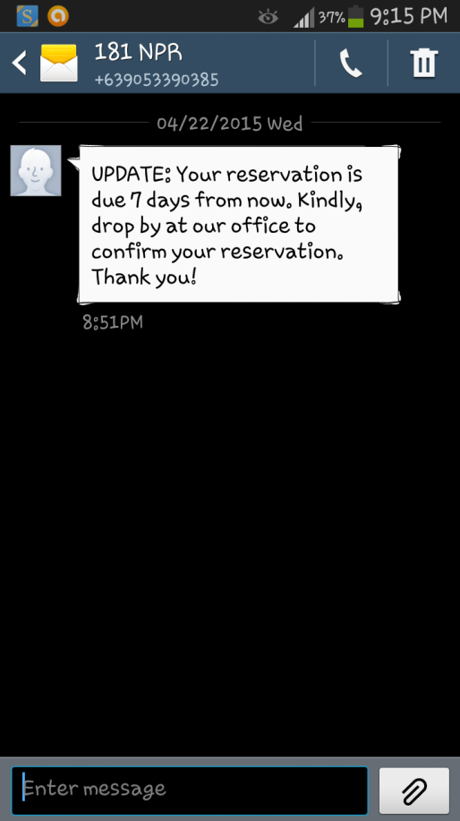

##### Figure 58: Received Messages

The recipient will receive messages for notification from 181 North Place Residence

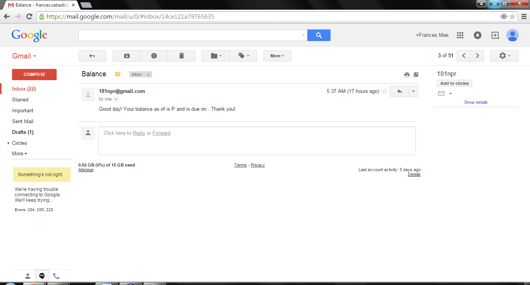

##### Figure 59: Received Email

The recipient will receive emails for notification from 181 North Place Residence

**Billing Module**

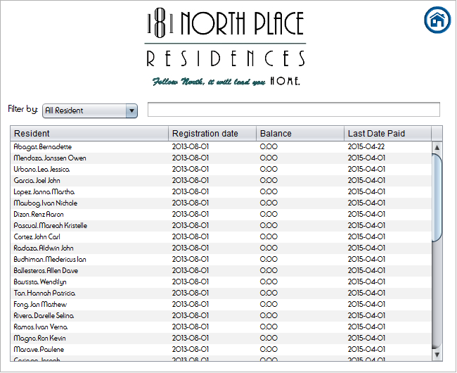 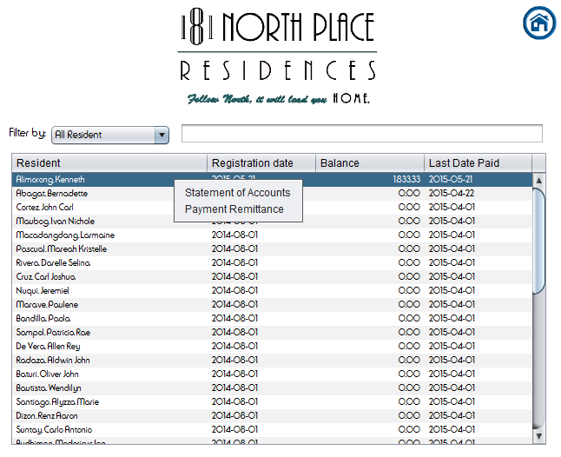

##### Figure 60: Billing of Residence

The Billing is for the computation for the payment of the residents.

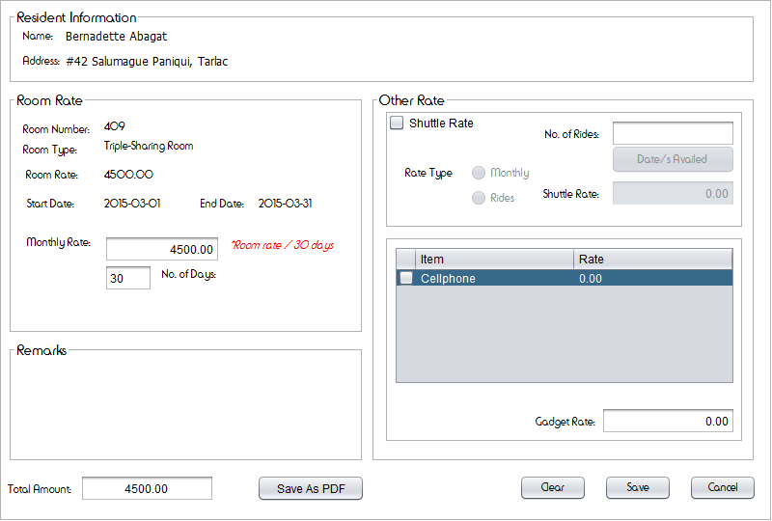

##### Figure 61: Statement of Accounts for Resident

The management will fill out necessary information about the payment of a resident for the computation and printing of Statement of Accounts to be given to the resident upon paying. It also allows the management to save the statement of accounts as PDF. The management can also type the monthly rate, Gadget rate, shuttle rate, and the total amount manually in case of error in computation of the system.

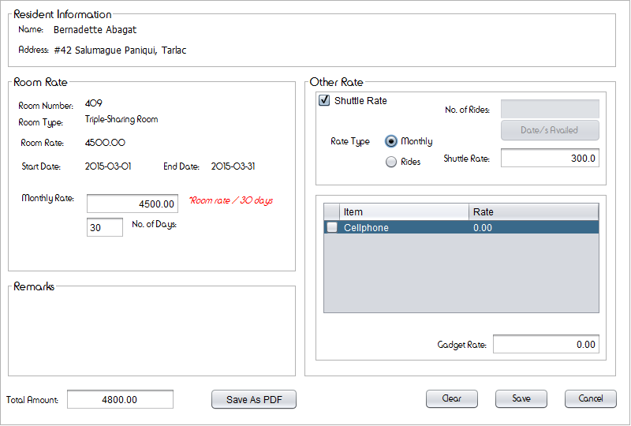 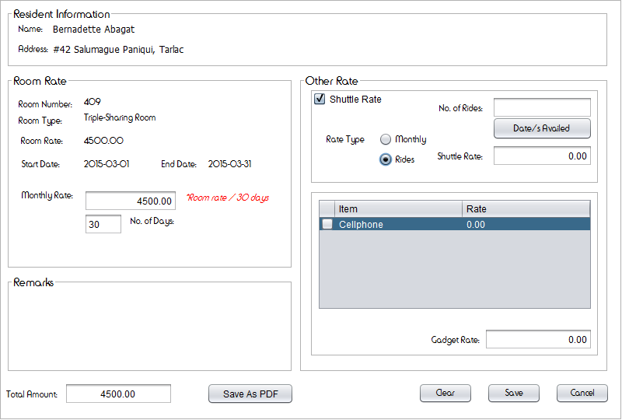

Figure 62: Shuttle Rate

The management will choose whether the resident rides shuttle monthly or occasionally for additional payment of the resident.

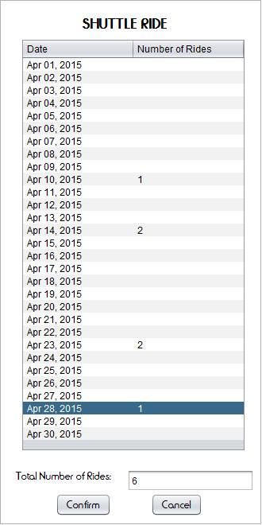

##### Figure 63: Shuttle Ride

When the “shuttle” radio button in the shuttle rate is clicked, the shuttle ride will appear which contains dates. The management can add numbers of rides by clicking the “number of ride” and this will reflect to the resident’s balance.

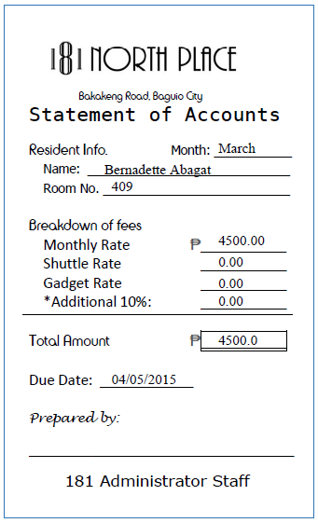

##### Figure 64: Statement of Accounts

Statement of accounts contains the breakdown of fees, total amount and due date of the payment of the resident to be given by the management.

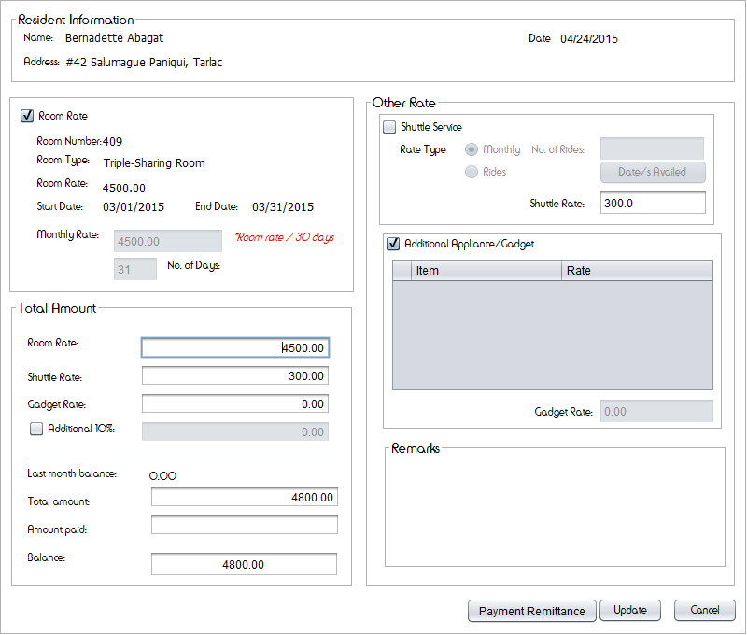

##### Figure 65: Monthly Billing

The management will fill out necessary information about the payment of a resident for the computation and printing of Payment Remittance to be given to the resident upon paying. It also allows the management to save the Payment Remittance as PDF. The management can also type in the text boxes in case of changes.

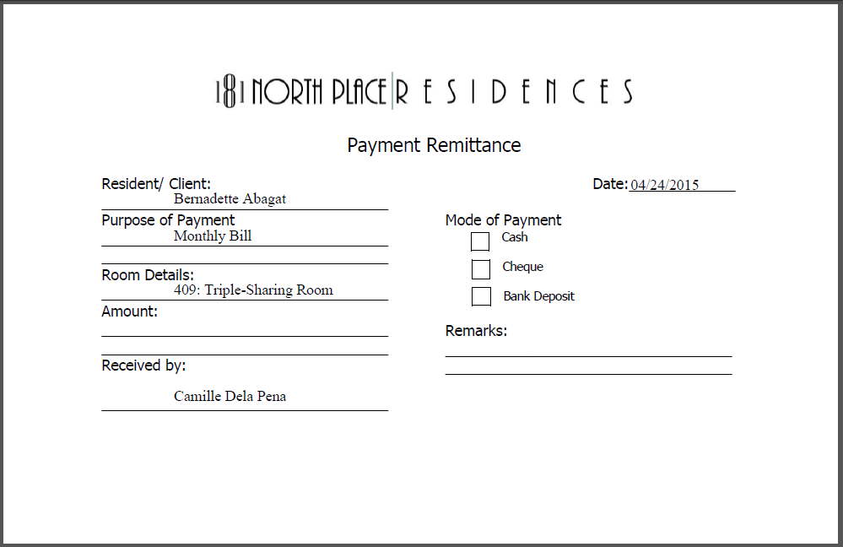

##### Figure 66: Payment remittance

Payment Remittance contains the amount, mode of Payment, and purpose of payment of the resident, to be given by the management.

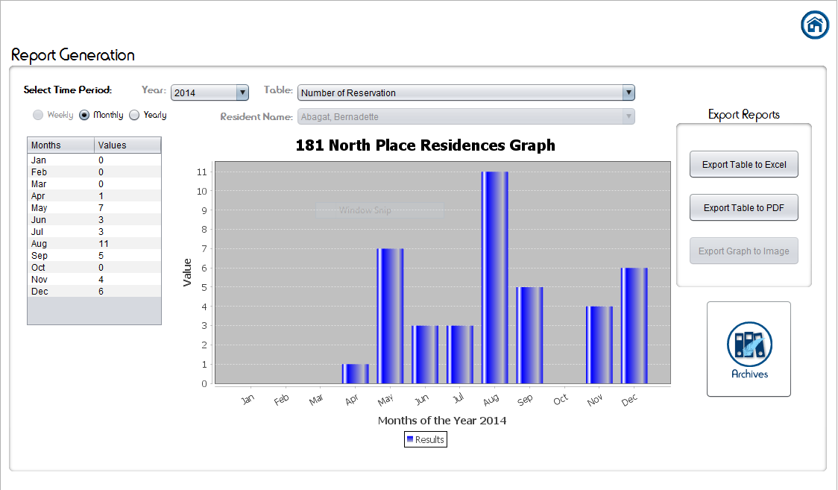

##### Figure 67: Report Generation

The Report Generation shows the summary of transaction to help the management for decision making. This contains graphs which represent the summary report for weekly, monthly and yearly number of reservation, registration, late residents, and late payers. The report generation also includes archives. The report generation can be exported as Excel, PDF, and Image.

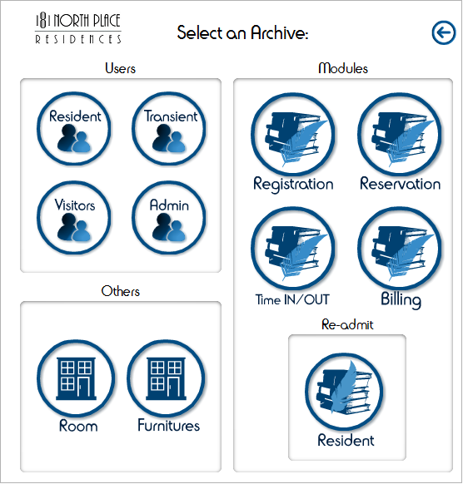

##### Figure 68: Archive

Archives included summary of information of all resident, transient, visitors, admin, registration, reservation, Time IN/OUT, billing, and resident who left the dormitory.

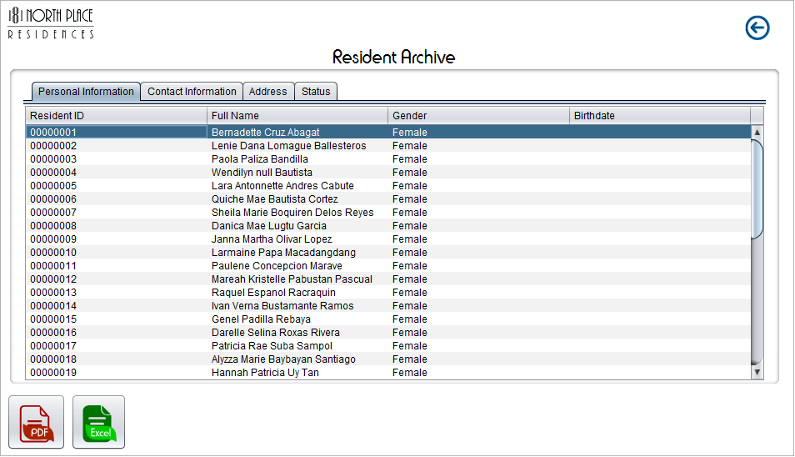

##### Figure 69: Resident Archive

Resident Archive shows the personal information, contact information, address, and status of all the residents. All the information can be saved as PDF and Excel.

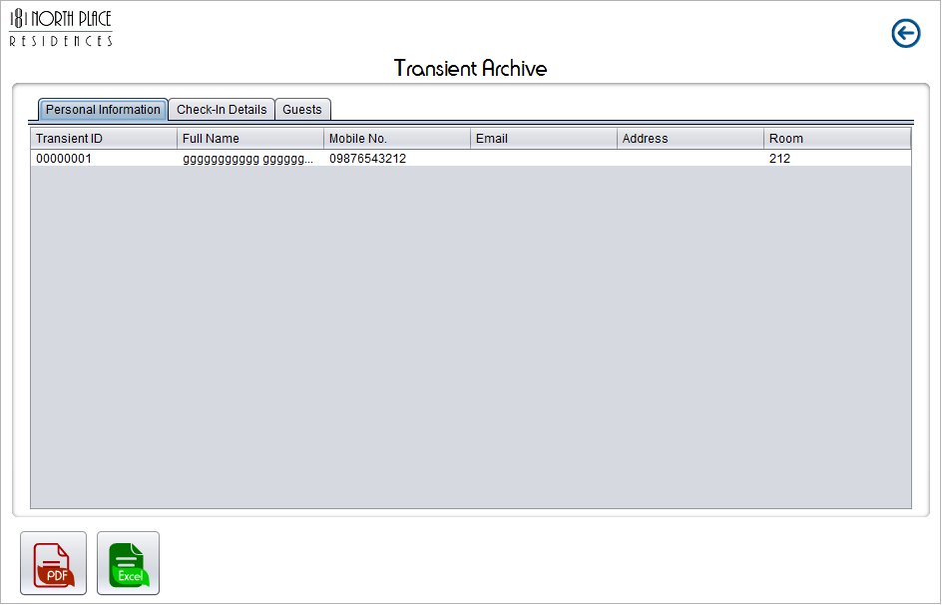

##### Figure 70: Transient Archive

Transient Archive shows all the personal information, check-in details and guests of the transient. All the information can be saved as PDF and Excel.

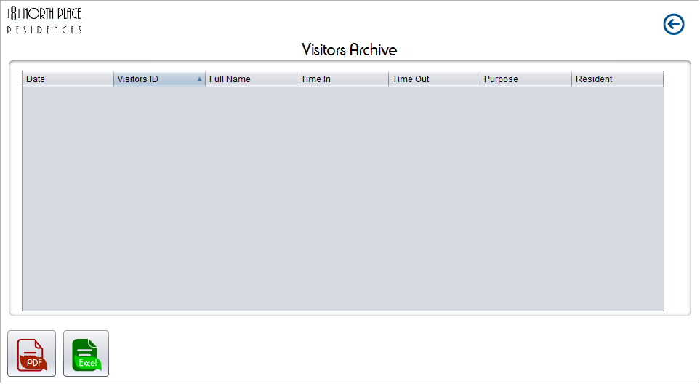

##### Figure 71: Visitors Archive

Visitors Archive shows visitors information: date visited, visitor’s ID, full name, time in, time out, purpose of visiting, and the resident whom the visitor will visit. All the information can be saved as PDF and Excel.

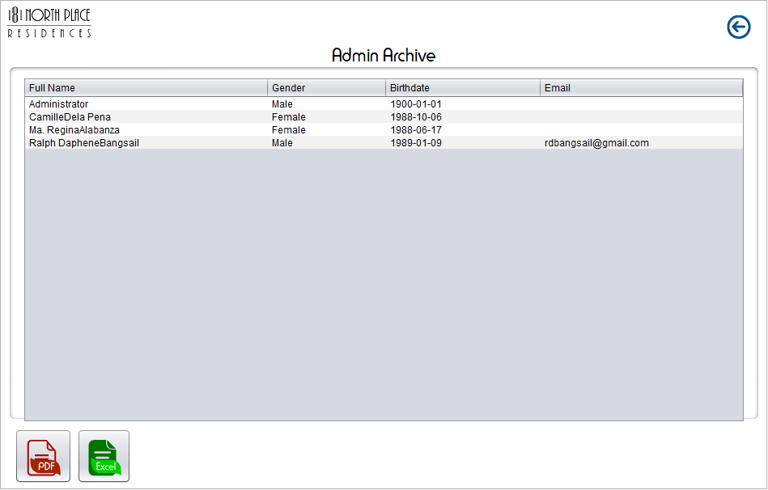

##### Figure 72: Admin Archive

Admin Archive shows information about the management or the admin’s full name, gender, birthdate and Email. All the information can be saved as PDF and Excel.

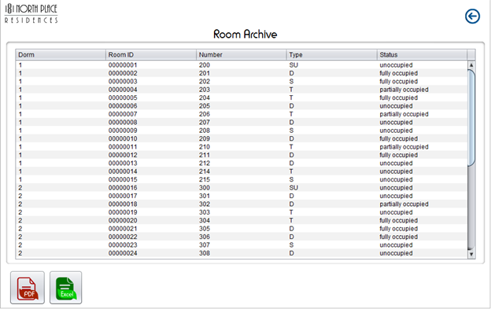

##### Figure 73: Room Archive

Room Archive shows all the information about the rooms in the dormitory: Dorm number, room ID, room number, and room type. All the information can be saved as PDF and Excel.

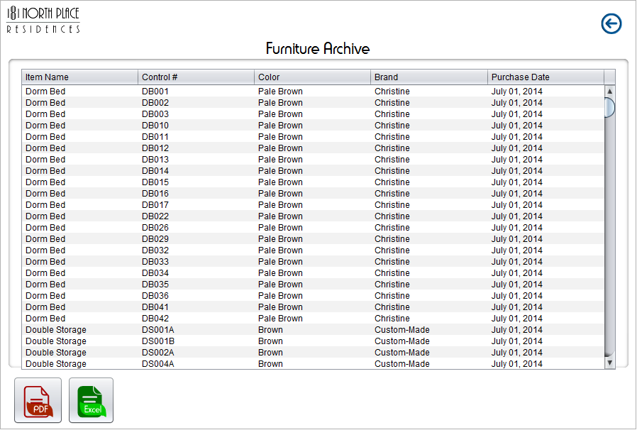

##### Figure 74: Furniture Archive

Furniture Archive shows the furniture’s item name, control number, color, brand and the date when the furniture was purchased. All the information can be saved as PDF and Excel.

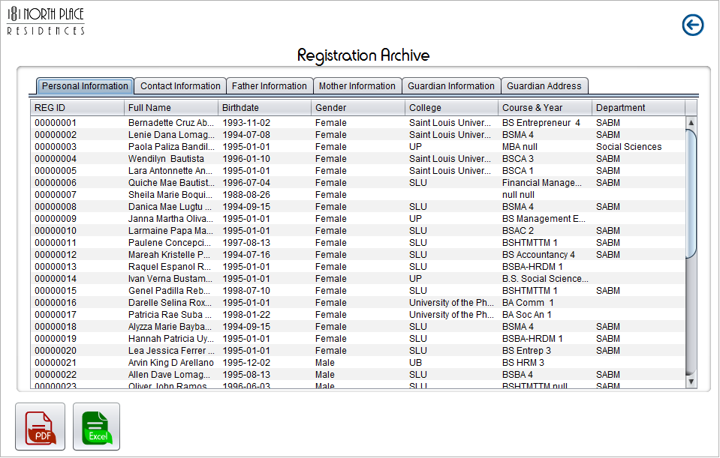

##### Figure 75: Registration Archive

Registration Archive shows the personal information, contact information, father’s information, mother’s information, guardian’s information, and guardian’s address of the registered residents. All the information can be saved as PDF and Excel.

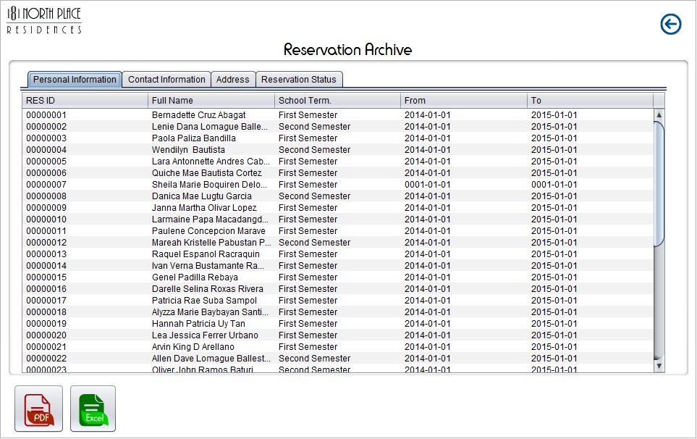

##### Figure 76: Reservation Archive

Reservation Archive shows the personal information, contact information, address, and reservation status of the reserved inquirer whether the reservations are already registered, pending or canceled. All the information can be saved as PDF and Excel.

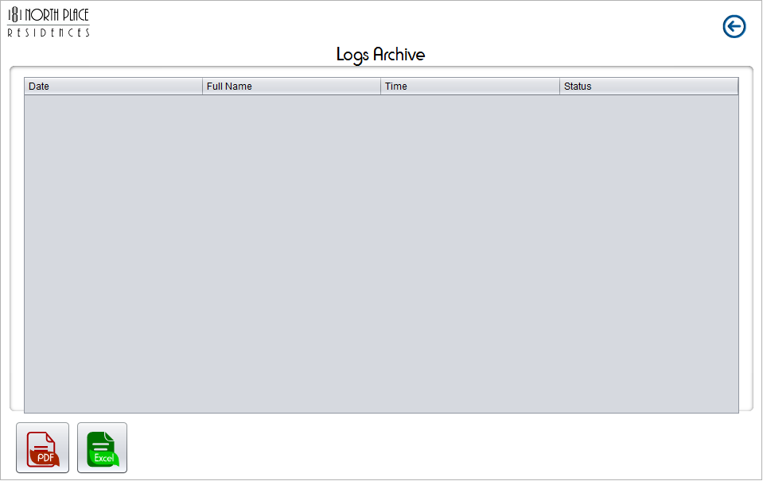

##### Figure 77: Logs Archive

Logs Archive shows the logs of the residents, the date, full name of the resident, time when they logged in or out, their status whether they are in or out of the dormitory. All the information can be saved as PDF and Excel.

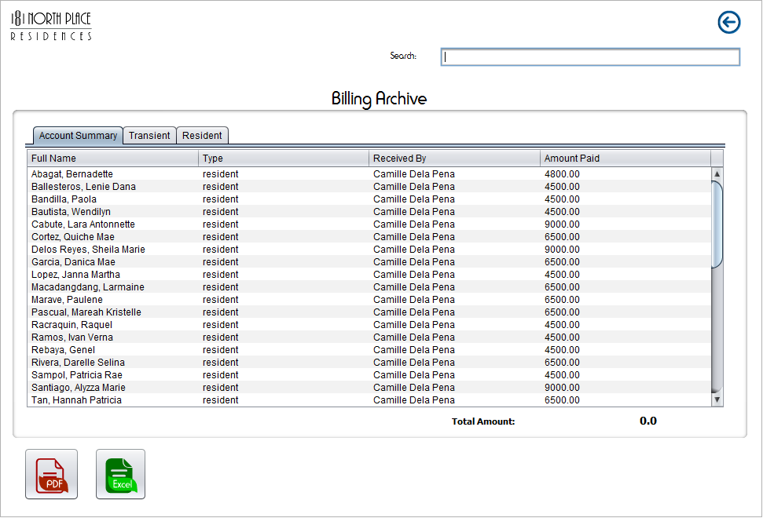

##### Figure 78: Billing Archive

Billing Archive shows the account summary of the resident and transient. It includes the date paid, transient and resident’s name and amount paid by the residents and transients.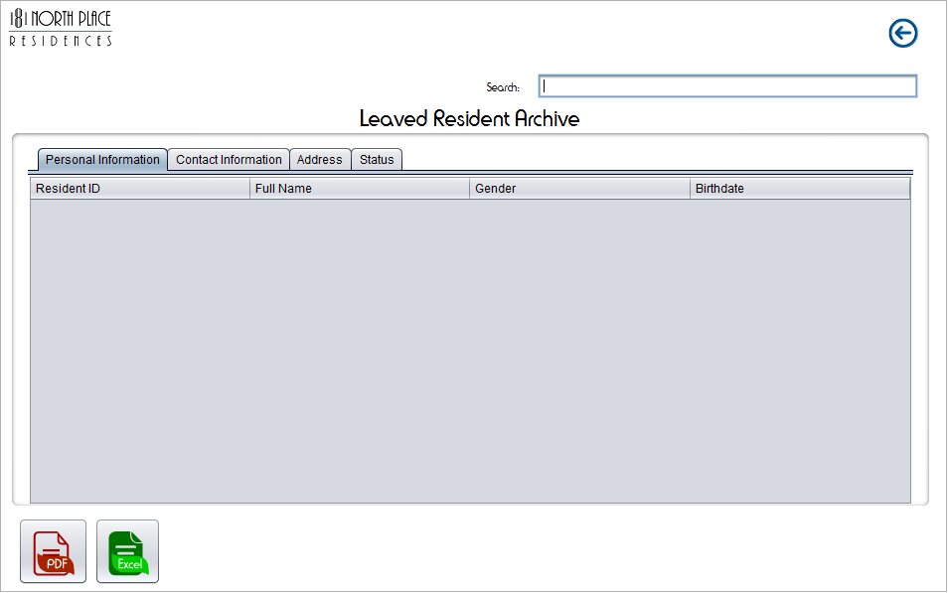

##### Figure 79: Leaved Resident Archive

Leaved Resident Archive shows the personal information, contact information address and status of the resident who already left the dormitory. All the information can be saved as PDF and Excel.

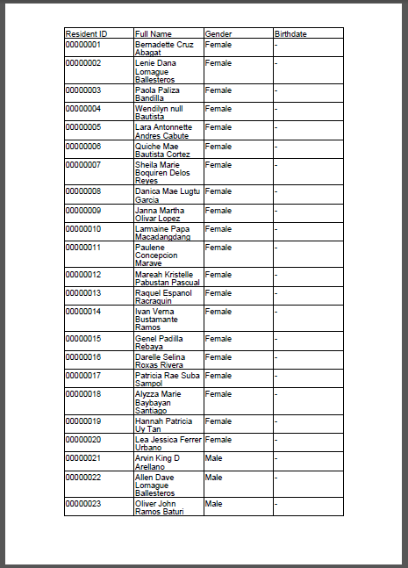

##### Figure 80: Sample PDF

All Information in the archives can be save as PDF

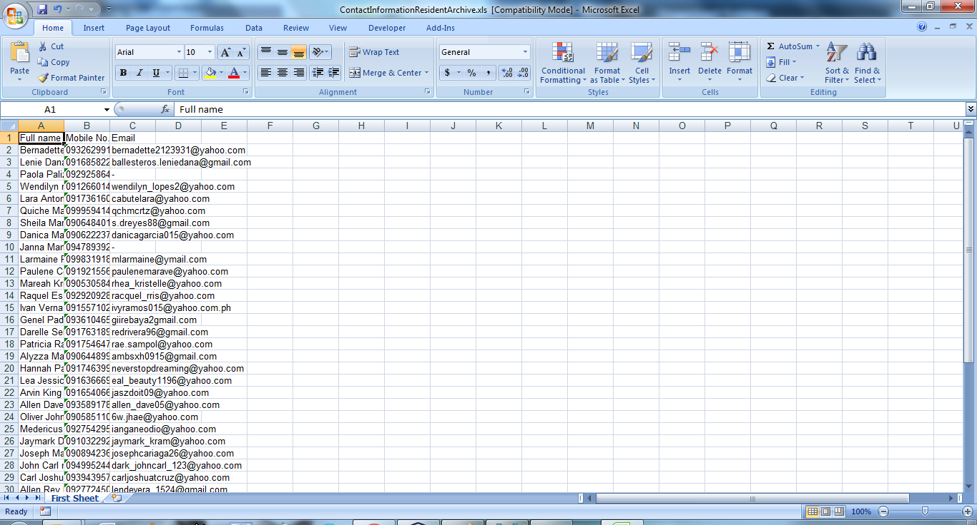

##### Figure 81: Sample Excel

All Information in the archives can be save as Excel.

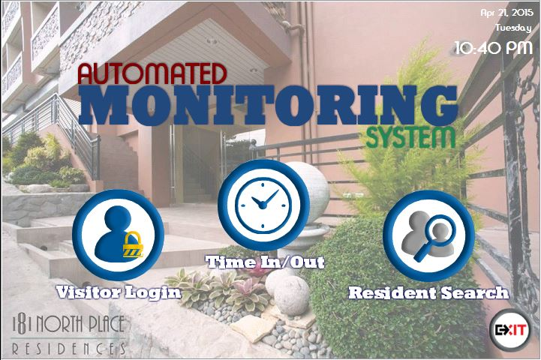

##### Figure 82: Main Menu (Lobby)

Figure 82 shows all the operations in the lobby, lets the guard select what to do. And also allows each resident to time-in or time-out.

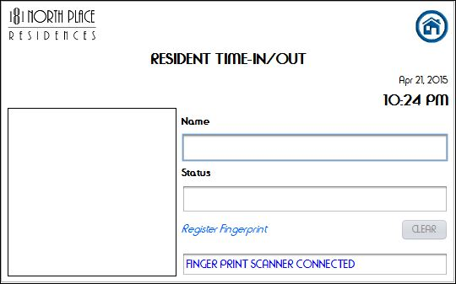

##### Figure 83: Time In/Out

Figures 83 let the residents to time-in or time-out or register the fingerprint of a resident.

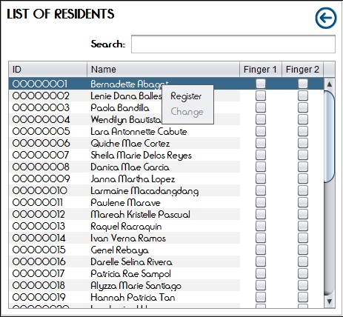

##### Figure 84: List of Residents (Register Fingerprint)

Figure 84 shows the list of residents, lets the management to register the fingerprint of a resident.

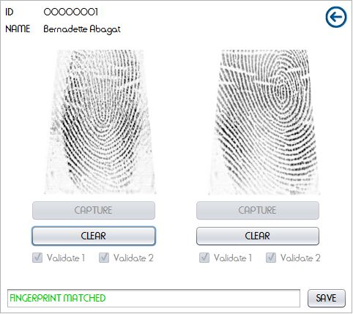

##### Figure 85: Register Fingerprint

Figure 85 lets the management to register and validate the resident’s fingerprint.

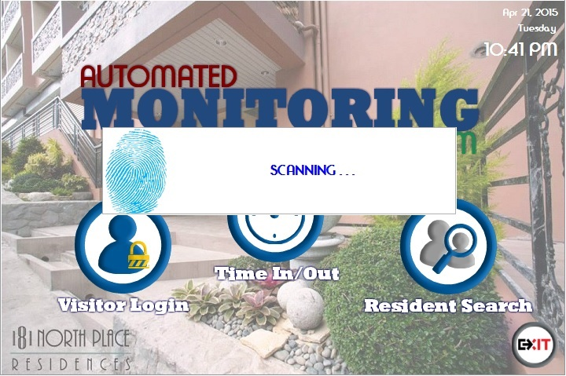

##### Figure 86: Fingerprint Scan

Figure 86 shows the prompt message “scanning” if a resident placed his/her finger on the fingerprint scanner.

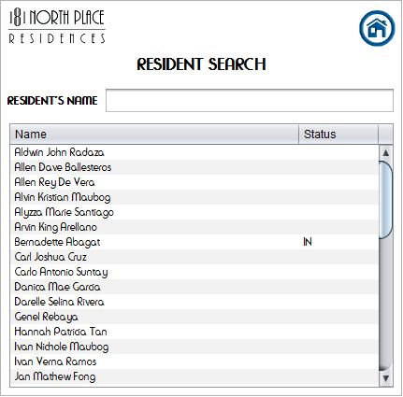

##### Figure 87: Resident Search

Figure 87 lists the resident with status whether the resident is logged in or logged out.

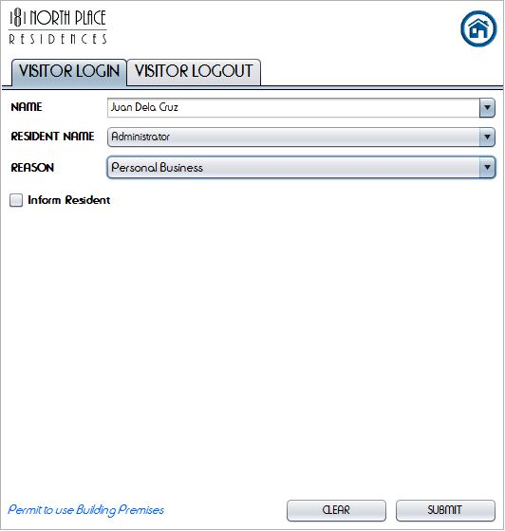

Figure 88: Visitor Login

Figure 88 lets the security personnel to enter the name of the visitor, selects the resident’s name or administrator, and the reason to visit the dormitory.

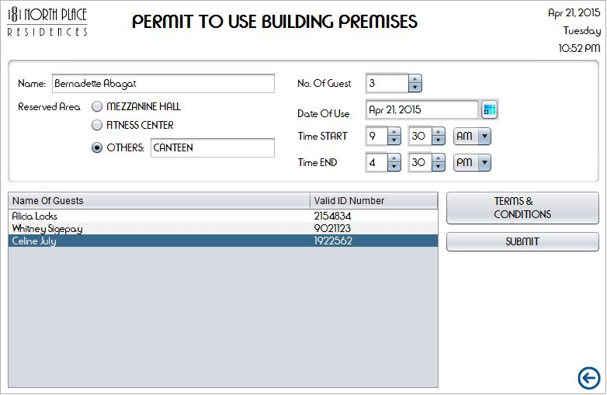

##### Figure 89: Permit to Use Building Premises

Figure 89 lets the guard enter the visitor’s name in group. To conforme, the resident must place his/her finger on the fingerprint scanner.

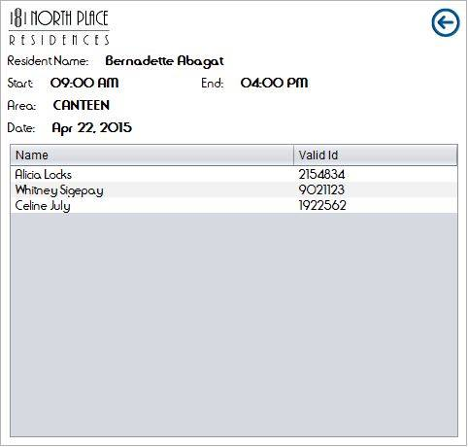

##### Figure 90: List of Visitors (Use of Building Premises)

Figure 90 lets the guard see the list of visitors who use the building premise

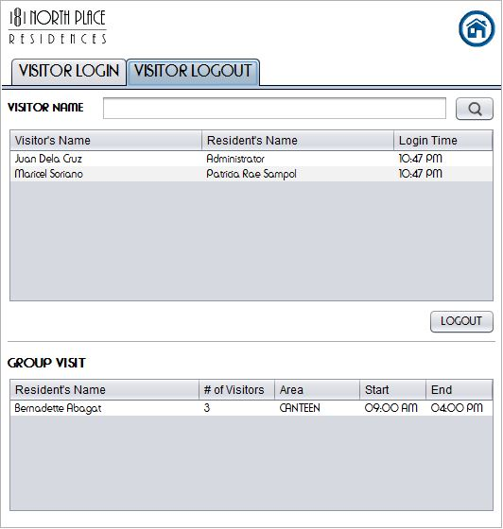

##### Figure 91: Visitor Logout

Figure 91 shows the list of the current visitor’s logged in in the dormitory. It allows the security personnel to log out a visitor.

# Chapter 4: Conclusions and Recommendations

## Conclusion

The project proponents helped the 181 North Place Residences in terms of automating the system with the following modules: Server, Reservation, Registration, Notification, Time-in and Time-out, Activation, Billing, Report Generation, Help, Back-up and Recovery, and Admin module. The system reduced the numbers of papers in the filing cabinets at the administration office, monitors real time login and logout of the resident who arrived beyond the curfew hour, notifies the parents and or guardians of the residents, easy computation of the balances of each and every resident. The work of the management becomes faster and efficient.

## Recommendation

The project proponents would recommend that 181 North Place Residences should implement the monitoring system for them to reduce the number of papers used, the time spent in organizing the files, the cost of the papers, the space where the files are stored, have an online reservation and registration for the renting of a room, a payroll system, and a monitoring system for the daily logs of the employees.

# References

1. *Adobe Acrobat - Wikipedia, the free encyclopedia*. (2015, April 24). Retrieved June 1, 2015, from http://en.wikipedia.org/wiki/Adobe_Acrobat
2. Alliance, S. (2014, November 10). Retrieved from http://irisid.com/download/news/Smart_Cards_and_Biometrics_030111.pdf
3. *An Attendance Monitoring System Using Biometrics*. (2015, January 27). Retrieved from http://www.ijarcsse.com/docs/papers/Volume_3/4_April2013/V3I4-0259.pdf
4. *Beginner's Guide to Mobile Plans - WhistleOut*. (2015, February 3). Retrieved from http://www.whistleout.com.au/MobilePhones/Guides/Beginner-Guide-to-Mobile-Plans-and-Contracts
5. Bellere, J. (2011, November 11). *Time and Attendance System by JhAdie Bellere on Prezi*. Retrieved from https://prezi.com/uh57ghko9ioy/time-and-attendance-system/
6. Cailleux, L., Bouabdallah, A., &Bonnin, J. (2014, November 10). *Human Trust | CPS-VO*. Retrieved from http://cps-vo.org/node/17801
7. *FOWiz - Free Missed Call Setup, SMS Integration, Desktop SMS, Voting, Poll, Click-to-Call, Call Tracking, Mobile Number Verification and more - FOWiz*. (2015, April). Retrieved from http://www.fowiz.com/
8. *FOWiz SMS Integration API | ProgrammableWeb*. (2015, February 3). Retrieved from http://www.programmableweb.com/api/fowiz-sms-integration
9. *HTML & CSS - W3C*. (2015, April 24). Retrieved from http://www.w3.org/standards/webdesign/htmlcss
10. *Incremental Development | QMetry*. (2014, November 11). Retrieved from http://www.qmetry.com/incremental.html
11. *Microsoft Excel - Wikipedia, the free encyclopedia*. (2015, April 24). Retrieved June 1, 2015, from http://en.wikipedia.org/wiki/Microsoft_Excel
12. *notification definition and synonyms | Macmillan Dictionary*. (2015, January 6). Retrieved from http://www.macmillandictionary.com/dictionary/british/notification
13. *Page not found – Intercorp Solutions*. (2014, November 10). Retrieved from http://intercorpsolutions.com/?software_products=dormitorymanagement-system
14. Shoewu, O. ,Makanjuola, N. , &Olatinwo, S. (2014, November 11). *Biometric-based Attendance System: LASU Epe Campus as Case Study*. Retrieved from http://pubs.sciepub.com/ajcrr/2/1/2/
15. *UN-Habitat iN PartNersHiP witH asia aNd tHe Pacific UN*. (n.d.). Retrieved from mirror.unhabitat.org/pmss/getElectronicVersion.aspx?nr=3391&alt=1
16. *USB Fingerprint Reader - U.are.U 4500 Reader*. (2015, April 22). Retrieved from http://www.crossmatch.com/UareU4500Reader/

# Appendix A

Text Message Template

**UPDATE: Your reservation is due 7 days from now. Kindly, drop by at our office to confirm your reservation. Thank you!**

Characters: 120

**UPDATE: Your reservation is due 3 days from now. Kindly, drop by at our office to confirm your reservation. Thank you!**

Characters: 120

**You are now successfully registered and already part of the residence. Please proceed to the admin office for other concerns. Thank you!**

Characters: 136

**We would like to inform you that you have a visitor whose name is** *<insertnamehere>.*

Characters: 71

**DUE: We would like to inform you that the due date of the rent is 5 days from now. Kindly, pay on or before the due date. Thank you!**

Characters: 137

**Good day! Your balance as of <datetoday> is P <balance> and is due on <duedate>. Thank you!**

Characters: 96

**Good day! We would like to inform you that your new roommate will be moving in not later than <date>.**

Characters: 73

**We would like to inform you that your child/ward <residentName> was not able to come in the dorm premises before the 10:00PM curfew last <date>**

Characters: 109

# Appendix B

## Interview 1

An interview was conducted by the fourth year IT students of Saint Louis University for their IT project, at 181 North Place Residences, 69 Bakakeng Road, Baguio City, on August 29, 2014 at around 10:38 am, with the following as interviewer:

Project Manager: Ralph Daphene B. Bangsail

Assistant Project Manager: Kathreen Ann G. Silen

Group Members:

Jefren R. Aguilar

Kenneth Van L. Alimorong,

Mark Herbert D. Cabuang

Helga Denise B. Galo

Frances Mae N. Sabado

Jaqueline L. Torres

and Ms. Regina P. Alabanza the administrative staff as the interviewee. The following questions were asked to the interviewee.

1. Where did the name of “181 North Place Residences” came from?

**Ans.** The number in the company name came from: The number 8 representing the number of grandchildren in the family and 11 which represents the number of siblings including their spouses. 8 being in the middle of 11 is symbolic of how the immediate family holds the bond together.

1. Is the dormitory exclusive for the students only?

**Ans.** Since 181 North Place Residences is not yet well known, we also accept working professionals who are willing to comply in the rules and regulations, aside from taking students as regular residents.

1. As a student, if I avail one of the rooms in the dormitory what are the things provided, and charges to be paid?

**Ans.** 181 North Place Residences, is a fully-fitted dormitory, every resident gets to have their own bed with mattresses, study desk, study chair are also provided, cabinets, window and shower curtains, a mirror and drying racks in the room, etc. The resident also gets to enjoy their own toilet and bath, making them feel as if they are living in their bedroom inside their homes.

1. Are the rooms connected to the Internet?

**Ans.** Each room has its own router which uses fiber optics in the network, the speed of 25 MBPS. Especially caters to the needs of the student for their school works.

1. How do the tenants reserve a room and pay the bills?

**Ans.** We are flexible in terms of payments. First if a tenant inquires and expresses intention to reserve a room he/she will choose a room and pay the reservation fee which is 2,000 pesos but not refundable, upon confirmation of his/her reservation after two weeks, the paid reservation fee will be deducted to the bill of the tenant. The tenant will then have to make a 1 month advance payment. When the tenant moves in to the dormitory he/she is required to pay a 2 months security deposit, which will be returned to them provided that there are no damages in the room and payment is paid on a timely basis.

1. What is the mode of payment?

**Ans.** Mode of payments can be thru bank, cash or check. But in the future, we would like to make online payment possible.

1. What are the technological facilities you use?

**Ans**. We use laptops in the office, and an ID printer. There are glass enclosures in the main entrances in each dorm floors and elevator ports which are properly secured with biometric scanner for access. Surveillance cameras, smoke detectors and sprinkler systems are installed all throughout the building for added security.

1. What is the most need for creating a system?

**Ans.** They want a system that can be used in implementing the curfew better; the system would send an e-mail/sms to the parent/ guardian of the tenant who failed to enter the building premises before 10:00 PM.

1. Are there other branches of 181 North Place Residence?

**Ans**. There are no other branches of 181 North Place Residence. The building in all transactions and processes are done in the building here in Bakakeng.

1. Do you want to track the history of the confirmation message?

**Ans.** At some point we would like to track the history of the confirmation message so that during a worst case scenario, we have backups or hard evidence to prove that we have sent a notification to the parent/guardian.

1. Who are the possible end users of the system?

**Ans.** Possible end users are the administrative staff and building administrator.

1. Is there a consequence if the student did not comply with the rules and regulation of the dormitory?

**Ans.** Since 181 North Place Residence is a commercial dormitory, we do not apply any sanction as regards arriving beyond the curfew, disciplinary action come from the parent/guardian if need be.

1. How many employees are there in the dormitory?

**Ans.** 181 North Place Residences has a building manager, building administrator, administrative staff, 2 housekeeping, 1 in personnel, maintenance staff, 2 security guards.

1. Is the biometrics only for login and logout purposes?

**Ans.** The biometrics is only intended for login and logout. The biometric machine at the lobby is intended for the login and log out of both the residents and personnel other biometrics installed in the elevators and dorm entrances are used for exclusive access.

1. Do you already have a database?

**Ans.** We have no significant database at the moment.

Some topics discussed during the interview:

Online Inquiry:

Since 181 North Place Residence does not have a website they use Facebook as their online inquiry, it is where a tenant can inquire about the dormitory and make transaction. The payment is made through bank.

*All transactions are manually made.

*the salary depends on the position of the employee

Approved by:

__________________________

Ms. Regina P. Alabanza

Administrative Staff

## Interview 2

An interview was conducted by the fourth year IT students of Saint Louis University for their IT project, at 181 North Place Residences, 69 Bakakeng Road, Baguio City, on September 5, 2014 at around 8:00 am, with the following interviewers:

Project Manager: Ralph Daphene B. Bangsail

Assistant Project Manager: Kathreen Ann G. Silen

Group Members:

Jefren R. Aguilar

Kenneth Van L. Alimorong,

Mark Herbert D. Cabuang

Helga Denise B. Galo

Frances Mae N. Sabado

Jaqueline L. Torres

and Ms. Camille G. Dela Pena the Building administrator as the interviewee. The following questions were asked during the interview.

1. How do you compute for the salary of an employee?

**Ans.** There are about 60 people currently employed by the 181 North Place Residences. As of the moment, we are using Excel to compute for the salary of the personnel based on weekly, bi-monthly and end of the month computations.

1. Do you employ both contractual and regular employees?

**Ans.** Since building has just begun its operation, the housekeeping personnel are on probationary status. Only the administrative staff are hired as regular employees. During the hiring process, the payroll has already been classified as weekly, bi-monthly or end-of-month compensation. We do not hire contractual employees as of the moment.

1. Do you have any payroll forms?

**Ans.** Each employee is hand out a payslip every pay day which reflects the days and hours of work, deductions if any, net income and other pertinent details.

1. How do employees receive their salary? Is it through cash, bank transaction or given as check?

**Ans.** The payroll is released thru cash basis attached with the payslip to see the breakdown of the computations.

1. How about the deductions?

**Ans.** The deductions are included in the computation however we deduct on the 30th of the month including the cash advances, government contribution, tax, etc.

1. Who computes and releases the payslip?

**Ans.** The building administrator has the sole right to administer this process. During her absence, the building manager takes charge of the task.

1. How will the tenants know when to pay the bill?

**Ans.** Payments are always due from the 1st through 5th day of the month. They are given a notification via text message at least 1 week before the collection of dues.

1. What are the billing needs of the dorm?

**Ans.** What we need for billing system is a statement of account reflecting the charges due for the current month. For transparency purposes, the statement must contain the amount for the monthly rent and other additional charges like electrical consumption and other services that the tenants did not pre-avail at the beginning of the previous month. This is applicable for our Shuttle Service where the residents have the option to avail of the service when necessary at a rate of Php 20.00 per ride.

1. How will you monitor if the residents who avail of the Shuttle Service?

**Ans.** We have a log sheet under the care of the driver where they register their names to avail of the service. Instead of paying Php 20.00 per use, they will be charged with the total number of rides at the beginning of the succeeding month. This is applicable for residents who did not avail of the special monthly rate of the Shuttle Service use.

1. How much will the monthly registration cost to avail for the Shuttle Service?

**Ans.** When a tenant avails the Shuttle Service, the monthly rate is much cheaper at Php 300.00 or roughly 10 Pesos per da, already good for a multiple number of trips, as compared to a walk-in basis at the rate of Php 20.00 a ride.

1. How can they pay for their monthly dues and charges?

**Ans.** The residents can pay thru cash basis, cheque or via bank transaction.

1. What are the consequences if they did not pay on time?

**Ans.** Once the deadline of payment lapses, there is an additional 10% surcharge to be collected on top of the total amount due. For example, if the monthly rent amounts to Php 5,000.00, they have to pay an additional of Php 500.00 as 10% penalty for late payment.

1. Who collects the payments?

**Ans.** All the fees are paid in the Administrative Office. Other personnel are not allowed to collect any fees. When availing for the Laundry and/or the Catering Service however, the resident is responsible to make the necessary transaction to the service provider concerned.

1. Do you give receipts within the payment?

**Ans.** Yes, but as of the moment we issue Memorandum Receipt for each transaction as official receipts are still under process with the BIR. Once the Official Receipt has been releases, all Memorandum Receipts will be replaced for transparency purposes.

1. Where do store the data for payroll?

**Ans.** For the housekeeping personnel who are compensated weekly, they are given a Daily Time Record (DTR) where they log down their tasks per day. The DTR which is submitted weekly also reflects the time-in and time-out of the personnel. The Administrative Staff will compute via Microsoft Excel the total compensation for the week where the minimum requirement for work is 8 hours per day and hours exceeding which is considered and duly compensated as Over Time Work.

1. Who installed the biometrics per floor?

**Ans.** The Resident Electrician is responsible for the installation of the stand-alone biometric units and upkeep and maintenance is supervised by the Administrative Staff.

1. Where will the biometrics be placed to monitor if residents adhere to the curfew?

**Ans.** It will be placed solely at the lobby entrance for proper monitoring since the biometric units installed per floor are only used to access inside the dormitory area.

1. What if they log-in in the main entrance at the lobby but left the building using another exit point?

**Ans.** We have our security personnel to facilitate the coming in and out of all guests and residents in the building. Beginning 7:30 pm daily, the only access in and out the building is via the main entrance at the lobby. As far as management is concerned, we have provided all the necessary measures to ensure the accord to our safety measures and their non-compliance to this particular protocol of logging out in the biometric unit is no longer our responsibility.

1. What if the other exit doors like in the elevator and basement were open?

**Ans.** Once basement access is already open, residents are still mandated to pass through the lobby since it is the building policy. However, since we are a commercial dorm and not a school dorm, their non-compliance to this policy have no sanctions.

1. Are there forms that the residents need to fill-up?

**Ans.** First, the client needs to fill-out a reservation form. This form is for the purpose of reserving the room or their choice for a period of 2 weeks in case they have not made a final decision in moving-in the building. Once they have arrived at a decision of transferring their things or what we call Confirmation of the room, they need to fill-out a number of other forms. One of which is the Contract of Lease where the first type is for the minor clients and the second type is for legal-age clients. Another form is the have Resident Information Sheet, where we get the basic personal information of the resident like their name, contact number, guardian’s details and parent’s information and checklist of all the pre-required forms. We also have them sign the House Rules and Regulations for their agreement, both resident and legal guardian is required to sign this document. The resident is also given a Key Release Form, indicating their responsibility in the proper use and safe-keep thereof. We also have them fill-out the Room Inventory Form, which enlists the building property endorsed to their care like the bed, trash can, cabinet, mattress, mirrors and the like. The Appliance and Gadgets Inventory Form, is accomplished to monitor the number of items which consume energy that are in their possession. Each resident is allowed up to three (3) electronic items which they may use without charge. If they exceed this allowed number of items, they will have to pay an additional charge in accordance to the wattage and voltage of the extra gadget on a monthly basis. Other forms include the Transient Reservation Form for guests and/or immediate family of the resident for filing.

1. How do you do the Room Reservations?

**Ans.** We accept Reservations made online. When this happens we just get the pertinent information and fill-out the Forms ourselves. After which, the client is required to make a bank deposit corresponding to the total amount due. We confirm the transaction by having the client send us an image of the deposit slip or call the bank where they made the payment.

1. Are the Resident allowed to bring in visitors?

**Ans.** Yes, outsiders are welcome in the common areas such as the Lobby, Gym and Mezzanine Hall. However, they are not allowed access inside the Dormitory floors for security purposes.

1. How will the guard identify if the person is a Resident or a Visitor?

**Ans.** We issue all residents their own IDs once they move in. This has its own control number and must be shown to the Security Personnel whenever necessary.

1. Do visitors have curfews?

**Ans.** Outsiders are only allowed inside the building premises up to 9:00 pm.

1. Are the residents allowed to keep their IDs?

**Ans.** Yes, but all fingerprint data and access inside the building will be deleted from the biometrics when the Contract of Lease has expired.

1. When will they register their finger on the biometrics?

**Ans.** Once they have fully-paid 1 month Advance Payment and required Security Deposit, we immediately enroll them in the system.

1. When I leave the dorm, will my data be retained?

**Ans.** The retention of Resident Records and other pertinent documents is good for a period of 5 years. But once the Contract of Lease has ended all data with the biometric scanners will be deleted.

1. How many rooms are there per dorm?

**Ans.** We have 14 dormitory rooms or regular rooms, and 1 private suite per floor which makes 15 rooms in total.

1. How many single, double and triple rooms?

**Ans.** In the current set-up of both Dorm 1 and Dorm 2, there are 5 Single rooms, 12 Double- Sharing Rooms and all the rest are Triple-Sharing Rooms. In the Dorm 3, there are 2 single rooms and the rest are set up as Triple-Sharing Rooms.

1. How do you monitor if a Room is occupied?

**Ans.** We keep a list of all rooms which are occupied both in soft copy and hard copy. And we also have a floor plan of the entire Dorm where we indicate occupied rooms, reserved rooms and vacant rooms.

1. Do you have an Inventory of the building properties?

**Ans.** Yes, keep a record of all building equipment by assigning control numbers to the items.

1. Do the Commercial Spaces also follow the building Curfew?

**Ans.** Not necessarily. The Commercial Space Tenants have the freedom to open and close shop at their perusal since the electricity consumption and the like are charged to their account. The business hours of the Cafeteria begin at 6:30am and end at 7:30 pm. And the Convenience Stores is open up until 10:00 pm. We do not hold the Tenants responsible for the hours that they conduct business.

1. Do they also have a Contract of Lease?

**Ans.** Yes, our Commercial Tenants have a Term or Lease for a period of 2 years.

1. How do you often check the Resident Log Book?

**Ans.** The Security Personnel monitor the the ingress and egress of residents daily and they make the necessary reports for residents who did not comply with the curfew on a daily basis.

1. Who are the personnel allowed to have access the Biometric Scanners?

**Ans.** Only the Administrative Staff are allowed access to the units.

1. What time is your Office open?

**Ans.** Our business hours are from 8:00 am up to 7:00 pm

1. How will you notify the parents or guardian of the Resident if they arrive after the curfew?

**Ans.** We send a notification via text message or e-mail if the parent or guardian is out of the country.

1. Are you willing to pay for the telecommunication to finance this process?

**Ans.** Yes. We allot a certain amount per month to accomplish this process.

1. What time is the curfew set at?

**Ans.** We set the curfew at 10:00 pm. When the resident comes in after that period, that is the time we send out the notification

1. Will the there be a difference in fees charged if the Resident leaves the Dorm for a vacation?

**Ans.** No, they still have to pay the total monthly due indicated in the contract as long as their personal belongings are inside the Rooms or building premises.

Approved by:

__________________________

Ms. Camille G. Dela Pena

Building Administrator

## Interview 3

An interview was conducted by the fourth year IT students of Saint Louis University for their IT project, at 181 North Place Residences, 69 Bakakeng Road, Baguio City, on September 9, 2014 at around 1:30 pm, with the following as interviewers:

Project Manager: Ralph Daphene B. Bangsail

Assistant Project Manager: Kathreen Ann G. Silen

Group Members:

Jefren R. Aguilar

Kenneth Van L. Alimorong,

Mark Herbert D. Cabuang

Helga Denise B. Galo

Frances Mae N. Sabado

Jaqueline L. Torres

and Ms. Camille G. Dela Pena the Building Administrator as the interviewee. The following questions were asked to the interviewee:

Notification via sms or e-mail

What are the instances that would require sending a notification to the resident?

* The successful registration as New Resident.
* Reminders for completion of requirements such as 2 pcs. ID photo, copy of their current class schedule, payment details etc prior to moving-in.
* Visiting guests in the building and/or advice regarding having a new roommate.
* Total amount due for rent and additional charges at the end of the month.
* Violations and/or incident report.

Activation and deactivation of account

What will happen to the Resident’s data once their Contract of Lease expires?

* As long as there is a file to pull out (report generation), there is no problem in deleting files. The data will have a maximum of five (5) year-retention period beginning after the expiration of the contract.

“Would you be able to indicate how many terms the resident rendered?”

* The records are with us but it is currently stored and archived*.*

Log Details

Why is it needed to capture or monitor the log details of the resident?

* It is to keep the parent or guardian informed of the correct time of entry of their child and/or departure from the building premises. This is also an accurate tool to identify whether an untoward incident happened to the resident within or outside the building premises.

Report Generation

* The report will be generated daily, weekly, monthly and yearly.
* For the residents, the generated report will reflect their log details, violations committed, visiting guests, observance of the curfew, payments due and outstanding balances.

Questions:

1. If for any reason the system implementation might affect the current operations, will the Administration be willing to make changes with the building policy?

* If it will help improve our business operations, we welcome the necessary changes if need be.

1. Who will maintain the system?

* An IT Technician duly authorized by the Administration shall man the process.

1. Is it okay to use at least two biometric scanners?

* It will prove costly to use two biometric scanners. But if needed, one unit will be used for to monitor time-in and another unit will be for the monitoring of time-out.”

The following inclusions were specially requested by Management:

* Notice for violations incurred as a Warning or subject for filing a Memo for any succeeding offense thereafter.
* Alert residents to visit the administration office via note in interface
* General Reminders, birthday greetings, and special announcements concerning the residents.
* Inform the resident for delayed payments, penalties and surcharges accordingly.
* Reminder to the Administration prior to the expiration of the 2-week Reservation made by the probable resident.
* Notification informing the probable resident 1 week prior to the expiration of the 2-week Reservation window.

Approved by:

__________________________

Ms. Camille G. Dela Pena

Building Administrator

## Interview 4

An interview was conducted by the fourth year IT students of Saint Louis University for their IT project, at 181 North Place Residences, 69 Bakakeng Road, Baguio City, on January 22, 2015 at around 2:15 pm, with the following as interviewer:

Project Manager: Ralph Daphene B. Bangsail

Assistant Project Manager: Kathreen Ann G. Silen

Group Members:

Jefren R. Aguilar

Kenneth Van L. Alimorong,

Mark Herbert D. Cabuang

Helga Denise B. Galo

Frances Mae N. Sabado

Jaqueline L. Torres

and Ms. Camille G. Dela Pena the Building Administrator as the interviewee. The following questions were asked to the interviewee.

1. Are you willing to show the breakdown of monthly fees of residents?

**Ans.** The 181 North Place Residences data that are the confidential can be shared to the group but with proper handling of the documents inputed.

1. Is it important to show the breakdown of monthly fees?

**Ans.** The Administration can avail in the breakdown of monthly fee depends on the item to be showed.

1. Do transients have to pay the down payment?

**Ans.** The company is requiring paying in full payment from the transients.

1. Do transients have to reserve a room?

**Ans.** The Administration allows the transient to reserve a room but they should pay the full payment.

1. Even the resident have a contract, can they still change rooms?

**Ans.** The resident cannot change room until the said contract, however the resident can change rooms in special case like the loss of money in their respective rooms and it has to be discussed. The resident can upgrade the room but cannot downgrade during the term, if there are events of changing rooms and switching of rooms it will be reflected in the amendment of contract.

1. What if the resident wants to leave the dormitory but the resident has a contract, will the resident still pay the full 5 months or the availed months only?

**Ans.** The resident can leave if they want but the security deposit will not be given back and like in the abnormal termination of contract.

1. How is your billing for your bringing in gadgets, you said that three (3) gadgets are only allowed to bring in the dormitory, do the residents have the right to pick what gadgets will they pay if they exceeded the three (3) gadgets in terms of wattage and voltage?

**Ans.** The registered three (3) gadgets are the only allowed free for the resident as appliance in the room. There will be extra charges of any gadgets added aside from the three (3) gadgets.

1. If the security fee in the reservation will be deducted in your first month or is the security fee an another fee and you still pay for your full monthly fee? How is the security fee deducted to the due balance of the resident?

**Ans.** Resident will pay 1 month advance and 2 months deposit. Security fee t will be deducted to the resident’s 1 month advance. If there are any damages or any instances to be deducted using the security deposit, this will be deducted on the next two (2) months deposit.

1. Do you have maximum usage for water or electricity?

**Ans.** There are no bills for the the water only for the electricity.

Some topics discussed during the interview:

* Additional services
* Contract
* Registering of a resident at the middle of the month

Approved by:

__________________________

Ms. Camille G. Dela Pena

Building Administrator

# Appendix C

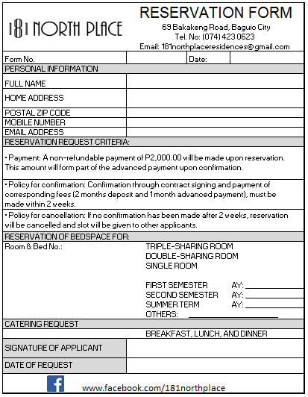

##### Figure 92: Reservation Form for Resident

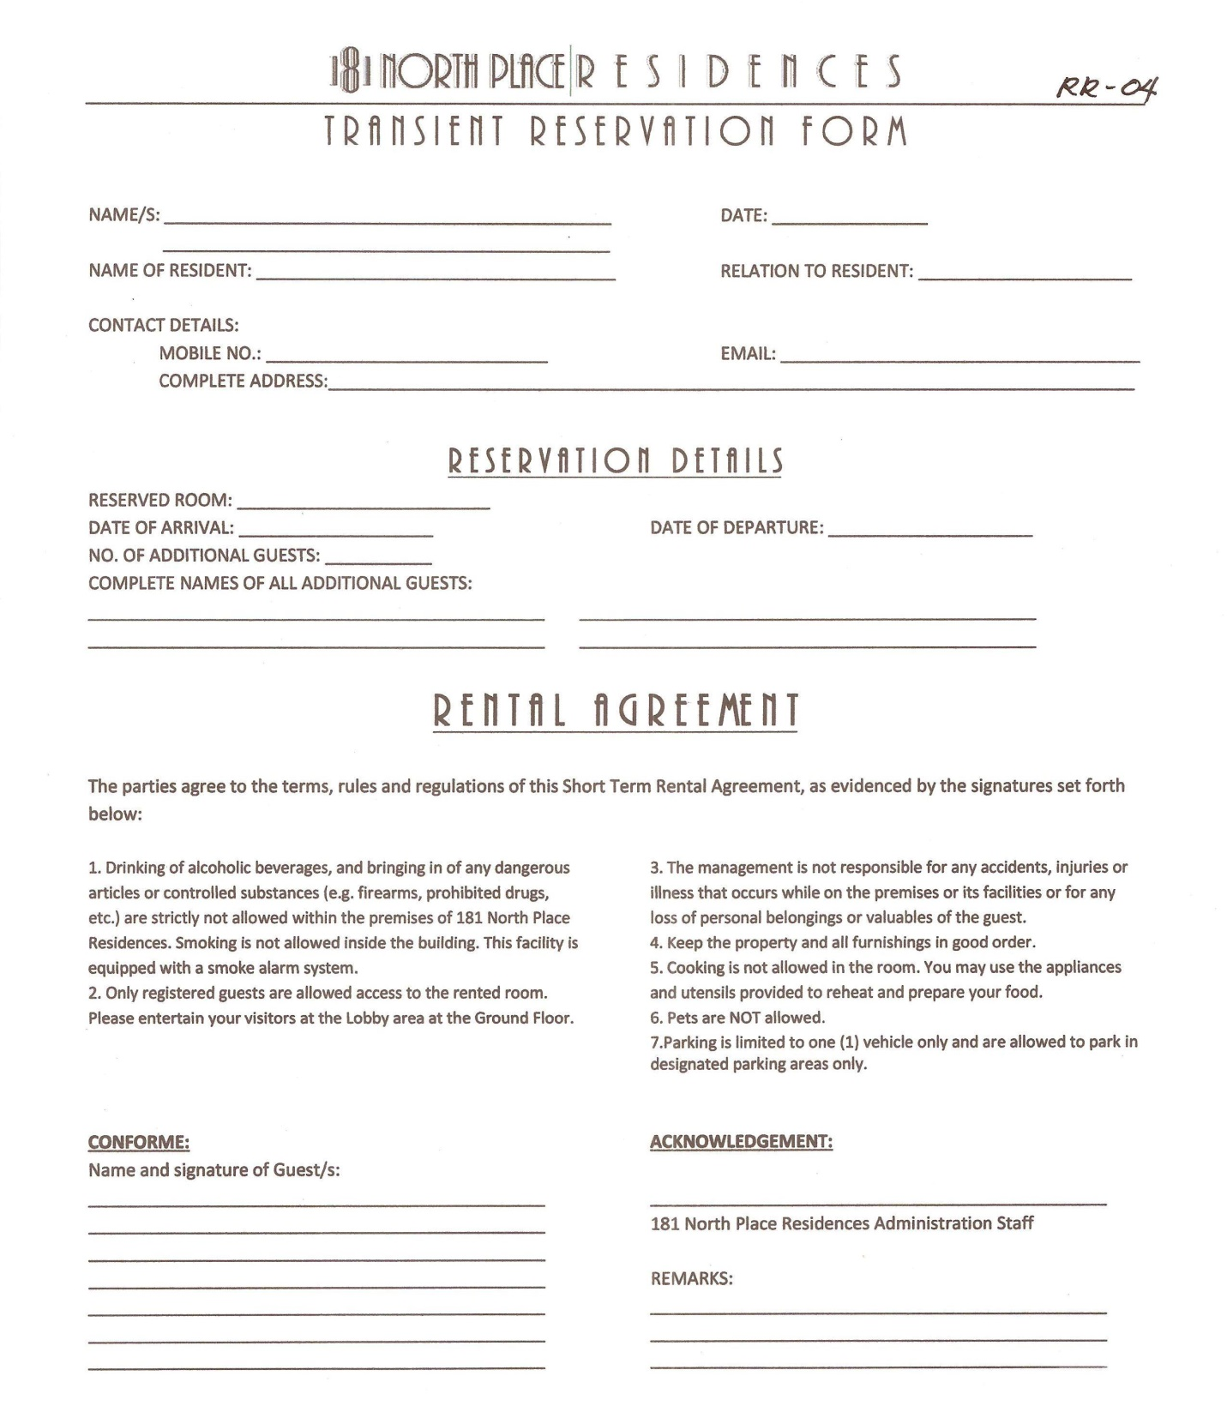

##### Figure 93: Reservation Form for Transient

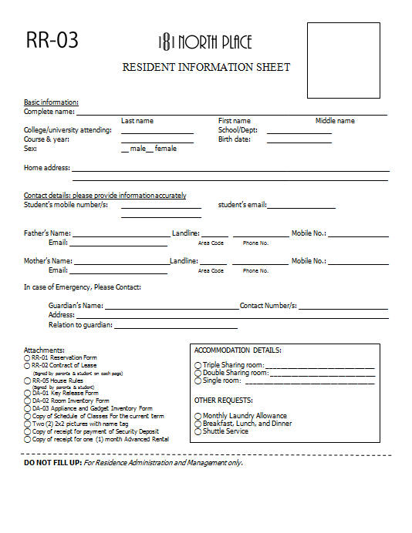

##### Figure 94: Resident Information Sheet

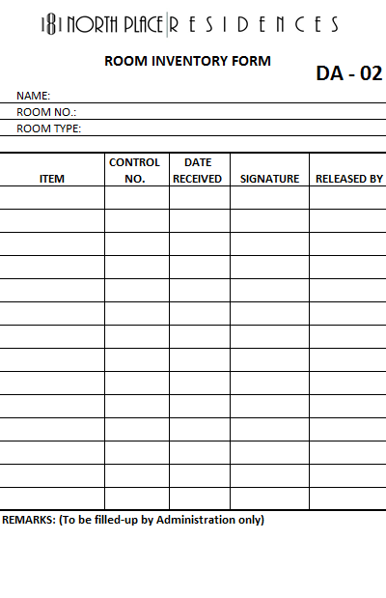

##### Figure 95: Room Inventory Form

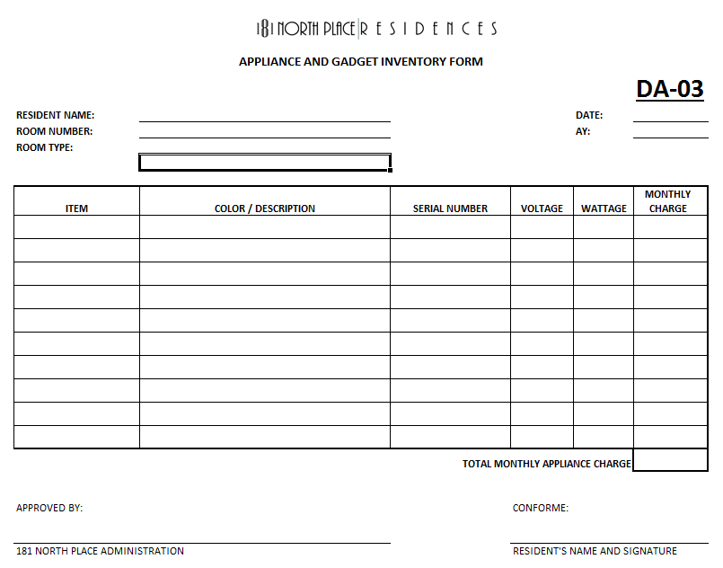

##### Figure 96: Appliance and Gadget Inventory Form

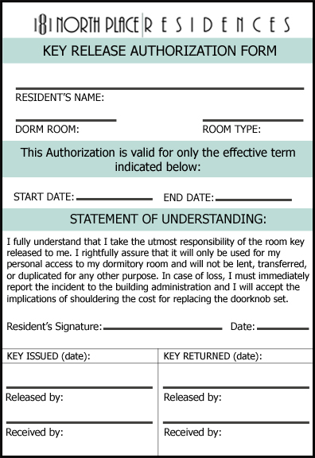

##### Figure 97: Key Release Authorization Form

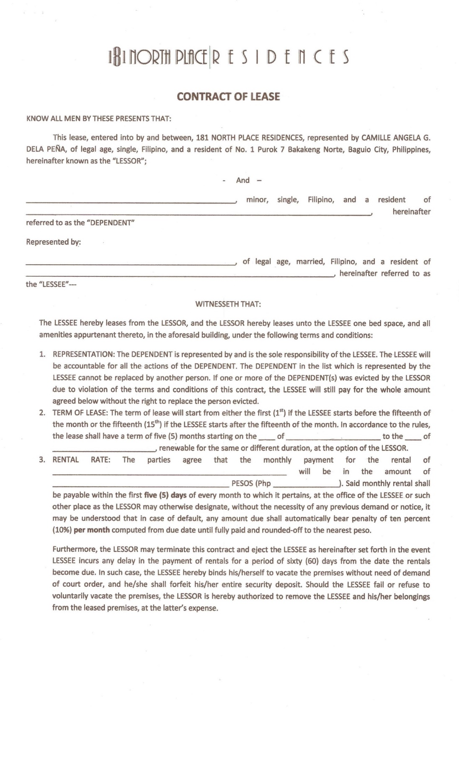

##### Figure 98: Contract of Lease for Minor (page 1)

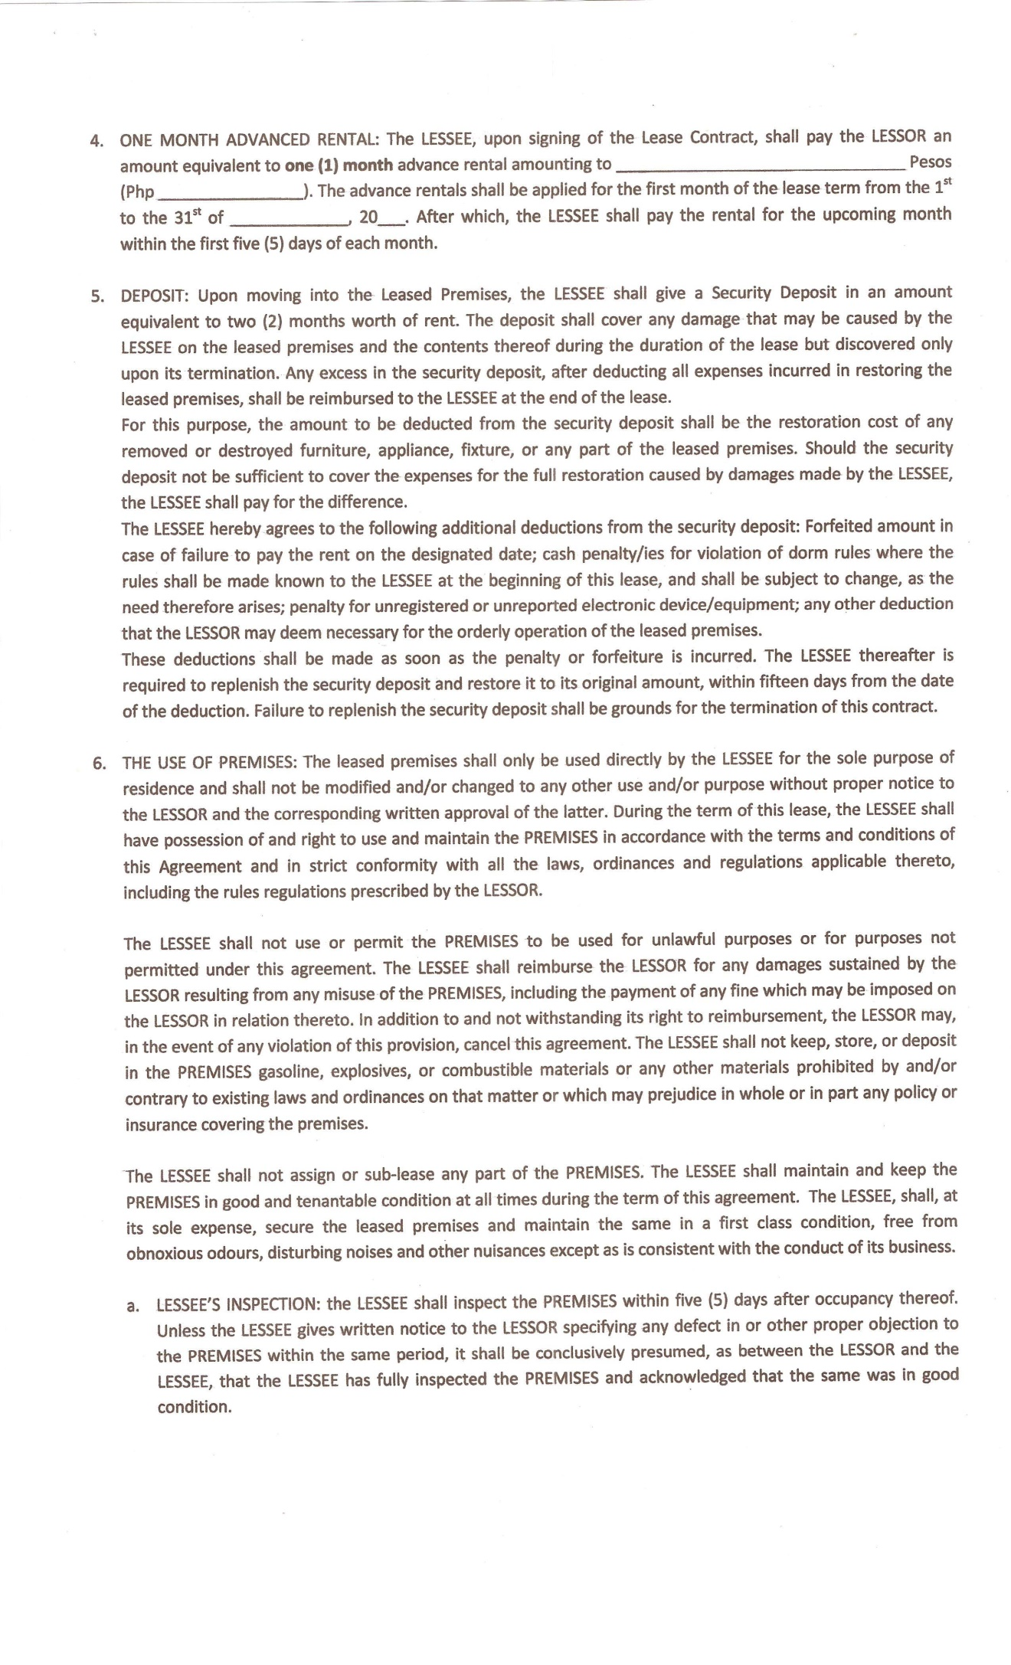

##### Figure 99: Contract of Lease for Minor (page 2)

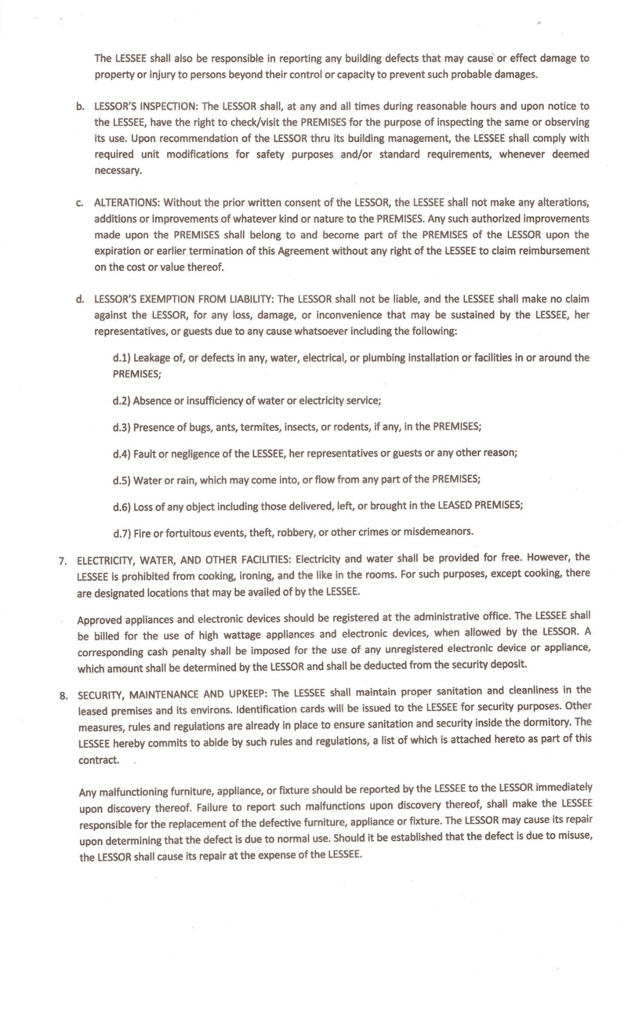

##### Figure 100: Contract of Lease for Minor (page 3)

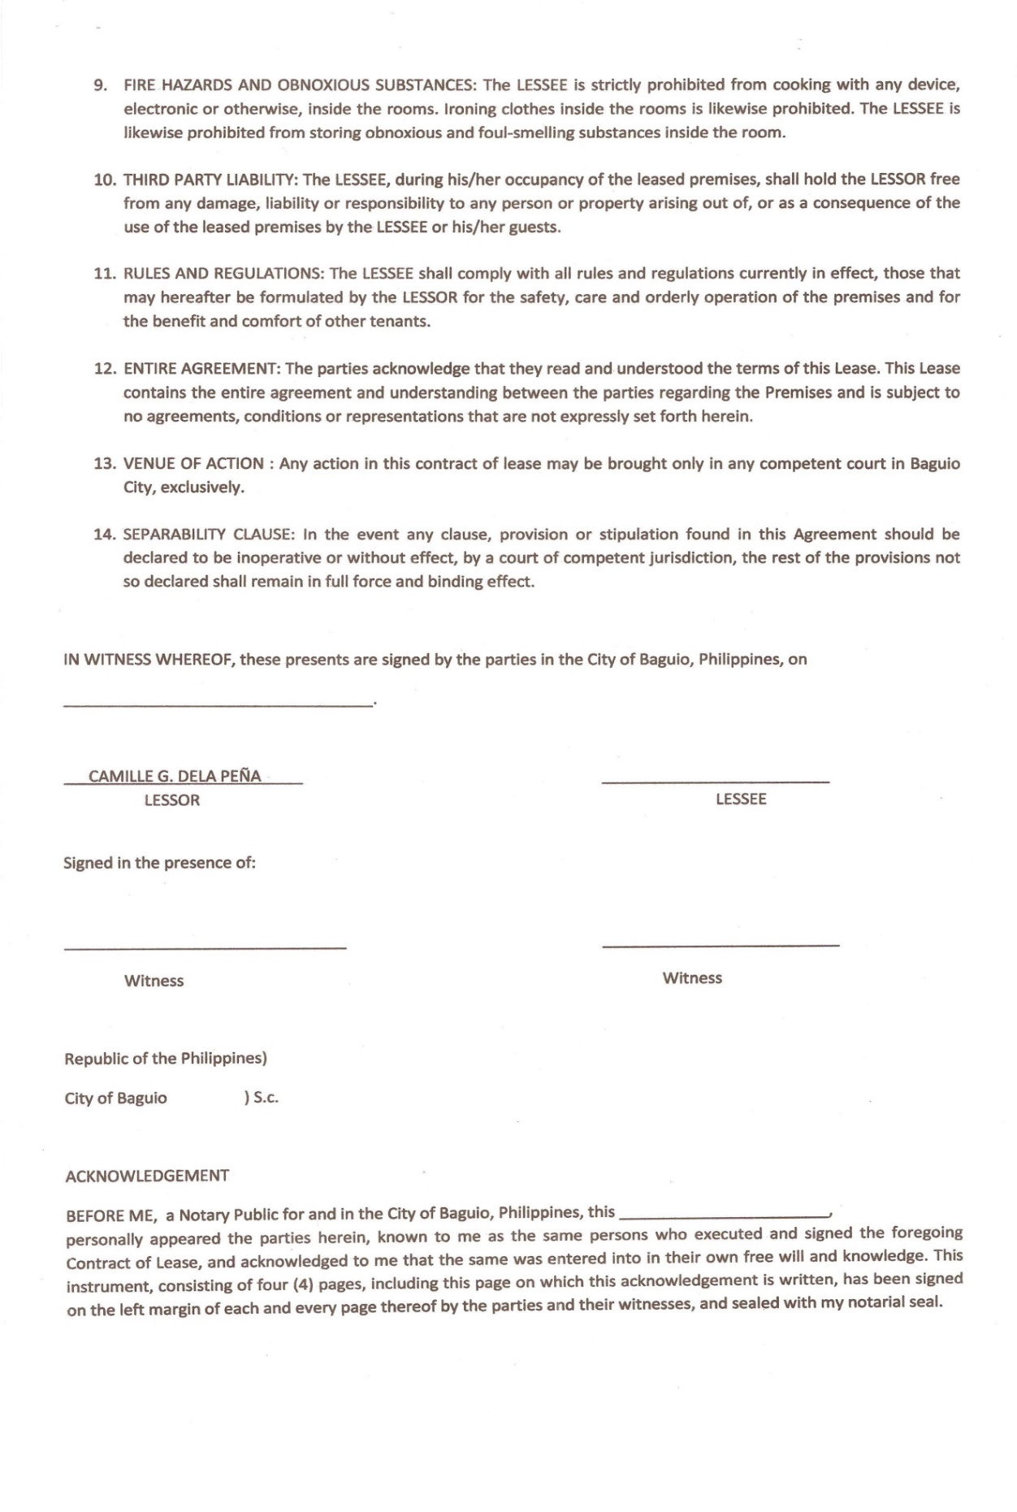

##### Figure 101: Contract of Lease for Minor (page 4)

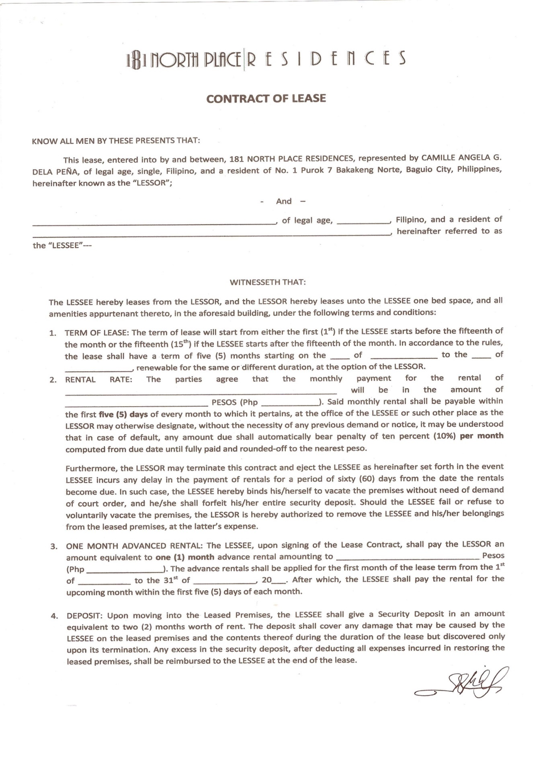

##### Figure 102: Contract of Lease for Non-Minor (page 1)

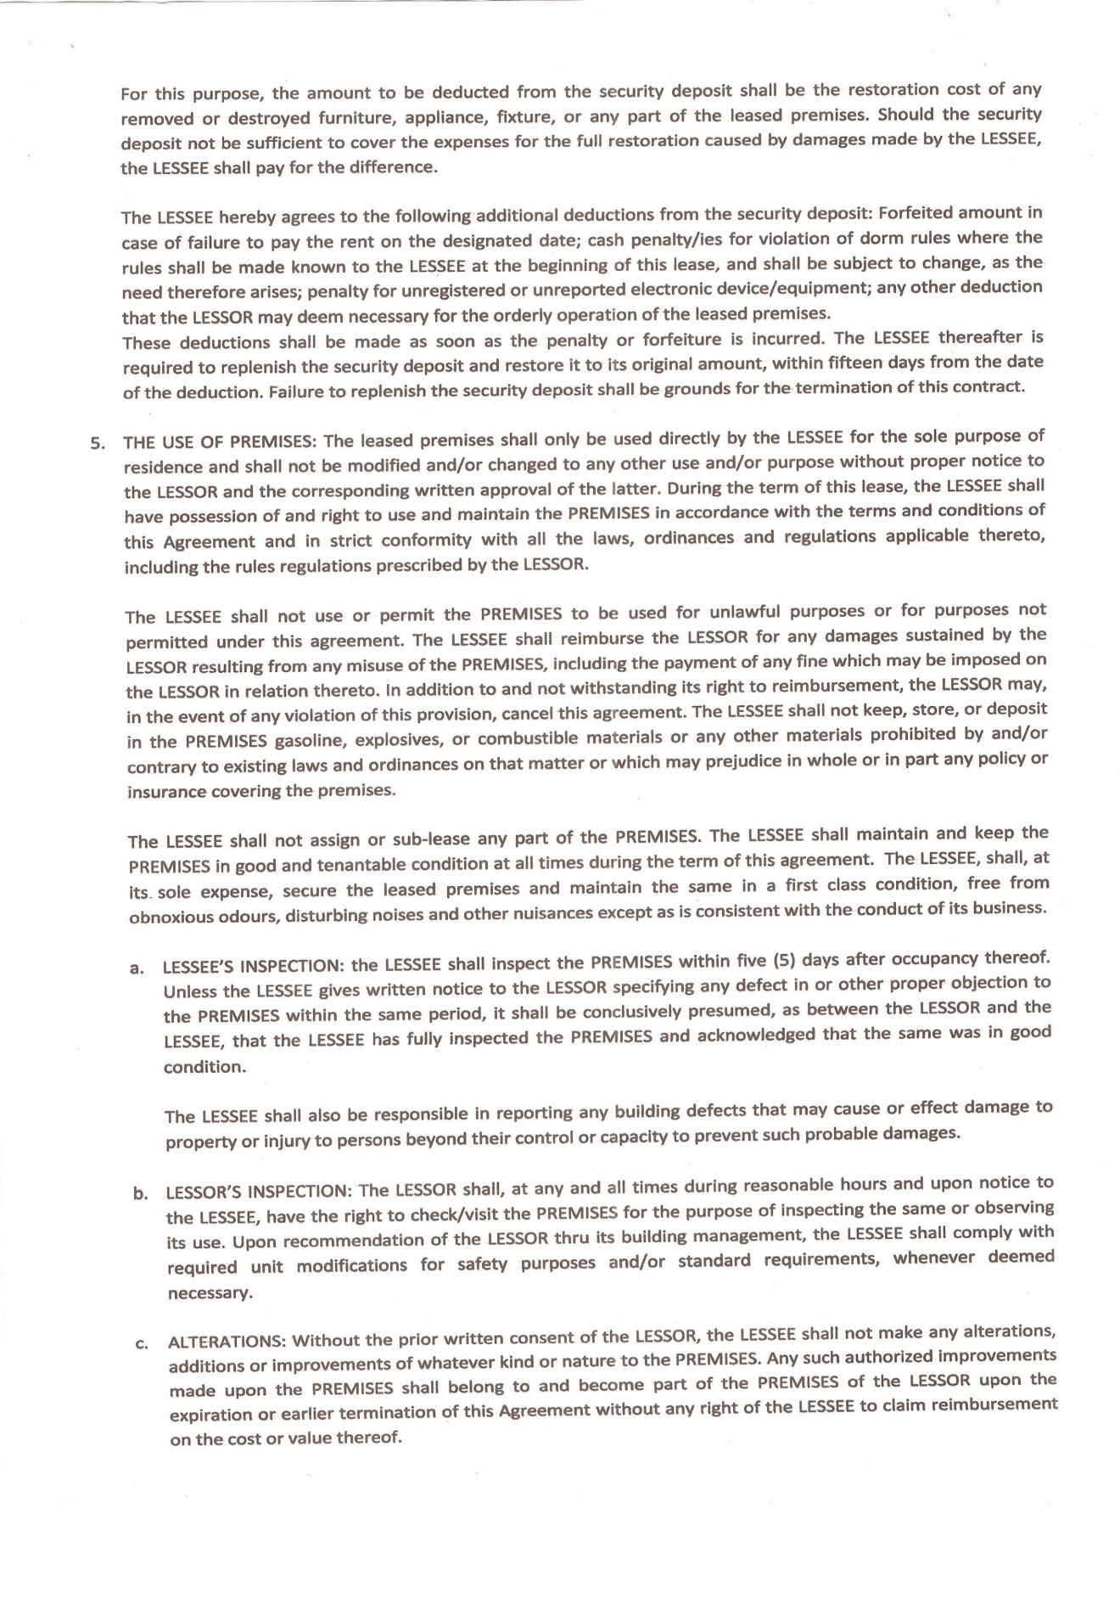

##### Figure 103: Contract of Lease for Non-Minor (page 2)

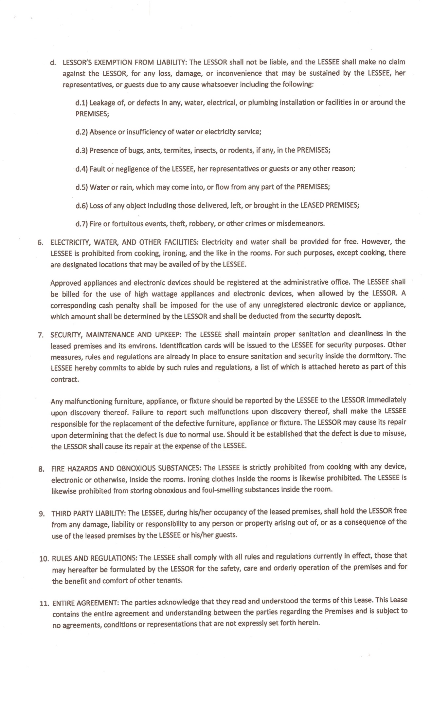

##### Figure 104: Contract of Lease for Non-Minor (page 3)

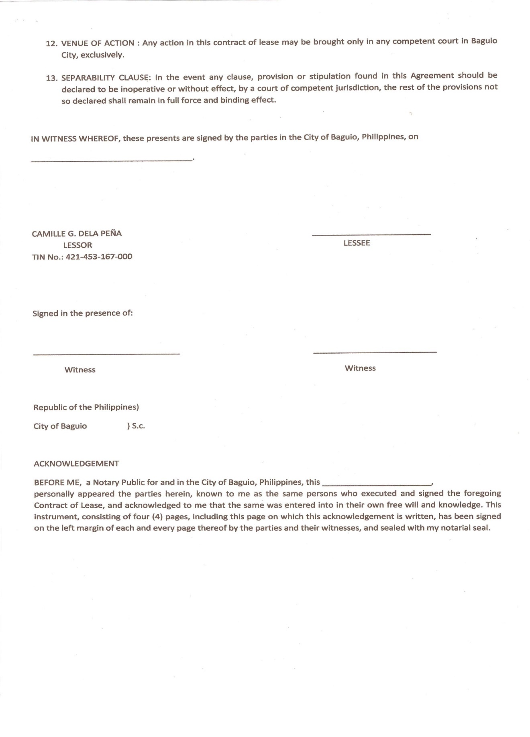

##### Figure 105: Contract of Lease for Non-Minor (page 4)

# Appendix D

IT 421 (IT Project 2)

Post Defense Report

Title: 181 North Place Residences: Automated Monitoring System

Adviser: Ms. Ria Andrea F. Nana

Date and Time of Defense: 7:30 – 9:00

Panel members:

Mr. Benedick Bacani

Mr. Dalos Miguel

Group Members:

Aguilar, Jefren R.

Alimorong, Kenneth Van L.

Bangsail, Ralph Daphene B.

Cabuang, Mark Herbert D.

Galo, Helga Denise B.

Sabado, Frances Mae N.

Silen, Kathreen Ann G.

Torres, Jaqueline L.

|  |  |
| --- | --- |
| Issues Raised | Group’s Plan of Action |
| Why is it allowed to set the dates of birth in today’s date or in the future dates? | The birthdate should not exceed to the date today or the future dates. |
| Why are passwords not encrypted on the database? | Passwords will be encrypted. |
| Why are rates allowed to be in negative value? | The system will restrict negative values to the rates. |
| Why the blank values on the rates are allowed? | It should not be allowed. |
| Figures (value of money) are left justified. | It should be right justified. |
| Rates based on the database are editable. | It should not be editable. |
| When choosing the mode of payment, what data should be captured? | The group will ask the client on what data to capture. |
| When leaving the dorm, there’s no validation about the balances on the account. | The system will check the account of the resident before leaving. |
| The placeholder on the templates of sms text messaging and e-mail. | It will be fixed. |
| Under report generation, should it be a line graph? | The graph will be changed to bar graph. |
| If the resident goes out/ in does he/ she need to login / logout every time? | Not every time you should log. If the resident will just buy outside the dormitory |
| The messages are only place holders? | The template under the messages, the place holders should be changed |
| What do you get when the transient / resident paid through bank deposit? | account name, transaction date, and amount are the details to be gotten |
| Under report generation is it all line graphs? | Bar graph for the use |
| When is the end of contract of residents? | Leave dorm |
| No verification if accounts are settled, violations if the resident will leave the dorm | User needs some details if the resident can leave or not |
| Rate on room rate under billing module | If blank it will not be saved |
| Figures about money | Right justified and it should have a comma |
| The rates should not be changed because they are based accounts | Item for discounts |
| Cheque number, bank deposit on remarks: what will be needed? | Account name, account number, and dates, deposit slip, capture image |
| Do you purge? How about after 10 years? | Create a back-up every year, that’s the purpose of archive |
| Stress testing, simultaneous testing | No intervention from the developer |

Certified correct:

________________________

Ralph Daphene B. Bangsail

# Appendix E

USER’S

MANUAL

181 North Place Residence

Table of Contents

1.0 GENERAL INFORMATION 2

1.1 System Overview 2

1.2 Organization of the Manual 2

2.0 SYSTEM SUMMARY 4

2.1 System Configuration 4

2.2 User Access Levels 4

2.3 Contingencies 4

3.0 GETTING STARTED 6

3.1. Install WampServer 6

3.2. Import Database using WampServer 2.5 6

3.3. Install JDK 8

3.4. Install U.are.U Driver 9

3.5. Install Server 10

3.6. Install Monitoring System 10

3.7. Install Lobby System 10

3.8. Install Backup and Recovery 11

4.0 USING THE SYSTEM 14

4.1 Launching the System 14

4.1.1 Launching the Server 14

4.1.2 Launching the Monitoring System 14

4.1.3 Launching the Lobby System 14

4.1.4 Launching the Backup and Recovery 14

4.2 Admin 15

4.2.1 Login 15

4.2.3 Edit Profile 15

4.2.4 Change Password 15

4.2.5 Logout 15

4.2.6 iLogBook 15

4.2.7 Admin Privileges 15

4.2.8 Notification 18

4.3 Lobby 18

4.3.1 Time-in and Time-out of resident 18

4.3.2 Visitors Log-in 19

4.3.3 Visitors Log-out 20

4.3.5 Permit to use the Building Premises 20

4.4 Resident 21

4.4.1 Reservation 21

4.4.2 Registration 21

4.4.3 Activation 23

4.4.4 Edit Resident Profile 23

4.4.5 Billing 25

4.4.6 Leave 26

4.5 Transient 26

4.6 Back-up and Recovery 28

4.7 Report Generation 29

4.7.7 Archives 30

1.0 GENERAL INFORMATION

# 1.0 GENERAL INFORMATION

General Information section give details in general terms the system and the purpose for which it is intended.

## 1.1 System Overview

181 North Place Residences Monitoring System is an automated monitoring system that uses a biometric device for the time logs, have a database for keeping records and allow the sending of important notifications through SMS text messaging and e-mail that contains of the violations like curfew and not complying with the house rules, special announcements, new roommates, visitors, balances and payments due.

## 1.2 Organization of the Manual

The user’s manual consists of five parts: General Information, System Summary, Getting Started, Using the System and Reporting.

General Information section give details in general terms the system and the purpose for which it is intended.

System Summary section presents a general overview of the system. The summary delineates the uses of the system, system’s configuration, user access levels and system’s behaviour in case of any contingencies.

Getting Started section describe how to install the system.

Using The System section provides a detailed description of system functions.

2.0 SYSTEM SUMMARY

# 2.0 SYSTEM SUMMARY

System Summary section presents a general overview of the system. The summary delineates the uses of the system, system’s configuration, user access levels and system’s behaviour in case of any contingencies.

## 2.1 System Configuration

181 North Place Residences: Automated Monitoring System is a stand-alone system. It is compatible with Windows 7 or higher versions of operating system. The application requires internet connection to enable sending of text messages and e-mail to the residents, resident’s parent or guardian. Data saved in database can be seen in the MySQL Workbench. After installing on the computer, 181 North Place Residences: Automated Monitoring System can be used immediately*.*

## 2.2 User Access Levels

The management is the only one who can use the system while, the resident can only use the biometric device.

## 2.3 Contingencies

In case of power outage data are not saved in internal memory of the operating device and there is no Internet connection available data cannot be saved in internal memory of the operating device, instead for the meantime use an Excel for the time-in and time-out of each resident as well as the visitors and record all the operations in the dormitory using forms. And when the power is already working, Back-up and Recovery is available for the management to input or upload the records. In case of data corruption, Back-up and Recovery is available to recover the previously backed-up records.

3.0 GETTING STARTED

# 3.0 GETTING STARTED

Getting Started section describe how to install the system.

## 3.1. Install WampServer

3.1.1. Download and install WampServer 32bit/64bit Version 2.5 or above from: <http://www.wampserver.com/en/>

## 3.2. Import Database using WampServer 2.5

3.2.1. Import Database:

3.2.1.1. Go to your browser and then type into the address bar the following: <http://localhost/phpmyadmin/index.php>

3.2.1.2. Press enter.

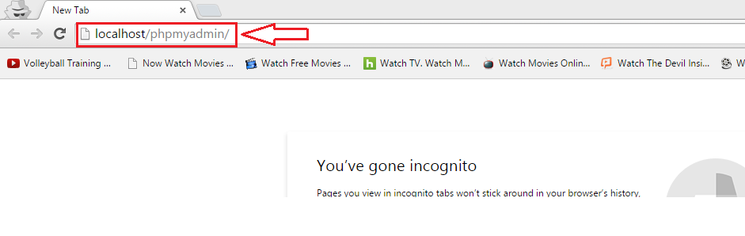

3.2.1.3. Press *Import.*

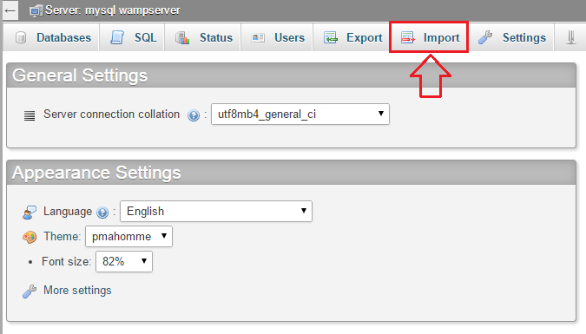

3.2.1.4. Press *Choose File.*

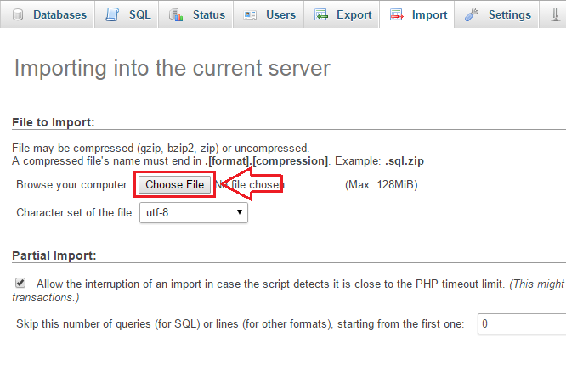

3.2.1.5.Choose the sql file (initialized DB.sql or populated DB.sql) provided: ..\data\initialized DB.sql or ..\data\populated DB.sql

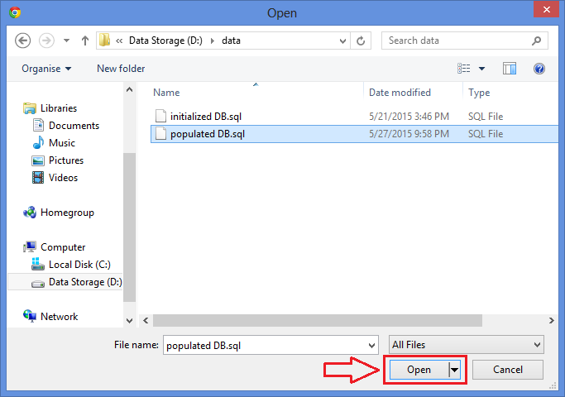

3.2.1.6. Scroll down and Press *Go.*

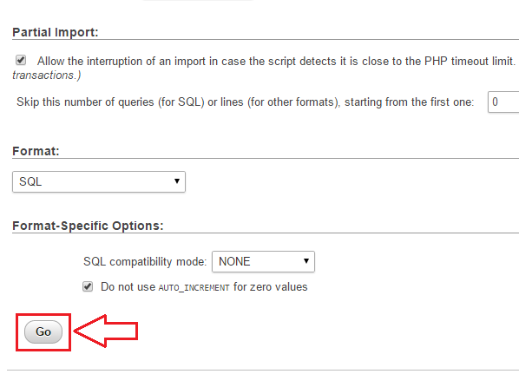

3.2.1.7. Wait until it is finished. Then a message will prompt:

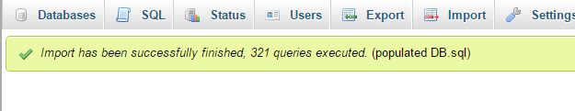

## 3.3. Install JDK

3.3.1 Download Java SE Development Kit 8(or above) Windows x64 and Windows x32 from: <http://www.oracle.com/technetwork/java/javase/downloads/jdk8-downloads-2133151.html>

3.3.2. Install Java 8 SDK 64 bit

3.3.2.1. Add JAVA_HOME in System Variables

3.3.2.1.1. Go to Environment Variables: Computer > Properties > Advanced System Setting > Environment Variables

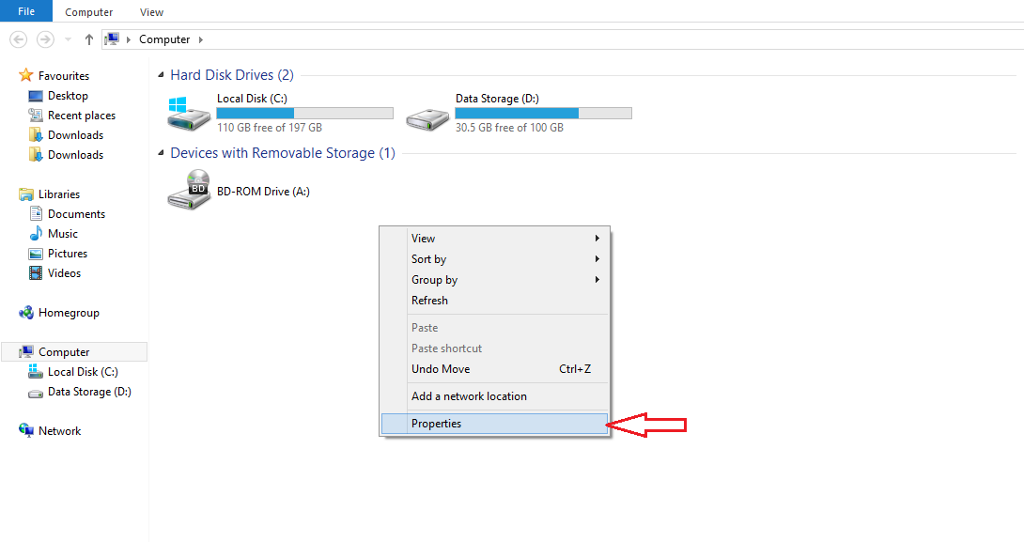

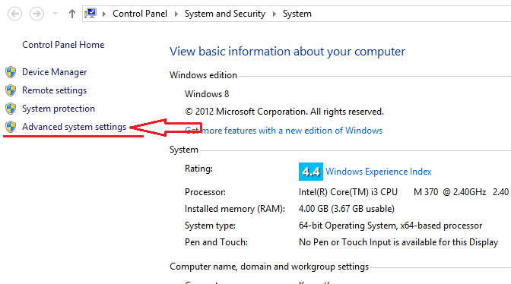

3.3.2.1.2. Then add JAVA_HOME with the path of the existing JDK

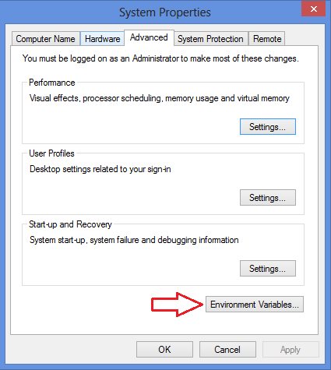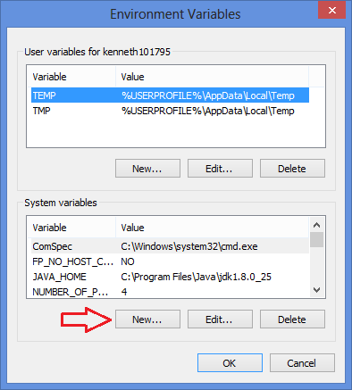 (eg. C:\Program Files\Java\jdk1.8.0_25)

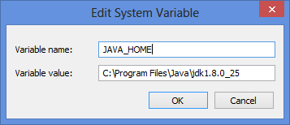

## 

## 3.4. Install U.are.U Driver

3.4.1. Install the Digital Persona U.ARE.U driver (SETUP.exe) provided

..\res\UareU\SETUP.exe

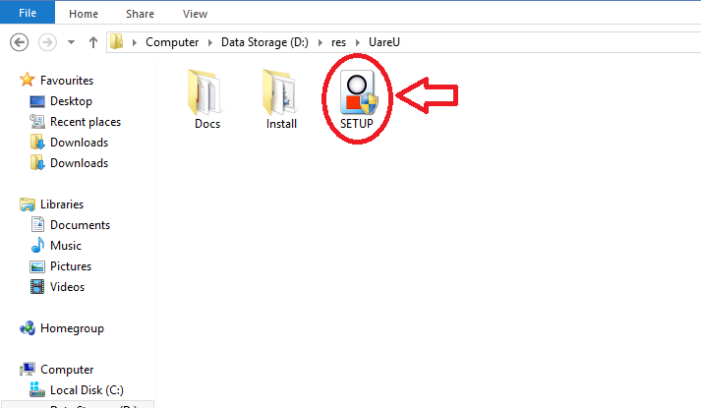

## 3.5. Install Server

3.5.1. Install the server system (181NPRServerSetup.exe) provided

..\res\181NPRServerSetup.exe

*Note:*

Open command prompt to check ipv4 address by typing “ipconfig”. The ipv4 address will be used to connect the Lobby Unit.

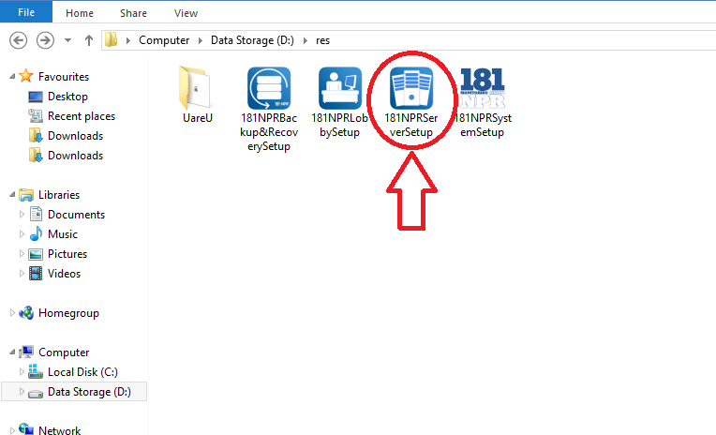

## 

## 3.6. Install Monitoring System

3.6.1. Install the main system (181NPRSystemSetup.exe) provided

..\res\181NPRSystemSetup.exe

*Note:*

Open command prompt to check ipv4 address by typing “ipconfig”. The ipv4 address will be used to connect the Lobby Unit.

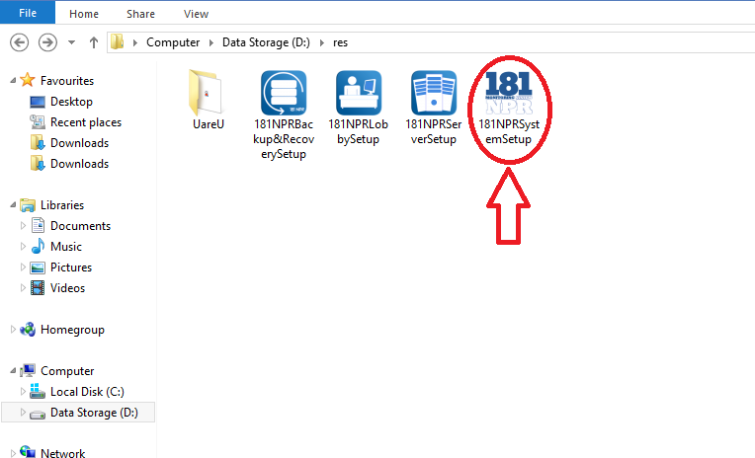

## 

## 3.7. Install Lobby System

3.7.1. Install the lobby system (181NPRLobbySetup.exe) provided

..\res\181NPRLobbySetup.exe

*Note:*

Make sure the lobby unit, monitoring system and the server are in one (1) network.

If the lobby unit is not connected to the server, type the ipv4 address of the server in the prompt message asking for ipv4 address.

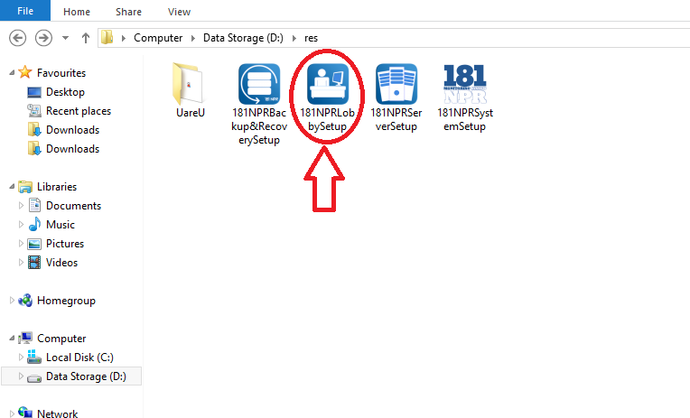

## 

## 3.8. Install Backup and Recovery

3.8.1. Install the backup and recovery system (181NPRBackup&RecoverySetup.exe) provided

..\res\181NPRBackup&RecoverySetup.exe

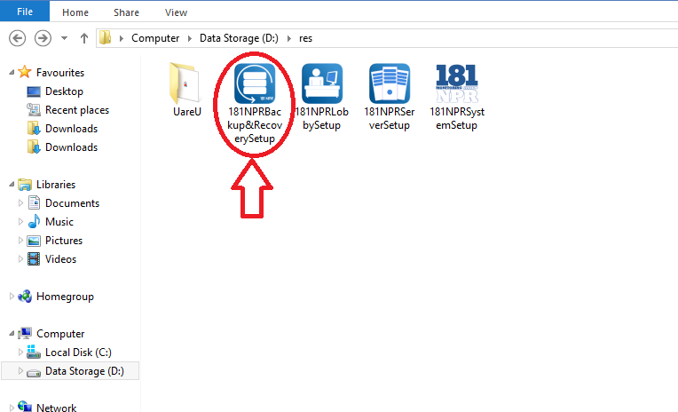

4.0 USING THE SYSTEM

# 4.0 USING THE SYSTEM

Using The System section provides a detailed description of system functions.

## 4.1 Launching the System

### 4.1.1 Launching the Server

4.1.1.1 Click the  icon to access the server.

4.1.1.2. To start the server click 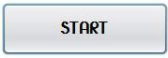.

4.1.1.3. To restart the server click .

4.1.1.4. To stop the server click .

*\*\*Note: You cannot access the system without starting the server.*

### 

### 4.1.2 Launching the Monitoring System

4.1.2.1. Click the 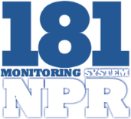 icon to access the monitoring system.

4.1.2.2. To start the system, a log-in interface will prompt.

### 4.1.3 Launching the Lobby System

4.1.3.1. Click the  icon to access the lobby.

### 4.1.4 Launching the Backup and Recovery

4.1.4.1. Click the 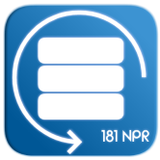 icon to access the back-up and recovery of the system.

## 4.2 Admin

### 4.2.1 Login

4.2.1.1. To Login type the credentials of the admin, the username and the password.

4.2.1.2. Click .

**4.2.2 Add Admin**

***First Option:***

4.2.2.1. Click the admin picture, located at the upper left of the interface.

4.2.2.2. Click List of Admins.

4.2.2.3. Click Add Administration, located at the lower left of the interface.

4.2.2.4. After filling up the information, click .

***Second Option:***

1. Click .

2. Click .

3. Click 

4. After filling up the information, click .

### 4.2.3 Edit Profile

4.2.3.1. Click the admin picture, located at the upper left of the interface.

4.2.3.2. Click Edit Profile.

 4.2.3.3. After editing, click .

### 4.2.4 Change Password

4.2.4.1. Click the admin picture, located at the upper left of the interface.

4.2.4.2. Click Change Password.

4.2.4.3. Type the current password, the new password and the confirmation of the new password.

4.2.4.4. Click .

### 4.2.5 Logout

4.2.5.1. Click the Admin picture, located at the upper left of the interface.

4.2.5.2. Click Logout.

### 4.2.6 iLogBook

4.2.6.1. Click .

4.2.6.2. Click .

### 4.2.7 Admin Privileges

#### 4.2.7.1 Accounts

4.2.7.1.1. Click .

4.2.7.1.2. Click 

4.2.7.1.3. Click .

4.2.7.1.4. Input the new Default Accounts.

4.2.7.4.1 The 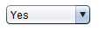 beside the *Biometrics* is used when the biometric is available (Yes) and unavailable (No).

4.2.7.1.5. To adjust the curfew hour:

4.2.7.1.5.1 Click 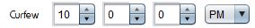.

4.2.7.1.5.2 Adjust the hour, minute, second, and period.

4.2.7.1.6. Click 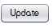 .

4.2.7.1.7. Click  to go back to the Admin Privileges menu.

#### 4.2.7.2 Manage Furniture

4.2.7.2.1. Click .

4.2.7.2.2. Click 

4.2.7.2.3. Click .

4.2.7.2.4. Check the furniture to be edited.

4.2.7.2.5. Click .

4.2.7.2.5.1 Edit the data to be edited.

4.2.7.2.5.2 Click .

4.2.7.2.6. Click , to add a new furniture.

4.2.7.2.6.1 Input the information of the furniture.

4.2.7.2.6.2 Click .

4.2.7.2.7. Click  to go back to the Admin Privileges menu.

#### 4.2.7.3 Room Rate

4.2.7.3.1. Click .

4.2.7.3.2. Click 

4.2.7.3.3. Click .

4.2.7.3.4. Select the room type 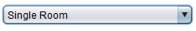.

4.2.7.3.5. Input the new room rate.

4.2.7.3.6. Click .

4.2.7.3.7. Click  to go back to the Admin Privileges menu.

#### 4.2.7.4 Shuttle Rate

4.2.7.4.1. Click .

4.2.7.4.2. Click 

4.2.7.4.3. Click .

4.2.7.4.4. Input the new Shuttle rate for Daily or Monthly.

4.2.7.4.5. Click .

4.2.7.4.6. Click  to go back to the Admin Privileges menu.

#### 4.2.7.5 Transient Rate

4.2.7.5.1. Click .

4.2.7.5.2. Click 

4.2.7.5.3.Click

4.2.7.5.4. To change the Family rate and Regular rate of the:

4.2.7.5.4.1 Current Transient Rate

4.2.7.5.4.1.1 Input the new Family Rate and Regular Rate

4.2.7.5.4.2 Current Extra Beddings Rate

4.2.7.5.4.2.1 Input the new Family Rate and Regular Rate

4.2.7.5.4.3 Current Private Suite Rate

4.2.7.5.4.3.1 Input the new Family Rate and Regular Rate

4.2.7.5.5. Click .

4.2.7.5.6. Click  to go back to the Admin Privileges menu.

### 4.2.8 Notification

4.2.8.1. Click .

4.2.8.2. Click .

4.2.8.3. Click *Residents:*

4.2.8.3.1 Select a resident.

4.2.8.3.2 Click 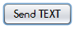,

4.2.8.3.2.1 Select the template in the drop down list



4.2.8.3.2.2 Click .

4.2.8.3.3 Click ,

4.2.8.3.3.1 Select the template in the drop down list



4.2.8.3.3.2 Click .

4.2.8.4. Click *Transients and Reservations:*

4.2.8.4.1 Select a transient or reserver

4.2.8.4.2 Click ,

4.2.8.4.2.1 Select the template in the drop down list



4.2.8.4.2.2 Click .

4.2.8.4.3 Click ,

4.2.8.4.3.1 Select the template in the drop down list



4.2.8.4.3.2 Click .

4.2.8.5. Click  to go back to the main menu.

#### 4.2.8.1 Sent Box

4.2.8.1.1. Click *SENT BOX,* at the upper left corner of the window. It will display the Time, Name of the receiver, the communication used (email or text), the type of the message, and the table where it came from.

4.2.8.1.2. To view the Message Details, double click the row.

## 4.3 Lobby

### 4.3.1 Time-in and Time-out of resident

4.3.1.1. By default, the Resident Time In/Out interface will automatically appear.

4.3.1.2. For the resident to time in/out, click 

4.3.1.3. Then, place the registered fingerprint of the resident in the fingerprint scanner.

4.3.1.3.1 If the fingerprint is recognized, the resident's name and status (logged in/out), will appear.

4.3.1.3.2 If the fingerprint is not recognized within three consecutive tries, the resident will type his/her ID number, then click .

4.3.1.3.2.1. If the the ID number is recognized, a Successful dialog box will appear, click .

4.3.1.3.2.2 If ID number is not recognized, Unsuccessful dialog box will appear, click  to re-enter the resident ID number.

4.3.1.4. Click the  to go back to the main menu of the Lobby Interface.

#### 4.3.1.1 Register Fingerprint

4.3.1.1.1. Click the .

4.3.1.1.2. Input the Admin Credentials.

4.3.1.1.3. Select the resident to be registered.

4.3.1.1.4. Right Click the Finger 1.

4.3.1.1.5. Click *Register.*

4.3.1.1.6. Click  .

4.3.1.1.7. Place the finger to be registered.

4.3.1.1.8. Click the *Validate 1,* then place the finger that was register.

*Note: Fingerprint Match will be shown if the finger print are matched, Fingerprint Unmatched will be shown if fingerprint are unmatched.*

4.3.1.1.9. Click the *Validate 2*, then place the finger that was registered.

*Note: Fingerprint Match will be shown if the finger print are matched, Fingerprint Unmatched will be shown if fingerprint are unmatched.*

4.3.1.1.10. Repeat step 6 to 9 for the Fingerprint 2.

4.3.1.1.11. Click 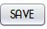.

### 4.3.2 Visitors Log-in

4.3.2.1. By default, the Resident Time In/Out interface will automatically appear.

4.3.2.2. Click the .

4.3.2.3. Click 

4.3.2.4. Fill up the information.

4.3.2.5. Select the reason for visiting.

4.3.2.6. Select the resident name to whom he will visit.

*\* *NOTE: But if the reason is for inquiring no need to select the resident name.*

4.3.2.7. If the visitor would like to inform the resident about his visit click the *.*

4.3.2.8. Click .

4.3.2.9. Click the  to go back to the main menu of the Lobby Interface.

### 4.3.3 Visitors Log-out

4.3.3.1. By default, the Resident Time In/Out interface will automatically appear.

4.3.3.2. Click the .

4.3.3.3. Click 

4.3.3.4. Click the , located at the upper left.

4.3.3.5. Select the visitor name or the name of the resident in the *'Group Visit'* that will logout. You can also search the name in the search field provided.

4.3.3.6. Click .

4.3.3.7. Click the  to go back to the main menu of the Lobby Interface.

**4.3.4 Resident Search**

4.3.4.1. To search for a resident, click the  .

4.3.4.2. Resident's name can be type in the search box.

4.3.4.3. Click the  to go back to the main menu of the Lobby Interface.

### 4.3.5 Permit to use the Building Premises

*\*\*NOTE: Permit to use the building premises is use for group visit, meetings and other matter that will need a venue inside the dormitory.*

4.3.5.1. By default, the Resident Time In/Out interface will automatically appear.

4.3.5.2. Click the .

4.3.5.3. Click 

4.3.5.4. Click the , located at the lower left.

4.3.5.5. Select the area from which they will reserve.

4.3.5.6. Click the 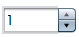 to add the number of Guest, then fill up the names of the visitors, in the text field provided.

4.3.5.7. Click the 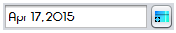 to select the date on when to use the premises.

4.3.5.8. Click the  to select the start and end time in using the premises.

4.3.5.9. Click the to validate the resident's finger print.

4.3.5.10. Click the 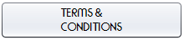 to know the rules in using the premise.

4.3.5.11. Click .

4.3.5.12. Click  to go back to the previous button.

4.3.5.13. Click the  to go back to the main menu of the Lobby Interface.

## 4.4 Resident

### 4.4.1 Reservation

4.4.1.1. Click  .

4.4.1.2. Click  .

4.4.1.3. Click  .

4.4.1.4. After filling up the information, click  .

4.4.1.5. Click  .

*\*\*Note: you can click the  to clear all the information that you have just encoded.*

#### 4.4.1.6 iFloorPlan

4.4.1.6.1. Click the  .

4.4.1.6.2. In the , you can select on what dorm the resident will be staying.

4.4.1.6.3. Click the room number and it will be selected automatically.

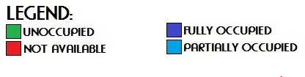

*\*\*Note:*

*1. UNOCCUPIED - the room is available for renting.*

*2. FULLY OCCUPIED - the room is not available for renting.*

*3. PARTIALLY OCCUPIED - the room is partially occupied, it can be rented depending on the number of the vacant slot/s.*

*3. NOT AVAILABLE - the room is not available because it is under maintenance.*

### 4.4.2 Registration

4.4.2.1. Click  .

4.4.2.2. Click  .

4.4.2.3. Right click the name of the person under the *"Tentative List of Resident(s)"*:

4.4.2.3.1 If you want to cancel the reservation, click *Cancel.*

4.4.2.3.2 If you want to register the reservation and continue, click *Register.*

4.4.2.3.2.1 Upon clicking the *Register*, you will now be able to add information about the resident.

4.4.2.3.2.2. To upload a picture, click on the .

4.4.2.3.2.3. To add furniture/s, click .

4.4.2.3.2.3. To add gadget/s or appliance/s, click .

4.4.2.4. After typing the information of the resident:

4.4.2.4.1. Click the  on the *registration form* to save the data on the under the resident's name.

4.4.2.4.2. Click the on the *registration form* to preview the data on the under the resident's name.

4.4.2.4.3. Click  on the *registration form* to cancel the registration form go back to the *main menu*.

#### 4.4.2.5 Add furniture

4.4.2.5.1. Under the registration, click .

4.4.2.5.2. Click on the  under the *Room Inventory* table.

4.4.2.5.3. Upon clicking, select a furniture from the left table (list of available furniture will be listed here).

4.4.2.5.4. After selecting a furniture, click  to assign the furniture to the resident.

4.4.2.5.5. If you want to remove a furniture from the *list of furniture(s) on the right table*, click .

4.4.2.5.6. Click  to cancel the assigned furniture on the resident and go back to the *inventory form*.

4.4.2.5.7. Click  to assign the furniture on the resident and go back to the *inventory form*.

4.4.2.5.7.1. Click the  on the *inventory form* under the *Room Inventory* table to save the confirmed furniture on the resident's name.

4.4.2.5.7.2. Click the on the *inventory form* under the *Room Inventory* table to preview the confirmed furniture on the resident's name.

4.4.2.5.7.3. Click  on the *inventory form* under the *Room Inventory* table to clear all the confirmed furniture on the resident's name.

**4.4.2.6 Add Gadget**

4.4.2.6.1. Under the registration, click .

4.4.2.6.2. To assign number of gadget/s or appliance/s, click the arrow up to add more gadgets, and arrow down to lessen the number of gadgets on the .

4.4.2.6.3. To input the gadget/s or appliance/s in the *Appliance and Gadget Inventory* table, type on the columns on the table.

4.4.2.6.4. After typing the gadget/s or appliance/s in the *Appliance and Gadget Inventory* table:

4.4.2.6.4.1. Click the  on the *inventory form* under the *Appliance and Gadget Inventory* table to save the gadget/s or appliance/s on the resident's name.

4.4.2.6.4.2. Click the on the *inventory form* under the *Appliance and Gadget Inventory* table to preview the gadget/s or appliance/s on the resident's name.

4.4.2.6.4.3. Click  on the *inventory form* to cancel the inventory form on the resident's name and go back to the *registration form*.

### 4.4.3 Activation

4.4.3.1. Click  .

4.4.3.2. Click  .

4.4.3.3. The list of residents will appear, right click on the name of a specific resident:

3.1. To activate the use of biometrics of a resident, click *Activate Biometrics.*

3.2. To deactivate the use of biometrics of a resident, click *Deactivate Biometrics.*

3.3. To view profile of a resident, click *View Profile.*

3.4 To change the room of a resident, click *Change Room.*

3.5. If a resident will leave the dorm permanently, click *Leave Dorm.*

4.4.3.4. Click the  to go back to the main menu.

### 4.4.4 Edit Resident Profile

4.4.4.1. Click  .

4.4.4.2. Click  .

4.4.4.3. The list of residents will appear, right click on the name of a specific resident, to view profile of a resident, click *View Profile.*

4.4.4.3.1. To edit the information of a resident, click. 

4.4.4.3.2. To change the resident's profile picture, click

#### 4.4.4.4 View Profile

##### 4.4.4.4.1 Edit Profile

4.4.4.4.1.1. Click  .

4.4.4.4.1.2. Click  .

4.4.4.4.1.3. The list of residents will appear, right click on the name of a specific resident.

4.4.4.4.1.4. Click *View Profile.*

4.4.4.4.1.5.Click .

4.4.4.4.1.6. Change the Information that needs to be change.

4.4.4.4.1.7. Click .

##### 4.4.4.4.2 Edit Furniture and Gadget

4.4.4.4.2.1. Click  .

4.4.4.4.2.2. Click  .

4.4.4.4.2.3. The list of residents will appear, right click on the name of a specific resident.

4.4.4.4.2.4. Click *View Profile.*

4.4.4.4.2.5. Click the  , located at the upper left.

4.4.4.4.2.6. To edit the information of a gadget:

4.4.4.4.2.6.1 Select a gadget.

4.4.4.4.2.6.2 Click .

4.4.4.4.2.6.3 Edit the information.

4.4.4.4.2.6.4 Click .

4.4.4.4.2.7. To add a gadget:

4.4.4.4.2.7.1 Click .

4.4.4.4.2.7.2 Input the information of the gadget.

4.4.4.4.2.7.3 Click .

4.4.4.4.2.8. To assign a furniture to a resident.

4.4.4.4.2.8.1 Select a furniture in the *Room Furniture List*

4.4.4.4.2.8.2 Click 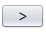

4.4.4.4.2.9. To remove a furniture assigned to a resident:

4.4.4.4.2.9.1 Select a furniture in the *Resident Furniture List*

4.4.4.4.2.9.2 Click 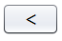

#### 4.4.4.5 Change Room

4.4.4.5.1. Click  .

4.4.4.5.2. Click  .

4.4.4.5.3. The list of residents will appear, right click on the name of a specific resident.

- 4.4.4.5.4. Click *Change Room.*

4.4.4.5.5. Select the new room of the resident by selecting:

4.4.4.5.5.1 In the drop down 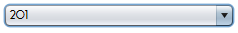

4.4.4.5.5.2 By using the 

4.4.4.5.6. Click .

### 4.4.5 Billing

4.4.5.1. Click  .

4.4.5.2. Click 

4.4.5.3. Search a resident in the search bar.

4.4.5.4. Click  to filter by category.

#### 4.4.5.5 Statement of Account

4.4.5.5.1. Click  .

4.4.5.5.2. Click 

4.4.5.5.3. Search a resident in the search bar.

4.4.5.5.4. Click  to filter by category.

4.4.5.5.5. If you want to check the statement of account of a resident just right click on the resident's name and click .

4.4.5.5.6. After clicking on the statement of accounts you can edit the monthly rate(room rate per 30 days), the shuttle rate which is monthly or the number of rides a resident accumulated within the day. If it is monthly just click on the radio button  for monthly, but if the resident accumulated the number of rides just click on the radio button  rides and click  and by double clicking on the  column you can already input the number of rides of a resident and it will already count, also choose the gadget of the resident that he/she will pay, you can also put your remarks.

\*\**Note: in the Date/s Availed, double click the space provided on the right side of the date, then type the number of rides the resident accommodated.*

4.4.5.5.7. Click .

#### 4.4.5.6 Payment of Remittance

4.4.5.6.1. Click  .

4.4.5.6.2. Click 

4.4.5.6.3. Search a resident in the search bar.

4.4.5.6.4. Click  to filter by category.

4.4.5.6.5. If a resident will pay for his/her monthly billing just right click on the resident's name and click .

4.4.5.6.6. If the resident will pay all (Room rate, Shuttle service, additional appliance/ gadget and additional 10%(if applicable)) click on the check boxes  of the room rate, Shuttle service, additional appliance/ gadget and additional 10% and the total amount will be automatically be shown at the total amount field.

4.4.5.6.7. A resident can also pay the room rate only, the shuttle rate only, the appliance only and the additional 10% only just click on the check boxes  for those fields.

4.4.5.6.8. The total amount, amount paid, and balance are shown, under the amount paid you can enter the amount that the resident will be paying.

4.4.5.6.9. You can also enter your remarks.

4.4.5.6.10. Click .

### 4.4.6 Leave

4.4.6.1. Click  .

4.4.6.2. Click  .

4.4.6.3. The list of residents will appear, right click on the name of a specific resident.

4.4.6.4. Select *Leave Dorm.*

## 

## 4.5 Transient

4.5.1. Click .

4.5.2. Click .

4.5.3. Click .

4.5.4. Fill up the necessary information.

4.5.5. If the transient is related to a resident and do not want to stay at the same room with the resident:

4.5.5.1 Click the and select the name of the resident.

4.5.5.2 Click 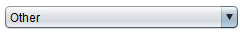 to select the relationship of the transient to the resident.

4.5.5.3 Click the  and select the room.

4.5.5.4 Click the  to choose the date of arrival and departure.

4.5.5.5 Click  to add additional guest, then fill up the names in the text field provided.

4.5.5.6 Input the monetary charge per person of the transient.

4.5.5.7 If extra bedding is needed, click  beside the *No. of Extra Bed/s,*then input the bed charge.

4.5.5.8 Input the *Total Amount* and the *Amount Paid*.

4.5.6. If the transient is related to a resident and would like to stay at the same room with the resident:

4.5.6.1 Click and select the residents name

4.5.6.2 Click  to select the relationship of the transient to the resident.

4.5.6.3 Click .

4.5.6.4 Click the  to choose the date of arrival and departure.

4.5.6.5 Click  to add additional guest, then fill up the names in the text field provided.

4.5.6.6 Input the monetary charge per person of the transient.

4.5.6.7 If extra bedding is needed, click  beside the *No. of Extra Bed/s,*then input the bed charge.

4.5.6.8 Input the *Total Amount* and the *Amount Paid*.

4.5.7. If the transient is not related to a resident:

4.5.7.1 Click the  and select the room.

4.5.7.2 Click the  to choose the date of arrival and departure.

4.5.7.3 Click  to add additional guest, then fill up the names in the text field provided.

4.5.7.4 Input the monetary charge per person of the transient.

4.5.7.5 If extra bedding is needed, click  beside the *No. of Extra Bed/s,* then input the bed charge.

4.5.7.6 Input the *Total Amount* and the *Amount Paid*.

## 4.6 Back-up and Recovery

4.6.1. Click the 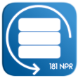 to open the Back-up and Recovery.

**Backup Database:**

4.6.1.1.A summary of the database tables is shown as a reference in the backing up of the database.

4.6.1.2. Click **,** to back-up the current database.

**Down System Back-up:**

4.6.2. Billing:

4.6.2.1 Click 

4.6.2.2 Select the resident to whom his/her statement of account or payment remittance must be added.

4.6.2.3 Right Click the name of the resident to select form *Statement of Account and Payment Remittance.*

4.6.2.4 Fill up necessary information.

4.6.2.5 Click  or  .

4.6.3. Reservation:

4.6.3.1. Click  .

4.6.3.2 Fill up the necessary information of the reserver.

4.6.3.3 Click  .

4.6.4. Registration:

4.6.4.1 Click  .

4.6.4.2 Fill up the necessary information.

4.6.4.3 Click  .

4.6.5. Transient:

4.6.5.1 Click  .

4.6.5.2 Fill up the necessary information.

4.6.5.3 Click  .

4.6.6. Time in/out:

4.6.6.1 Click  .

4.6.6.2 Click  to upload an Excel file that contains the logs of the resident.

4.6.6.3 Click  to compare the value of the Excel file to the database.

4.6.6.4 The affected row/s will be shown in the Logs.

*\*\*NOTE: Fixed the rows in the Excel file that were affected, then re-upload the Excel file. A successful message will be shown if there are no more rows that were invalid.*

4.6.7. Visitor Login:

4.6.7.1 Click  .

4.6.7.2 Fill up the necessary information.

4.6.7.3 Click  .

**Recover Database:**

4.6.8.1. Click  to upload a new database.

4.6.8.2. Click  .

## 4.7 Report Generation

4.7.1. Click .

4.7.2. Click .

4.7.3. Click and select on what result to be shown.

*\*Note: you can select, Number of Reservation, Number of Registration, Number of Late Residents and Number of Payers.*

4.7.4. Click 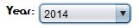to select on what year.

4.7.5. Click  to select time period.

4.7.6. Click 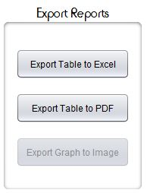 to export the result to Excel, PDF and Image.

### 4.7.7 Archives

4.7.7.1. Click .

4.7.7.2. Click  to show the list of the Personal Information, Contact Information, Address and Status of the resident.

4.7.7.2.1 Click  to export the information to PDF.

4.7.7.2.2 Click  to export the information to Excel.

4.7.7.3. Click  to show the list of the Personal Information, Check-In Details, and Guest of each transient.

4.7.7.3.1 Click  to export the information to PDF.

4.7.7.3.2 Click  to export the information to Excel.

4.7.7.4. Click  to show the list of the visitors.

4.7.7.4.1 Click  to export the information to PDF.

4.7.7.4.2 Click  to export the information to Excel.

4.7.7.5. Click  to show the list of Administrator's information.

4.7.7.5.1 Click  to export the information to PDF.

4.7.7.5.2 Click  to export the information to Excel.

4.7.7.6. Click  to show the list Resident. It will show the Personal Information, Contact Information, Father Information, Mother Information, Guardian Information and Guardian Address.

4.7.7.6.1 Click  to export the information to PDF.

4.7.7.6.2 Click  to export the information to Excel.

4.7.7.7. Click  to show the list of all the reserver in 181 North Place Residences.

4.7.7.7.1 Click  to export the information to PDF.

4.7.7.7.2 Click  to export the information to Excel.

4.7.7.8. Click  to show the logs of the resident.

4.7.7.8.1 Click  to export the information to PDF.

4.7.7.8.2 Click  to export the information to Excel.

4.7.7.9. Click  to show the Account Summary, the Transient and Resident's Date Paid, Name, Received by and Amount Paid.

4.7.7.9.1 Click  to export the information to PDF.

4.7.7.9.2 Click  to export the information to Excel.

4.7.7.10. Click  to show the room details. It shows the Dorm Number, Room Id, Room Number, Room Type and Room Status.

4.7.7.10.1 Click  to export the information to PDF.

4.7.7.10.2 Click  to export the information to Excel.

4.7.7.11. Click  to show the Furnitures of the dormitory. It shows the Item Name, Control Number, Color, Brand and Purchase Date.

4.7.7.11.1 Click  to export the information to PDF.

4.7.7.11.2 Click  to export the information to Excel.

4.7.7.12. Click  to show the list of Resident who left the dormitory. It shows the Personal Information, Contact Information, Address and Status of the resident.

4.7.7.12.1 Click  to export the information to PDF.

4.7.7.12.2 Click  to export the information to Excel.